
The Upper Room
Emmaus

September 1997 | of the Greater Fredericksburg Area

From the Lay Director . . .

Dear Brothers and Sisters in Christ,

First, I would like to thank all of you for your prayers during my recent illness. I am happy to say that I am feeling much better and will be able to attend our next gathering.

The next item I need to tell you is that we will meeting at St. Matthias UMC again in September. The gathering will be on September 6 not September 20 as previously announced. We were scheduled to meet at Rehoboth UMC but, because of our scheduling changes we needed to change the location. We apologize to Rehoboth for any inconvenience this may have caused.

I have been hearing some grumbling about things not being organized or things not getting done right. Please remember what the book of James says about the tongue.

"Likewise the tongue is a small part of the body, but it makes great boasts. Consider what a great forest is set on fire by a small spark. The tongue also is a fire, a world of evil among the parts of the body. It corrupts the whole person, sets the whole course of his life on fire, and is itself set on fire by hell. All kinds of animals, birds, reptiles and creatures of the sea are being tamed and have been tamed by man, but no man can tame the tongue. It is a restless evil, full of deadly poison. With the tongue we praise our Lord and Father, and with it we curse men, who have been made in God's likeness. Out of the same mouth come praise and cursing. My brothers, this should not be. Can both fresh water and salt water flow from the same spring? My brothers, can a fig tree bear olives, or a grapevine bear figs? Neither can a salt spring produce fresh water." James 3:5-13

Please be patient with me, I am still trying to figure out what my roles are and who is in charge of what. Also, if you see something that needs done please jump in and do it. There are a number of volunteer positions within the community that need filled. If anyone is willing to volunteer please contact me.

Now that I have that off my chest lets concentrate on the upcoming weekends. We need to keep the teams and the pilgrims of these weekends in our prayers. I trust that the prayer vigils will be filled and that a sufficient number of people will sign up to Cha for the weekends.

DECOLORES!!

In His Service,

Kim Rice


The Next Fredericksburg
Gathering

Where: St. Matthias UMC

When: September 6, 1997
Fellowship at 6:00 p.m. Please bring
snacks and refreshments to share.

The board will meet at 4:00 p.m. at the church.

PLEASE NOTE THE LOCATION & DATE CHANGE!!

1997 Weekends

Fredericksburg Men #25 Sep. 11-14
WLD: Dennis Perkins
Fredericksburg Women #26 Oct. 2-5
WLD: Karen King

Upcoming Gatherings

October 11, 1997 Fairview Baptist

November 8, 1997 Fairview Baptist

December 13, 1997 Chancellor Christian

January 10, 1998 Chancellor Christian

FREDERICKSBURG EMMAUS
BOARD OF DIRECTORS

Rice, Kim - Lay Director
Libby, Pat - Asst. Lay Director
Larson, Barbara - Secretary
Rice, Judy - Treasurer
Saathoff, Brent - Spiritual Director

Barnett, Dick Olds, Barbara
Cianelli, Gino Olds, David
Curry, Bowie Perkins, Dennis
Garfield, Cathy Tessier, Patti
Garfield, Larry

“The Fredericksburg and Chrysalis Communities do not encourage or sanction the use of Community directories for profit use.”

News...

Dallas Emmaus Weekends

Emmaus #95 September 11-14 (women’s)
Emmaus #96 September 18-21 (men’s)
Emmaus #97 October 9-12 (women’s)
Emmaus #98 October 16-19 (women’s)

If you are interested in sending agape for these weekends, please mail it to: David Adams, 2002 Gallante Drive, Carrollton, TX 75007.

DEADLINE for the October newsletter is September 10! Please send your articles to editor, Barbara Olds. Mail to 343 Longwood Drive, Stafford, VA 22554; fax to 540-286-0639; or e-mail to dolds@erols.com. For the timely delivery of our newsletter, it is important to get those articles in on time!

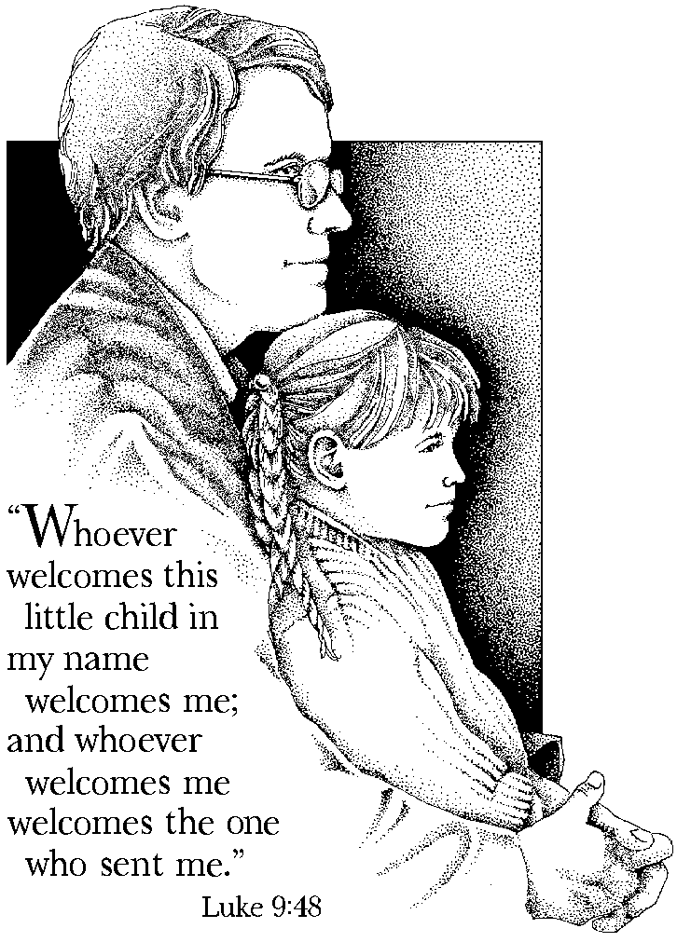

Prayers and Praises


_ Pray for Eddie Rice
_ Prayer for a job
_ Praise for new baby girl
_ For those with addiction relapses
_ Families with financial problems
_ Thank God for his son, Jesus
_ Prayers for all teens & young adults
_ Praise for answered prayer & guidance
_ For Emmaus #25 &# 26 Teams
_ Prayer for John Singer--attempted suicide
_ For my sister, Jessica Morrow, and all others heading
to college for the first time
_ Praise to our Father for His blessings & His grace
_ Prayer for 14yr old girl who is pregnant
_ Prayer for Robert & Sara and their future
_ Praise for abundant provision
_ Pray for Susannah as she follows God’s will for her
life by attending bible college in Ohio
_ For Kim Rice continued healing
_ Prayer for pastor needed at Woodbridge Christian
_ Pray for mother-in-law who does not have much time
to come to the Lord
_ Let’s praise our Lord together as he has made clear to
me the ministry in which I am to be involved
_ Prayer for Anna (3yrs) and her educational therapy
_ Prayer for wife for continued healing
_ Prayer for 5yr old grandson Michael that he will be
able to hear
_ Praise for approval of daughter’s college loan!
_ Prayer for son that he would know Christ
_ For my wife whose heart is heavy burdened
_ Pray for the Men’s Walk that the men would know the
agape love of Jesus in a deeper way
_ Praise God for His word which is “a lamp unto our
feet and a light unto our path!”
_ Prayer for Bruce Anderson beginning to teach Senior
High Sunday School this fall
_ Praise for God’s gift of life, loving & longevity!
_ Pray for understanding between parents and teens
_ Healing for eye tumor — blind in one eye — Susan
_ Dorothea Seiden — 79 & failing
_ Prayers that a loved one will choose recovery
_ Thank God for our health & wealth given by Him!
_ Praise God for continued goodness, mercy & love!!
_ Prayers for ministry of InterVarsity Christian
Fellowship at Drew University & campuses
across the U.S.
_ Prayer for son & daughter & youth group
_ Continued prayer for recovery of Scott Young; has to
undergo one more surgery to put intestines back
inside body
_ Pray for Stand in the Gap October 4th “God is in
Control--Stand Back and Watch”
_ For uncertainty as I will be starting in a new school
_ Prayer for Bethel UMC Youth Group on their return
from their mission trip in the inner city of
Indianapolis
_ Prayer for our pastors at our home church

Reunion Groups

Below is a list of Reunion Groups in our Community. Please call the contact person if you are interested in joining them.

Rainbow Group
Meets: Tuesdays at 8:15 p.m.
Location: Hope Lutheran Church, Waldorf, MD
Contact: Phil Landweer

Location: Red Robin, Woodbridge, VA
Contact: Pat Libby at 703-670-6056

Meets: Wednesdays at 8:00 a.m.
Location: C21 Adventure
Contact: Carolyn Canaday at 540-898-2900

Meets: Sunday afternoons
Contact: Anita Schmidt

Contact Jennifer Tolbert at 703-680-1318 — she is interested in beginning a reunion group in the Woodbridge area

If there are any other Reunion Groups in our Community, please provide Barbara Olds with the information, and she will add them to the list.

Fredericksburg Emmaus #25
“Blessed are the Pure in Heart...”

Pilgrims  Stanley Bice, Jr. First United Methodist  Ben Blankinship Lake of the Woods  Nick Finamore Calvary United Methodist  Al Grella Lake of the Woods  Willie Guill, Jr. Melrose United Methodist  Alan Hager Spotsylvania Presbyterian  David Henry Fairview Baptist  Steven Johnson First United Methodist  John Leddon Morrisville United Methodist  Mark Lehman Immanuel Mennonite  John Mathis Fairview Baptist  Michael McDonald Woodbridge Christian  Gary Miller First United Methodist  Joe Neiswander Woodbridge Christian  Al Ridenour Spotsylvania Baptist  Harlan Schertz Spotsylvania Assembly  Peter Schatz Fairview Baptist  Haag Scott Lake of the Woods  Glen Smith Bethel United Methodist  Wayne Weeden St. John Baptist  Wayne Welsh Calvary United Methodist |  | Team  Tom Ambrose Wes Pryce  Joe Cooper Al Rios  Curt Edsall Ken Roark  Larry Garfield Steve Russ  John Helsley, Jr. Steve Seiden  Matt Himes Bill Smith  Ken Hinkle David Smith  Robert Jenkins Kelly Snoddy  Maurice Kniceley Bubba Solt  Victor Larson Joe Swetnam  David Olds Richard Warner  Dennis Perkins Al Welker  “Blessed are the Pure in Heart for They shall see God.”

Matthew 5:8
Schedule - Fredericksburg # 25 - Sept 11-14, 1997

The team for Fredericksburg Men’s Walk #25 invites sponsors, families and community participation in the following events:

WHEN WHERE WHAT
Thurs.,Sept 11 7:00 P.M. Camp Easter Seal Pilgrim check-in/Fellowship followed by Sponsor’s Hour

Sat., Sept 13 7:45 P.M. Salem Baptist Candlelight - Please bring flowers for the team to use Sunday mile before 1/8 morning!!! Community will gather at Salem for Praise, intersection of VA Fellowship and Communion. We will move to Camp Easter
Routes 721& 630 Seal for 9:30 P.M. Candlelight Service.

Sun., Sept 14 3:30 P.M. Camp Easter Seal Closing - Gather at 3:30 for Closing Service at 4:00 P.M..

Fredericksburg Emmaus #26

“Shine Like Stars in the Universe”
Team Assignments

Susan Anderson Asst Table Leader Readings
Jean Aylesworth Table Leader Readings
Keith Boyette Spiritual Director Sanctifying Grace Sunday 10:00 a.m.
Janet Dunn Music Director
Mark Dunn Spiritual Director Prevenient Grace Friday, 11:15 a.m.
Means of Grace Saturday, 10:15 a.m.
Diana Farrar Music Team Discipleship Saturday, 8:00 p.m.
Laura Henchen Asst Table Leader Changing Our World Sunday, 8:50 a.m.
Phyllis Howse Table Leader Readings
Janis Ingham Asst Table Leader Readings
Karen King Lay Director Perseverance Sunday, 1:05 p.m.
Lynn Kline Asst Table Leader Christian Action Saturday, 2:35 p.m.
Barbara Larson Table Leader Growth Through Study Saturday, 8:55 a.m.
Pat Libby Asst Table Leader Fourth Day Sunday, 2:45 p.m.
Joy Charity O’Halloran Spiritual Director Obstacles to Grace Saturday, 4:00 p.m.
Susan Perkins Asst Lay Director Priorities Friday, 9:15 a.m.
Linda Perry Asst Lay Director Body of Christ Sunday, 11:10 a.m.
Trina Roark Table Leader Readings
Darlene Roberts Table Leader Readings
Brent Saathoff Spiritual Director Justifying Grace Friday, 3:00 p.m.
Brenda Smith Table Leader Readings
Patti Tessier Asst Table Leader Priesthood of All Believers Friday, 1:30 p.m.
Betty Gray Thompson Asst Lay Director Life in Piety Friday, 7:30 p.m.

The Team Chapel is open to the Community during the various talks. Each speaker will have a team member in the chapel as their prayer partner. A speaker’s grouping members, family or others who have attended a weekend are invited and welcomed to be a part of this special time. Chapel Prayer Partners should be discreet in arriving and departing from Camp Easter Seal and should be in the prayer chapel 30 minutes prior to “Talk Time” listed above.

From the Supply Coordinator. . .

As the men’s and women’s Fall walks approach, it is once again time to prepare the supply trunks. As you remember, there are many items that are needed to support all that goes into a Walk to Emmaus weekend. Listed below are some of the consumable supplies that will be needed. If you would like to donate items, please contact me, Tom Frank, at 540-786-2226. Your help is greatly appreciated.

Items Needed:

Magazines Pens (black or blue)
Pencils Filler Paper (prefer college ruled)
Glue/Glue Stick Play Doh - red, blue, yellow, white
Facial Tissue Candles - 9" white taper
Matches Markers (basic set of 8)
Scotch Tape (in dispenser)
Folders (3-prong w/pockets in front & back)
Poster Paper — not poster board, but flip chart style
“First Stones” (if you don’t understand, call!)
Comfort Table Items — small “travel” size items such as toiletries, aspirin, cold medications — NO SOAP!!

Thanks so much for your support!!!



Dear Brothers & Sisters in Christ,

After many month’s of prayer and planning, Fredericksburg Emmaus #24 is now a memory. Oh, but how sweet that memory is. After all was said and done, we can honestly say that Fredericksburg 24 was done His way. We had intended to send a short note earlier, but we’ve been enjoying some much needed R&R. We would like to thank everyone in the community for their unwavering support. We appreciated everything.

From the shortest whispered prayer to the last folded chair, thank you. To all of the hands that blessed us throughout each day. For lifting all those heavy trunks, we know much they weigh. For setting up a tea party just so. I’m sure you must have heard all the giggles and OOOOHHHS!

The Candlelight line just seemed to go on and on and on. I’d forgotten that on Sunday pilgrims tend to get up at the crack of dawn. We laughed and sang and ate and ate. Inevitably the team stayed up too late. All of the beautiful flowers brought so many smiles. And the hands that sorted them allowed the team to rest for awhile.

The bell, the bell, the wonderful sound of the bell. We seemed to be off schedule but could anybody tell? No, because we had prayed long ago for God to have His way. And He did just that, right through to Sunday.

He touched each and every one of us, despite all of the frill and fuss. Thank you Lord for sending so many to bless such a few, that’s just like you.

De Colores,

The ladies of Fredericksburg Emmaus 24
C. Jenkins, WLD

