
The Upper Room
Emmaus

March 1998 | of the Greater Fredericksburg Area

From the Lay Director . . .

Dear Brothers and Sisters in Christ,

First of all I want to remind everyone that the March gathering will be MARCH 7, 1998 at First Christian Church. This move was made so that the gathering did not conflict with the candlelight service for the men's weekend.

While I'm talking about candlelight, I have a couple of things I would like to say about that. First, I would like to let everyone know that we are changing the candlelight time on the weekend to 9:15p.m. We are making this change based on comments the Board has received from previous Weekend Lay Directors. The idea is that making this minor time adjustment will allow the team and pilgrims to get to the chapel a little earlier and possibly get to bed just a little earlier. In order to accomplish this, we will be starting the service at Salem Baptist promptly at 7:45p.m. We will be conducting our normal service and leaving Salem for Camp Easter Seal at 8:45p.m. Your cooperation of being punctual to Salem will be greatly appreciated.

The other thing I wanted to say about candlelight is this: We, as a community, need to get out and support our men's weekends by having a BIG turn out for candlelight. It seems to me that the attendance at candlelight for the men's weekends is smaller than for the women's weekends. I realize part of this is because the men have already walked and can't wait to see their wives. This makes it that much more important for the community to get out and support the men.

I hope to see all of you at candlelight!!!

In His Service,
Kim Rice

The Next Fredericksburg

Gathering

Where: First Christian Church

When: March 7, 1998

Fellowship at 6:00 p.m. Please bring snacks and refreshments to share.

The board will meet at 4:00 p.m. at the church.

Upcoming Gatherings

April 18, 1998 Fredericksburg UMC

May 9, 1998 Fredericksburg UMC

June 13, 1998 Woodbridge Christian

July 11, 1998 Woodbridge Christian

1998 Weekends

Men’s March 12-15
October 8-11

Women’s March 26-29
November 5-8

“The Fredericksburg and Chrysalis Communities do not encourage or sanction the use of Community directories for profit use.”

Prayers and Praises

_ Nikki & Bo’s baby - Austin
_ Kelly Seiden
_ Praise for answered prayers!!
_ Jim Ritter - surgery
_ My non-Christian friends
_ Barbara Shifflet - cancer
_ For the upcoming Weekends
_ Betty Finamore - medical tests
_ Lee Rice struggling with life choices
_ James Mercado & Mike Danley - friends who need
God’s guidance and strength
_ Daughter’s pregnancy
_ Praise for the faithful servants who minister in
Emmaus
_ Larry Brown - pancreatic cancer
_ Bobby & Drew
_ Jason Bicknell that he can open up to God’s love
_ For a wonderful son & husband
_ Pray for Andrea Aulbert who is to have dual lung
transplant
_ Job for my son
_ For Angel & Eddie Fulkerson
_ Fredericksburg Chrysalis Community
_ Emmaus #27 Team and Pilgrims
_ Pray for Diane Philipp - tests
_ Robert & Velma Lankard healing from surgery and
poor health
_ Lee Roark - continued prayer for strength & support
_ Pray for sister Pat who has growth on her ovary
_ Prayers for family of John H. who is dying and
conversion of his friends
_ Joe Reed - continued prayer that God would raise up
$6,000 in support to make three missionary trips
_ Calvary United Methodists Youth Fellowship
_ Prayers for the families of two students at Suitland
High School who died this past month
_ Praise that 3yr old granddaughter is responding to
medication to control heart problem
_ The Taylors - cancer & death in family
_ Rachel Miller - find Jesus & vice versa!
_ Members of Mens #27 & Womens #28 teams & their
families
_ Gwyn - healing
_ Amy - healing

DEADLINE for the April newsletter is March 11. Please send your articles to editor, Barbara Olds. Mail to 343 Longwood Drive, Stafford, VA 22554; fax to 540-286-0639; or e-mail to dolds@erols.com. For the timely delivery of our newsletter, it is important to get those articles in on time!

Agape

We sent over 100 general agape letters for walks in the following communities -- Northwest Georgia, Cedar Rapids Iowa, Emmaus of the Rockies - Eastern Colorado, Utah and Wyoming, Loudoun Valley Virginia, Richmond Virginia, San Antonio Texas, Southwest Virginia, Lagniappe Country Louisiana, Central Illinois, Elizabethtown Kentucky, Georgia,
San Diego California, Mountain Top North Carolina, Northwest San Antonio Texas.

We sent letters for Emmaus walks and Chrysalis Flights to the following communities -- Florida Aldersgate, Eastern Washington, Arizona, Memphis Tennessee, Bloomington/Normal Illinois. Please keep
these communities in your prayers.
FREDERICKSBURG EMMAUS
BOARD OF DIRECTORS

Rice, Kim - Lay Director
Libby, Pat - Asst. Lay Director
Larson, Barbara - Secretary
Rice, Judy - Treasurer
Saathoff, Brent - Spiritual Director

Barnett, Dick Olds, David
Garfield, Cathy Perkins, Dennis
Garfield, Larry Roark, Ken
Ogren, Mark Tessier, Patti
Olds, Barbara

Wanted!
Warm Hearts and Giving Hands

If you have these, then please contact the following individuals to volunteer to serve as a Cha on the upcoming Weekends. YOU are needed!

Men’s Weekend March 12 - 15
Contact: David Olds
(540) 286-0638
e-mail: dolds@erols.com

Chas are needed for Friday and Sunday.

Women’s Weekend March 26 - 29
Contact: Debbie (Buttram) McKeen
(540) 891-7605

Chas are needed for Thursday, Friday, and Sunday.

Interested in serving on the Emmaus Board?

If so, please contact Pat Libby, Cathy Garfield, or Dennis Perkins, members of the Nominating Committee, or any current Board member. We are accepting nominations!!!



Fredericksburg Emmaus #28
“...if anyone is in Christ, he is a new creation”
March 26-29, 1998

Pilgrims

Nynan Anderson Prince of Peace
Ruth Ash Melrose UMC
Kay Barr Crown of Life
Churalene Bice First UMC
Jennifer Bowles Fredericksburg Baptist
Gloria Brewster Morrisville UMC
Elaine Buckey Fredericksburg UMC
Rosaline Bush EPC of Fredericksburg
Melissa Coppage Old Bridge UMC
Peggy Dobbins Melrose UMC
Stacey Floyd Fairview Baptist
Wendel Goldman Trinity UMC
Catherine Guill Melrose UMC
Alice Harding Melrose UMC
Marcia Johnson Fredericksburg UMC
Jody Lewandowski Morrisville UMC
Susanne Menc Lake of the Woods
Heide Mercer Spotsy Presbyterian
Laura Mick Calvary UMC
Angela Neely Lake of the Woods
Jean Newsome Melrose UMC
Debra Owen Lake of the Woods
Sandy Payne Crown of Life
Beth Riviere Lake of the Woods
Mary Schatz Fairview Baptist
Ellen Schertz Spotsy Assembly of God
Christine Schroth Fredericksburg UMC
Elizabeth Sherba Lake of the Woods
Paige Shutlock Spotsy Presbyterian
Roberta Sites First Christian Church
Sharon Smith Fairview Baptist
Judy Staddan First Christian Church
Susan Vizzuto Germanna Church
Melanie Walz Chancellor Christian
Kimberly Wenrich Chancellor Christian
Tammy Wickes Chancellor Christian

Fredericksburg Emmaus #28
“...if anyone is in Christ, he is a new creation”
Team Assignments

Pat Barnett Asst Table Leader Readings
Mary Burge Asst Music Director
Carolyn Canaday Lay Director Perseverance Sunday, 1:05 p.m.
Melissa Canaday Table Leader Christian Action Saturday, 2:35 p.m.
Mark Dunn Spiritual Director Justifying Grace Friday, 3:00 p.m.
Means of Grace Saturday, 10:15 a.m.
Obstacles to Grace Saturday, 4:00 p.m.
Anjela Eubank Asst Table Leader Readings
Vonnie Hinkle Table Leader Priesthood of All Believers Friday, 1:30 p.m.
Readings
Carolyn Jenkins Music Director
Nancy Kail Asst Table Leader Discipleship Saturday, 8:00 p.m.
Pat Libby Asst Lay Director Life in Piety Friday, 7:30 p.m.
Lola McDonald Asst Table Leader Readings
Debbie McKeen Cha Coordinator
Sandra Morgenstern Asst Table Leader Readings
Betty Moses Table Leader Changing Our World Sunday, 8:50 a.m.
Barbara Olds Asst Lay Director Fourth Day Sunday, 2:45 p.m.
Debbie Porter Asst Table Leader Readings
Anita Schmidt Table Leader Growth Through Study Saturday, 8:55 a.m.
Diane Tanner Table Leader Body of Christ Sunday, 11:10 a.m.
Patti Tessier Table Leader Readings
Betty Gray Thompson Asst Lay Director Readings
Sonny Thompson Spiritual Director Prevenient Grace Friday, 11:15 a.m.
Means of Grace Saturday, 10:15 a.m.
Sanctifying Grace Sunday 10:00 a.m.
Pat Weinhardt Floater Priorities Friday, 9:15 a.m.

The Team Chapel is open to the Community during the various talks. Each speaker will have a team member in the chapel as their prayer partner. A speaker’s grouping members, family or others who have attended a weekend are invited and welcomed to be a part of this special time. Chapel Prayer Partners should be discreet in arriving and departing from Camp Easter Seal and should be in the prayer chapel 30 minutes prior to “Talk Time” listed above.
Schedule - Fredericksburg # 28 - March 26-29, 1998

The team for Fredericksburg Men’s Walk #27 invites sponsors, families and community participation in the following events:

WHEN WHERE WHAT
Thurs.,Mar 26 7:00 P.M. Camp Easter Seal Pilgrim check-in/Fellowship followed by Sponsor’s Hour

Sat., Mar 28 7:45 P.M. Salem Baptist Candlelight - Please bring flowers for the team to use Sunday 1/8 mile before morning!!! Community will gather at Salem for Praise, intersection of VA Fellowship and Communion. We will move to Camp Easter
Routes 721 & 630 Seal for 9:15 P.M. Candlelight Service.

Sun., Mar 29 3:30 P.M. Camp Easter Seal Closing - Gather at 3:30 for Closing Service at 4:00 P.M.

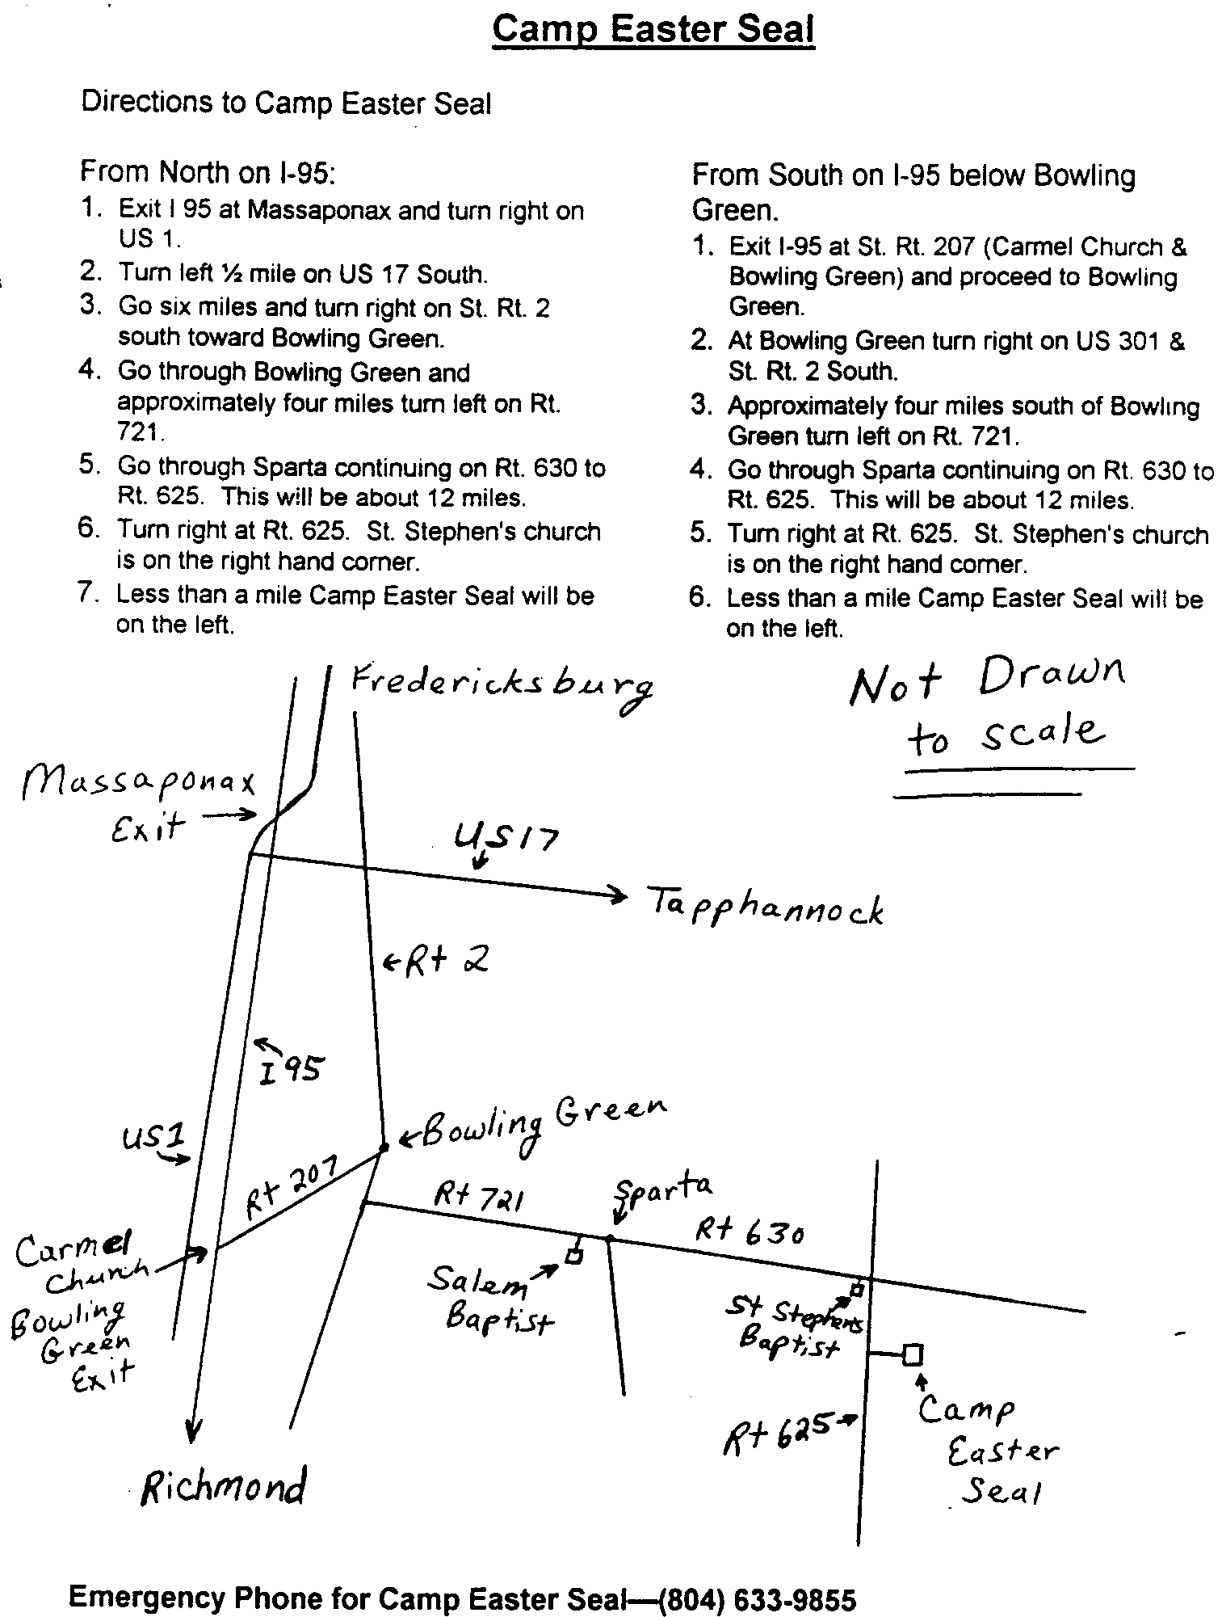

Fredericksburg Emmaus #27
“...as for me and my house, we will serve the Lord”
March 12 - 15, 1998

Pilgrims

Greg Basye Melrose UMC
Paul Beach Grace Church
Jamie Bowles Fredericksburg Baptist
Don Buckey Fredericksburg UMC
Bo Clatterbuck Bethsaida UMC
Sean Bonner Woodbridge Christian
Gerald Carter Mt. Pleasant Baptist
Carlton Crooks Melrose UMC
Mike Cotter Fredericksburg UMC
Steve Ecklund Calvary UMC
John Hagy Fredericksburg UMC
Jim Helm Remington UMC
Bob Hemming Lexington Park UMC
David Hanry Fairview Baptist
Wray Johnson Fredericksburg UMC
Brian Lewis Bethel UMC
Bob Liebau Fredericksburg UMC
Paul Martin Round Oak Baptist
Pat Menc Lake of the Woods
Mike Neely Lake of the Woods
Harlan Schertz Spotsy Assembly of God

Anthony Schroth Fredericksburg UMC
Derek Sharp Rock Church of F’burg
Bob Sherba Lake of the Woods
Gary Smith North Stafford Baptist
Harry Wickes Chancellor Christian

Team

Tom Ambrose
Dick Barnett
Fredy Calderon
Joe Cooper
Curt Edsall
Tom Frank
Marty Gardner
Charlie Harper
Mike Iden
Phil Landweer
Mo Moses
Mack McClafferty
Tony Morris
Joe Neiswander
Stephen Northcutt
Mark Ogren
Dave Olds
Wes Pryce
Jim Ritter
Ken Roark
Larry Tubbs
Richard Warner
Al Welker
Lynn Wilbur
Harry Woehrle
Roger Wood

Schedule - Fredericksburg # 27 - March 12-15, 1998

The team for Fredericksburg Men’s Walk #27 invites sponsors, families and community participation in the following events:

WHEN WHERE WHAT
Thurs.,Mar 12 7:00 P.M. Camp Easter Seal Pilgrim check-in/Fellowship followed by Sponsor’s Hour

Sat., Mar 14 7:45 P.M. Salem Baptist Candlelight - Please bring flowers for the team to use Sunday 1/8 mile before morning!!! Community will gather at Salem for Praise, intersection of VA Fellowship and Communion. We will move to Camp Easter
Routes 721 & 630 Seal for 9:15 P.M. Candlelight Service.

Sun., Mar 15 3:30 P.M. Camp Easter Seal Closing - Gather at 3:30 for Closing Service at 4:00 P.M.

Chrysalis
Corner

From the Lay Director. . .

Hey Chrysalis Community,

I hope everyone is having a great month. It was nice to see some old faces back at the gathering. I hope it was fun for all. I also hope to see more faces at the gathering in March on the 7th.

I am in the process of planning a Chrysalis social event on the 30th of May. Anyone who would like to help plan or have any ideas about it, please let me know. I am also looking for people to do the Chrysalis 4th day talks and devotions during the gatherings. I hope to have people ready for next month. If you feel like you want to do this please either contact Gena Edsall or myself.

We have a new Lead Spiritual Director of the Community, it is Margie Turbyfill. I know that we all will work together well and do many great things for this community. We need all of your support and prayers to make this work. I hope to see you all next month.

Fly with Christ!

Lee Rice

The Chrysalis Board will meet at 3p.m. the day of the Gathering at First Christian Church.

Story to consider:

Last week I took my children to a restaurant. My six-year-old son asked if he could say grace. As we bowed our heads he said, "God is good, God is great. Thank you for the food, and I would thank you even more if Mom gets us Ice Cream for dessert. And liberty and justice for all! Amen!"

Along with the laughter from the other customers nearby, I heard a woman remark, "That's what's wrong with this country. Kids today don't even know how to pray. Asking God for Ice Cream! Why, I never!"

Hearing this, my son burst into tears and asked me, "Did I do it wrong? Is God mad at me?" As I held him and assured him that he had done a terrific job and God was certainly not mad at him, an elderly gentleman approached the table.

He winked at my son and said, "I happen to know that God thought that was a great prayer."

"Really?", my son asked.

"Cross my heart", then in theatrical whisper he added (indicating to the woman whose remark had started this whole thing), "too bad she never asks God for Ice Cream. A little Ice Cream is good for the soul sometimes."

Naturally, I bought my kid Ice Cream at the end of the meal. My son stared at his for a moment and then did something I will remember the rest of my life. He picked up his Sundae and without a word walked over and placed it in front of the woman. With a big smile he told her, "Here, this is for you. Ice Cream is good for the soul sometimes and my soul is good already!"
- Unknown -

Hi All
Rejoice in the Lord always and again I say Rejoice!

I've been walking around the past few days singing... "There's a source for help in every need, there's a place to dwell down on your knees..." I don't know if that is the way the words actually go or not but those words just keep coming and I began to ponder on scriptures like...bear one another’s burdens...love one another... pray one for another...pray for others that you may be healed... greater love has no man than this that he lay down his life for a friend...do not forsake the assembling of yourselves together...

Then I wondered why so many Christians are hurting and lonely when God's word offers so much more. In examining my own life, I noticed that when I am going through some of my worst trials, I pray more, but it is for others around me who are suffering. God sets my mind on things around me and on Him so that I will not exalt my own problems above Him.

When I get busy doing things that minister or help others in their time of need, in the midst of my own horrible trial, I am looking to Him for guidance and a praise report which always come. Before I know it, I have endured my own problem and became an overcomer in yet another area of my life. I could be ashamed of the things that have happened or I can share it to help ease the suffering of another. I can testify to the glory of God. Hallelujah!

I am often asked, "How do you do it?' "How can you stay happy while all of that crap is happening in your life?" I never thought much about the one and only answer I can give..."God!"

I wonder how many people/Christians out there are hurting because they are not reaching out above their own problems and trials touching the life of the ones God has put in their path. Maybe the person who should be reaching out, isn't? What is it that is being exalted in our lives...Bills... Jobs...The Car...Our own Church... Family Issues...Self...or is it the Most High God, and His will and desire for our lives? Can we open up our lives as a book of testimony about what God has done and what He can do for others (isn't that what the Bible is full of, testimonies?)...or close our lives up in a bottle or worse...There's a "source of help" (maybe it's you) in every need, there's a place to dwell down on your knees...

Have a blessed month full of God's love flowing like a river...

Love in Jesus.

Angel

FREDERICKSBURG CHRYSALIS
BOARD OF DIRECTORS

Edsall, Gena - Adult Lay Director
Rice, Lee - Youth Lay Director
Landweer, Phil - Secretary
Dunn, Mike - Treasurer
Turbyfill, Margie - Spiritual Director

Benefield, Jamie Fulkerson, Robert Sr.
Boyette, Keith Morrow, Nathan
Edsall, Christa Olds, Barbara
Farrar, Jeremy Ritter, Jim
Fulkerson, Angel Williams, Melanie

