
The Upper Room
Emmaus

October 1998 | of the Greater Fredericksburg Area

From the Lay Director . . .

Dear Brothers and Sisters in Christ,

We now have two Emmaus teams preparing for upcoming weekends! Team members have their assignments, and pilgrims have been selected for the weekends. Excitement is in the air, because we as a community of believers have come together to share with others what has so freely been given to us. Praise God!

As I sat in the talk room on the weekend of Emmaus 11, I never stopped asking myself, why were the members of this team preforming all of these wonderful acts of love? Don't they have friends and family they would rather be with? After Saturday night, I asked myself the same question about the members of the community. By Sunday, I still didn't quite understand why all of these people, with smiling faces and colorful outfits, felt that it was so important to be a part of showing all of us pilgrims the unending Love and Grace of God.

It took my first experience as a team member to feel the joy of being a servant. Not only was I serving the pilgrims, but I found so many opportunities to serve my team mates. The real surprise came to me when I began to receive and feel the love coming from my team mates, the sponsors, the Chas, and the community. The love and support was overwhelming!

I am reminded of how the disciples were arguing as to who would sit at the place of honor at the last supper. To me, it was a kind of not knowing why they were there dialog. But then Jesus gave to them and
us an example of being a servant by washing His disciple's feet. They may not have known at that moment what was happening or what they were being prepared for. When they went out into the world and began serving others, they knew then.

Have you put on your servant's robe? You don't have to team to be a servant on a weekend. You can write agape, send food agape, be at the candlelight service on Saturday night, be at closing, serve as a Cha,
sponsor someone, or pray for the team and pilgrims. Pray for the Holy Spirit to guide you in your service.

I am going to share with you something a friend sent me as encouragement for service. It was written by Everette Hale.

I am only one, but I am one.
I cannot do everything,
but I can do something.
What I can do, I should do
and with the help of God,
I will do!

May the God of creation, grace, and love use us and our faith in Him for greater works.

Your Brother in Christ,

Dennis Perkins

1998 Weekends
Note: Expanded Facilities for Closing. We will be able to use the new gymnasium.

Men’s October 8-11
WLD: Dick Barnett

Women’s November 5-8
WLD: Betty Gray Thompson

The Next Fredericksburg

Gathering

Where: First Christian Church

When: October 3, 1998

Fellowship at 6:00 p.m. Please bring snacks and refreshments to share.

The board will meet at 4:00 p.m. at the church.

Upcoming Gatherings

November 14, 1998 First Christian Church
December 12, 1998 Chancellor Christian
January 16, 1999 Chancellor Christian

If you enjoyed the colorful placemats on your Walk, why not pass on the joy to others? Help is needed to prepare placemats for the upcoming weekends. Approximately 65 placemats are used at each mealtime. If you would like to help decorate, etc., please contact Tina Cooper at 540-310-0865.

"Would you like to sew agape bags for upcoming walks? They are simple to sew! I have directions, fabric and cording. Call Diana Farrar at 540-372-7535. If you want to help but are ‘sewing impaired,’ you may donate rainbow-hued fabric (Walmart has a terrific selection) and cording."


Reunion Groups...

We would like to list the Reunion Groups active in the Fredericksburg Emmaus Community. If you are a member of a reunion group, please send the information to Barbara Olds, Editor. Please provide the name, meeting time, place, and contact with phone number.

Great Is Thy Faithfulness Emmaus Reunion Group
Meets 7:30 PM Tuesdays
Prince Of Peace United Methodist Church
6299 Token Forest Drive
Manassas, Virginia
Contact: Lloyd Biller (703) 590-1512

Rainbow Reunion Group
Meets 8:15 PM Tuesdays
Hope Lutheran Church
Waldorf, Maryland
Contact: Phil Landweer (301) 374-9333

Pastor's Weekly Meeting
Meets 8:00 PM Thursdays
Bowie Curry's Home
1415 Stafford Ave.
Fredericksburg, Va.
Contact: Mark Dunn (540) 786-4025

Lakeside Reunion Group (Men)
Meets 8:00 PM Tuesdays
Lake Of The Woods
Contact : Vic Larson (540) 972-1928

Rainbow Reunion Group (Women)
Meets 9:00 AM Fridays
Lake Of The Woods
Contact : Barbara Miller (540) 972-7418

Clowns For God Reunion Group
Meets 8:15 PM Tuesdays
Contact : Joe Cooper (540) 310-0865

“The Fredericksburg and Chrysalis Communities do not encourage or sanction the use of Community directories for profit use.”

Prayers and Praises . . .


_ Praise for blessings in my life!
_ Prayer for tests and two surgeries
_ Work or retirement?
_ Prayers for son
_ Our family
_ Pray for church staffing & support
_ Prayers for Pilgrims #30
_ Pray for my son Shaun Devine in Monroe, WA
_ Praise for Team #30 Women’s Walk
_ Pray for Andrea Aulbert - lung transplant
_ Scott Young - surgery on September 15
_ Pray for strength to heed God’s voice
_ Praise & Thanks for selling my house in 3 days!!
_ For our Country
_ Prayers for Pilgrims & Team #29
_ Margaret Olds hospitalized with Krohns disease
_ Prayer for Keith Harrison recovering from bypass
surgery
_ Prayers for God’s Love & Protection over all
involved on #29 & #30
_ Pray for Chrysalis Board & getting weekends going
again
_ Pray for God’s help in my life
_ Prayer for Diana Farrar’s surgery
_ Praise for this wonderful caring community, for the
way God is working in our lives, and for a
terrific family!!
_ Pray for the guidance of parents and their children
_ Pray for my health & overcoming the hold it has on
me!
_ Pray for first-time team members who will be giving
a talk
_ Prayers for Joann Rogers - shots in vertebrae to cure
pain
_ Pray for Jerry Pritchard - terminal cancer
_ Praise for God’s gift to all who accept!!!
_ Pray for the problems we have in our country
_ Pray for our Youth!!
_ Pray for our country’s presidential leadership
_ Pray for family and friends who are fighting cancer
_ Pray for Robert, Sara & Darren Fulkerson
_ Praise for the band, Set Free, who led the music at the
Gathering!
_ Salvation for loved ones
_ Pray for Collins’ family in WV whose mother was
killed in line of duty (police officer)
_ Pray for John, a 6-year old with leukemia
_ Prayers for the Smith family son, David Moore -
muscular dystrophy; he is in the final stages
_ Prayer for salvation of children & grandchildren
_ Family & loved ones

_ Pray for Carolyn Jenkins mother who is quite ill &
for Carolyn’s family
_ Prayers for His guidance for financial concerns and a
stressful situation
_ Prayers for Chrysalis board – unity & support for
Chrysalis
_ Prayer for all God’s Children to join Reunion Groups
_ Praise for God’s leading in our lives
_ Prayers for our children as they begin a new school
year
_ Prayers for friends in need
_ Shaun Devine in his internship
_ Praise God for how he’s working in my life!
_ Prayer for our Chrysalis youth; the rebuilding of our
community
_ Pray for Bryan Graham - need prayer for guidance &
understanding
_ Praise for how well Chris is doing and continued
prayers
DEADLINE for the November newsletter is October 10. Please send your articles to editor, Barbara Olds. Mail to 343 Longwood Drive, Stafford, VA 22554; fax to 540-286-0639; or e-mail to dolds@erols.com. For the timely delivery of our newsletter, it is important to get those articles in on time!
FREDERICKSBURG EMMAUS
BOARD OF DIRECTORS

Perkins, Dennis - Lay Director
Barnett, Dick - Asst. Lay Director
Larson, Barbara - Secretary
Libby, Pat - Treasurer
Ogren, Mark - Spiritual Director

Cooper, Joe Perkins, Susan
Garfield, Cathy Rice, Kim
Mottley, Keith Roark, Ken
Olds, Barbara Tessier, Patti
Olds, David

Fredericksburg Emmaus #29
Jesus said, “anyone who has faith...will do even greater things than these... ”
Team Assignments

Bruce Anderson Floater Readings
Dick Barnett Lay Director Perseverance Sunday, 1:05 p.m.
Robert Davis Asst Table Leader Readings
DDU - Grouping & Grouping Practice
Mark Dunn Asst Spiritual Director Sanctifying Grace Sunday 10:00 a.m.
Curt Edsall Asst Lay Director Discipleship Saturday, 8:00 p.m.
Tom Frank Music Director
Malcolm Graham Asst Table Leader Readings
DDU - Devotions
Rich Haggerty Floater Readings
Robert Hemming Asst Table Leader Readings
Larry Morgenstern Asst Lay Director Fourth Day Sunday, 2:45 p.m.
Mark Ogren Lead Spiritual Director Means of Grace Saturday, 10:15 a.m.
Dennis Perkins Table Leader Changing Our World Sunday, 8:50 a.m.
Gene Philipp Asst Music Director
Wes Pryce Asst Lay Director Priorities Friday, 9:15 a.m.
Eddie Rice Table Leader Christian Action Saturday, 2:35 p.m.
Jim Ritter Asst Spiritual Director Obstacles to Grace Saturday, 4:00 p.m.
Ken Roark Table Leader Body of Christ Sunday, 11:10 a.m.
Tony Schroth Asst Table Leader Life in Piety Friday, 7:30 p.m.
Gary Smith Asst Spiritual Director Justifying Grace Friday, 3:00 p.m.
Tom Smith Table Leader Growth Through Study Saturday, 8:55 a.m.
Gary Staddan Asst Spiritual Director Prevenient Grace Friday, 11:15 a.m.
Don Walz Table Leader Readings
Richard Warner Lead Cha Coordinator
John Weinhardt Asst Cha Coordinator
Wayne Welsh Asst Table Leader Priesthood of All Believers Friday, 1:30 p.m.
Tommy Whitaker Table Leader DDU - Emmaus Story
Harry Wickes Asst Table Leader Readings
DDU - Fourth Day

The Team Chapel is open to the Community during the various talks. Each speaker will have a team member in the chapel as their prayer partner. A speaker’s grouping members, family or others who have attended a weekend are invited and welcomed to be a part of this special time. Chapel Prayer Partners should be discreet in arriving and departing from Camp Easter Seal and should be in the prayer chapel 30 minutes prior to “Talk Time” listed above.

Fredericksburg Emmaus #29
Jesus said, “anyone who has faith...will do even greater things than these... ”
Pilgrims

Andy Anderson | Calvary United Methodist Church
Mark Anderson | Spotsylvania Presbyterian
Herman Brock | St. Stephen’s Baptist
Charlie Cooper | Melrose United Methodist Church
Donnie Cross | Prince of Peace United Methodist Church
Ray Curtis | Chancellor Christian Church
Bill Davis | Reconciliation Community Church
Charles Doyal | St. Matthias United Methodist Church
David Eubank | Spotsylvania Presbyterian
Will Floyd | Fairview Baptist Church
Bob Hamill | Morrisville Methodist Church
David Holland | Bethel United Methodist Church
Bill Holt | St. Matthias United Methodist Church
Greg Howard | Fredericksburg United Methodist Church
Jerry Kreft | Ebenezer United Methodist Church
Gregg Lamb | Fredericksburg United Methodist Church
Greg Linton | Woodbridge Christian Church
Barkley Lloyd | Calvary United Methodist Church
Matt Lohr | Waters Memorial United Methodist Church
Hank McCaslin | Fredericksburg United Methodist Church
George McDonald | Woodbridge Christian Church
John Mann | Fredericksburg United Methodist Church
Eddie Osborne | Chancellor Christian Church
Paul Prewitt | Fredericksburg United Methodist Church
Chris Rogers | Fredericksburg United Methodist Church
Jarrod Smith | Fredericksburg Baptist Church
Greg Sweitzer | First United Methodist Church
James Taylor | Lake of the Woods Church
Mark Tessier | Remington United Methodist Church
Charles Tillapaugh | Wright’s Chapel United Methodist Church
Greg Weakley | Cherrydale Baptist

Schedule - Fredericksburg # 29 - Oct 8-11, 1998

The team for Fredericksburg Men’s Walk #29 invites sponsors, families and community participation in the following events:

WHEN WHERE WHAT
Thurs.,Oct 8 7:00 P.M. Camp Easter Seal Pilgrim check-in/Fellowship followed by Sponsor’s Hour

Sat., Oct 10 7:45 P.M. TBA Candlelight - Please bring flowers for the team to use Sunday morning!!! Community will gather for Praise, Fellowship and Communion. We will move to Camp Easter Seal for 9:15 P.M. Candlelight Service.

Sun., Oct 11 3:30 P.M. Camp Easter Seal Closing - Gather at 3:30 for Closing Service at 4:00 P.M. Closing
will be held in the new gym.

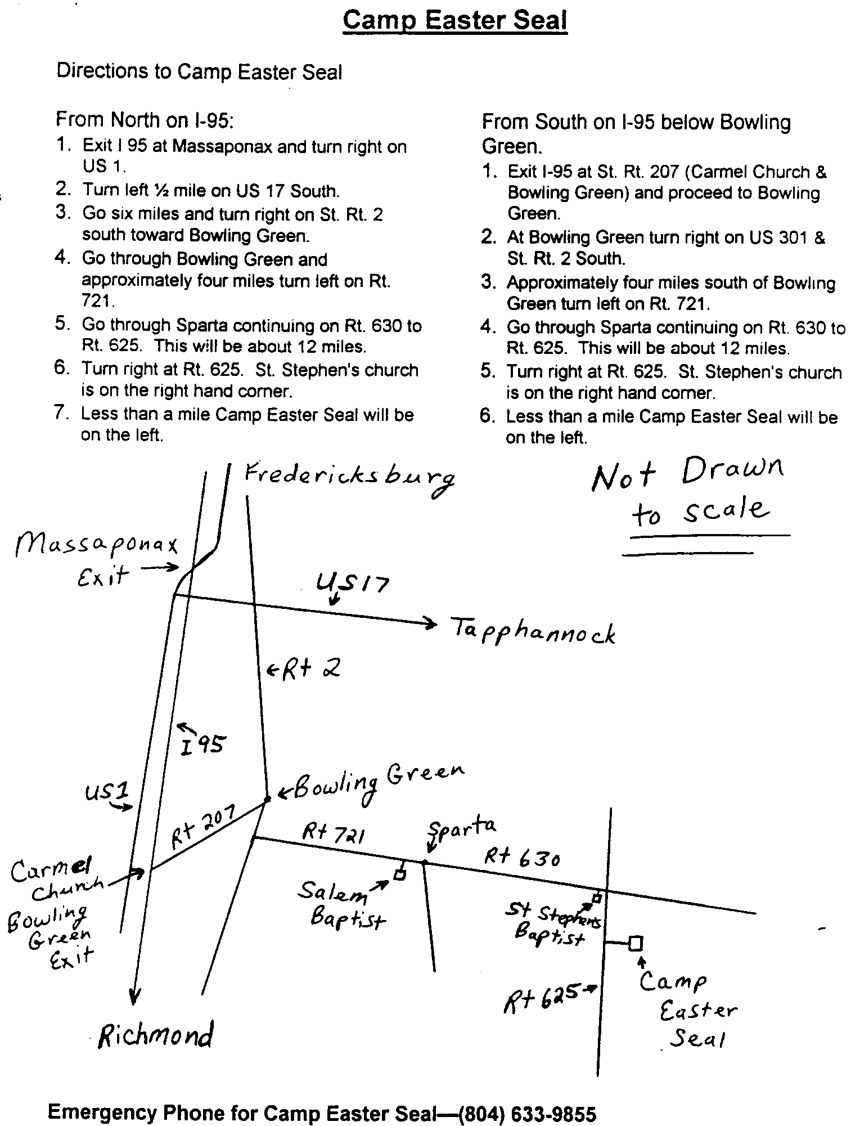
Fredericksburg Emmaus #30
“Love God and Love Your Neighbor”
Team Assignments

Jean Aylesworth Asst Table Leader Readings
DDU - Teaming Talk w/ Debbie Devine
Brooke Bevan Team Cha/Table Servant Readings
Jennifer Bowles Team Cha/Table Servant Readings
Judy Cover Table Leader
Sandy Crossley Asst Table Leader Readings
Debbie Devine Cha Coordinator DDU - Teaming Talk w/ Jean Aylesworth
Joanie Elkins Team Cha/Table Servant Readings
Diana Farrar Asst Music Director Priesthood of All Believers Friday, 1:30 p.m.
Angel Fulkerson Asst Lay Director Growth Through Study Saturday, 8:55 a.m.
Cathy Garfield Agape Coordinator Readings
Vonnie Hinkle Asst Table Leader Life in Piety Friday, 7:30 p.m.
Phyliss Howze Asst Table Leader Changing Our World Sunday, 8:50 a.m.
Marilynne Landweer Table Leader Discipleship Saturday, 8:00 p.m.
Sally Lawrence Asst Table Leader Readings
Lola McDonald Table Leader Readings
Debbie McKeen Music Director Readings
DDU - Sponsorship Talk
Sandy Morgenstern Table Leader Body of Christ Sunday, 11:10 a.m.
Readings
Keith Mottley Spiritual Director Sanctifying Grace Sunday 10:00 a.m.
Mark Ogren Spiritual Director Obstacles to Grace Saturday, 4:00 p.m.
Susan Perkins Asst Lay Director
Darlene Roberts Asst Agape Coordinator Christian Action Saturday, 2:35 p.m.
Ellen Schertz Team Cha/Table Servant Readings
Christine Schroth Table Leader Readings
Barbara Simpson Asst Lay Director Priorities Friday, 9:15 a.m.
Readings
Bill Smith Spiritual Director Means of Grace Saturday, 10:15 a.m.
Florence Smith Team Cha/Table Servant Fourth Day Sunday, 2:45 p.m.
Patti Tessier Asst Cha Coordinator
Betty Gray Thompson Lay Director Perseverance Sunday, 1:05 p.m.
Emily Thompson Asst Table Leader
Melanie Walz Team Cha/Table Servant Readings
Rosemary Welch Spiritual Director Justifying Grace Friday, 3:00 p.m.
Bob Winston Spiritual Director Prevenient Grace Friday, 11:15 a.m.
Barbara Wood Table Leader

A Note from Angel. . .

Hello Community!

God desires (at least) equal time and He has given us a way. Jesus is the Way, the Truth...and the Life. Jesus Is Lord of All!
Ouch!
Out of the abundance of the heart, the mouth speaks. Amen!

Last month, I wrote about God being a jealous God, about adultery and fornication hoping to stir in us, about our need to give God more of ourselves. I got some feedback. Whew! Did I ever get some feedback! This subject seemed to stir something in some marriages that I had not intended so please forgive me... :-) ...unless of course, God was speaking to you.

I once heard a speaker teach on adultery and its original meaning of "mixing seed." Let's consider what kind of seed mixing is going on in our own lives. Let's consider our relationship/walk with God. Let's not consider anyone else's, but let us examine ourselves.

How often do we pray? Now, how often do we talk to our friends...family...co-workers...to our computers...? Here we have relationships but who or what is getting the quality time? Equal time, at least? Remember, our God is a jealous God.

Now, consider another thing: How often do we sit alone with God, talking with Him, and listening to what He has to share with us? How often do we sit with another person, with the television or radio, with our computer, with... ? Are we giving equal time, at least? Remember, Our God Is A Jealous God.

One more thing... What do we consider intimate in our own life, dear to us? How do we outwardly express intimacy? How would we want to be treated in being an intimate part of someone else's life? We reap what we sow, amen. Jesus laid down His life for each of us, putting our needs above His own. He teaches us through the Word, and through His example about relationships...especially with the Father. Remember, Our God Is A Jealous God!

He is seeking an intimate relationship with "YOU."
He asks "YOU"... invites "YOU" ... to come... The choice is yours. Will you come?

Even though He is a jealous God. Even though He wants us all for Himself. Even though we often choose to commit adultery concerning our relationship with Him. Even though I am talking about equal time with God when really His desire is to receive our best, not our left overs. Even though our God is a Jealous God. He is also a Loving and Forgiving God. Grace! Hallelujah!

Surely, the one thing about our Heavenly Father that will never cease to amaze me is that He still loves us no matter what we choose. He will never leave us nor forsake us. Never!

Love in Jesus,
Angel

Chrysalis
Corner

Dear Brothers and Sisters,

Elections for the Chrysalis Board were held at the September Gathering. The following people were elected to the Board of Directors to serve a three-year term:
Malcolm Graham
Kristy Seiden
Rev. Margie Turbyfill
Warren Wooten

Congratulations and God Bless You for answering His call to serve.

Chrysalis held an all day training session on September 12. Helen Kerrigan, the area advisor, came to share with us. We went through a 72-hour weekend in an 8-hour day!! Insight and blessings were abundant. We want to thank the members of the Fredericksburg Emmaus Community who came to learn more about Chrysalis.

We ask for your prayers and support as we prepare for a girls’ weekend to be held in April 1999. Please prayerfully consider serving as a member of the team. We need you to submit your applications now for consideration as team members.
The Chrysalis Board will meet at 4 p.m. the day of the Gathering at First Christian Church.

As Emmaus is an avenue in which to uplift and strengthen adult church members, Chrysalis is a way in which we can strengthen the youth of our churches. Is there a young person in your congregation that comes to mind? Then consider offering them the gift of an opportunity to grow closer in their walk with God. Applications for both girls and boys are being accepted.

May the grace of God fill you with peace.

Fly With Christ!!
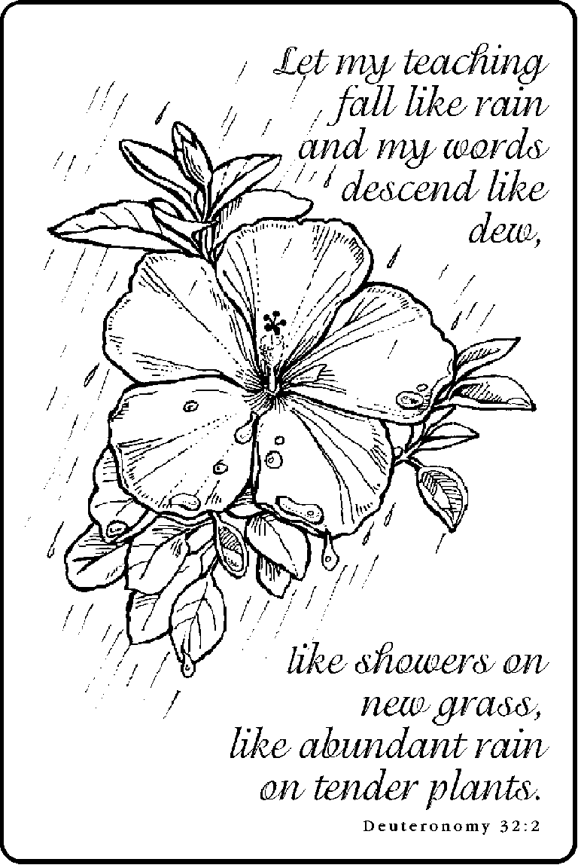
FREDERICKSBURG CHRYSALIS
BOARD OF DIRECTORS

Edsall, Gena - Adult Lay Director
- Youth Lay Director
Landweer, Phil - Secretary
- Treasurer
Turbyfill, Margie - Spiritual Director

Benefield, Jamie Morrow, Nathan
Boyette, Keith Olds, Barbara
Fulkerson, Angel Ritter, Jim
Fulkerson, Robert Sr. Seiden, Kristy
Graham, Malcolm Wooten, Warren

