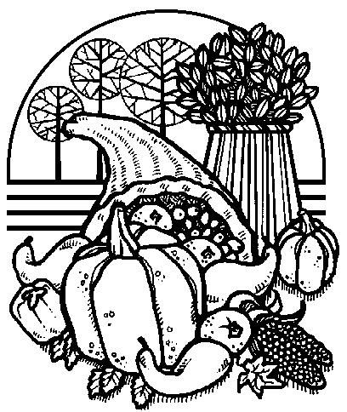
The Upper Room
Emmaus

November 1998 | of the Greater Fredericksburg Area

From the Lay Director . . .

Dear Brothers and Sisters in Christ,

God is so good! He has led His teams through two awesome "Walk To Emmaus" weekends. I would like to thank Dick Barnett, Betty Gray Thompson, and the teams for being faithful to God's call and allowing Him to use them as earthen vessels to be filled and to pour out God's love. "For I have been poured out like a drink offering, and the time has come for my departure. I have fought the good fight, I have finished the race, I have kept the faith." 2 Timothy 4:6-7

I was searching through my closet one day looking for a shirt to wear. I was looking for a t-shirt, something casual to wear as I spent time with friends. I came across my fishing shirt. Do you have articles of clothing that you wear when you go certain places? Then I started
thinking about this, and I said to myself, "Every shirt should be my fishing shirt!" I should wear the love of God wherever I go and be prepared to be a fisher of men and women.

I believe God places us where He wants us to be. I find it kind of interesting that there are so few Pastors but so many lay people. Our pastors truly have their hands full. They visit the sick and the hurting, serve on many community projects, perform weddings, baptisms,
funerals, head committees, lead retreats, teach classes, counsel their congregation, prepare sermons each week, sing praises to God, are prayer warriors, encourage, outreach, and nurture their flock. These men and women of God also have families that they care for. They would love to reach everyone in need, but they are already stretched beyond belief.

We lay people are usually in secular jobs where we see and spend time with the unsaved everyday. We have gotten to know many of these people and much about their families. They know we go to church and spend much of our time involved in church activities. Do they have a personal relationship with God? Are we waiting for our pastor to reach them? What would it take for us to convert our business attire to a "fishing shirt" and share with someone what God has done and is doing in
our lives? God has given each and everyone of us our own personal testimony!

I am praying that in your fourth day, you remember to support your local church and your pastors. Ask them what can you do to help. Be an example for others and remember to take God with you wherever you go, sharing His love with others.

In His Service,

Dennis Perkins

1998 Weekends

Note: Expanded Facilities for Closing. We will be able to use the new gymnasium.

Women’s November 5-8
WLD: Betty Gray Thompson

The Next Fredericksburg
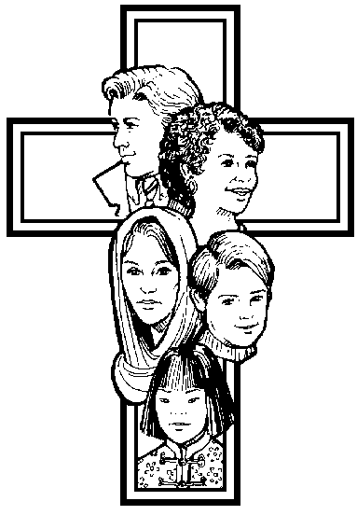
Gathering

Where: First Christian Church

When: November 14, 1998

Fellowship at 6:00 p.m. Please bring snacks and refreshments to share.

The board will meet at 4:00 p.m. at the church.

Upcoming Gatherings

December 12, 1998 Chancellor Christian
January 16, 1999 Chancellor Christian


If you enjoyed the colorful placemats on your Walk, why not pass on the joy to others? Help is needed to prepare placemats for the upcoming weekends. Approximately 65 placemats are used at each mealtime. If you would like to help decorate, etc., please contact Tina Cooper at 540-310-0865.

"NEEDED: BRIGHT RAINBOW-HUED FABRIC AND CORDING. Call Diana Farrar at 540-372-7535 to say you'll help. Thank you 'sew' much to the band of

agape bag sewers that came forward to help make bags for the weekends. Thank you for being a part of God blessing the pilgrims on the walks."

Reunion Groups...

We would like to list the Reunion Groups active in the Fredericksburg Emmaus Community. If you are a member of a reunion group, please send the information to Barbara Olds, Editor. Please provide the name, meeting time, place, and contact with phone number.

Great Is Thy Faithfulness Emmaus Reunion Group
Meets 7:30 PM Tuesdays
Prince Of Peace United Methodist Church
6299 Token Forest Drive
Manassas, Virginia
Contact: Lloyd Biller (703) 590-1512

Rainbow Reunion Group
Meets 8:15 PM Tuesdays
Hope Lutheran Church
Waldorf, Maryland
Contact: Phil Landweer (301) 374-9333

Pastor's Weekly Meeting
Meets 8:00 PM Thursdays
Bowie Curry's Home
1415 Stafford Ave.
Fredericksburg, Va.
Contact: Mark Dunn (540) 786-4025

Lakeside Reunion Group (Men)
Meets 8:00 PM Tuesdays
Lake Of The Woods
Contact : Vic Larson (540) 972-1928

Rainbow Reunion Group (Women)
Meets 9:00 AM Fridays
Lake Of The Woods
Contact : Barbara Miller (540) 972-7418

Clowns For God Reunion Group
Meets 8:15 PM Tuesdays
Contact : Joe Cooper (540) 310-0865

“The Fredericksburg and Chrysalis Communities do not encourage or sanction the use of Community directories for profit use.”

Prayers and Praises . . .


_ Prayer for our country
_ Praise for the team of Emmaus #29
_ Prayer for Jarrod & Christina
_ Pray for healing for Jamie’s back
_ Pray for Donna Cramer
_ Praise for love & friendships that last
_ Prayer for bladder tests in October
_ Prayer & Praise for the team of Emmaus #30
_ Pray for my daughters who are non-believers
_ Pray for my mother who has an upcoming MRI
_ Praise that Roger Wood’s grandmother is blessed to be
with our Lord!
_ Pray for continued recovery of Suzanne Menc from
spinal meningitis
_ Prayer & Praise for the Pilgrims of Emmaus #29
_ Pray for marriages
_ Praise for healing in my son – NO cancer!!!
_ Margaret Olds with Krohns disease
_ Prayer for my granddaughter Marie
_ Praise & blessings for the Pilgrims God has chosen
_ Pray for John, a 6-year old with leukemia
_ Prayer for Christine, Tony & Brandon Schroth
_ Pray for my wife on the Women’s Walk
_ Praise the Lord for his Love & Blessings!!!
_ Diabetes controlling me
_ Praise for Joe & Tina Cooper for their new home
_ Healing Xenia
_ Pat - surgery on Tuesday
_ Tristan Cooper – praise for new life!!
_ Prayer for Judy’s mom who has Alzheimers
_ Praise for Jesus in our lives!!
_ Salvation for our loved ones
_ Pray for our country’s presidential leadership
_ Bobby & Drew – wisdom for teen years
_ Pray for Robert, Sara & Darren Fulkerson
_ Chrysalis Community and Board
_ Prayers for friends in need
_ Sarah Olds – changes in her life
_ Praise for God’s protection & His guidance
_ Prayer for our Chrysalis youth; the rebuilding of our
community
DEADLINE for the December newsletter is November 21. Please send your articles to editor, Barbara Olds. Mail to 343 Longwood Drive, Stafford, VA 22554; fax to 540-286-0639; or e-mail to dolds@erols.com. For the timely delivery of our newsletter, it is important to get those articles in on time!
Friendship

Oooo
Some people ( )
come into our lives ) /
and quickly go.. . ( _/

oooO
( ) Some people
) ( become friends
\_) and stay a while...

Leaving beautiful Oooo
footprints on our ( )
hearts... ) /
(_/
oooO
( ) and we are
\ ( ~ never ~
\_) quite the same
because we have
made a good friend!!

FREDERICKSBURG EMMAUS
BOARD OF DIRECTORS

Perkins, Dennis - Lay Director
Barnett, Dick - Asst. Lay Director
Larson, Barbara - Secretary
Libby, Pat - Treasurer
Ogren, Mark - Spiritual Director

Cooper, Joe Perkins, Susan
Garfield, Cathy Rice, Kim
Mottley, Keith Roark, Ken
Olds, Barbara Tessier, Patti
Olds, David

Reunion with a Friend by Samianna Langi

Last year, I requested the Emmaus Board to place me as the Reunion Group coordinator because I felt this was an important and vital part of our community if we wanted Emmaus to grow and thrive. We all know reunion groups are only effective and thriving if our community members are willing and determined to form groups on their own rather than if I were to call everyone and place people into groups they wouldn't want to be in.

I had previously participated in a group soon after my walk. This reunion group met every single week. Sometimes there were two people and other times there were ten. When times were difficult or when there
were occasions to be joyous, this was the group that shared those moments. I found myself being accountable to my daily actions, my devotions and time with God. When I was somehow growing further from my Lord, I sat with my group and felt nearer to my Lord because I was surrounded by friends who walked with me through my difficulties.

It has been over a year now since I've participated in any regular reunion group, but I've filled my schedule with a lot of church work. I've become more active in my church, the Body of Christ. I'm a Sunday school teacher, choir member, Vacation Bible School director, newsletter editor, etc., etc. I had come to think that working and getting involved in church activities were enough spiritually that in the back of my mind, I contemplated that a reunion group is perhaps unproductive and pretty much useless in my life at this time.

Faith Weedling stopped by my church the other week while I was doing VBS stuff. She suggested starting a reunion group and we agreed to meet the following week. She stopped by as decided but I was still busy doing VBS stuff. I had forgotten. We reunioned next to my work station and for the first time in a very long time I was able to share intimately and seriously about my spiritual life with a friend God had
sent to me. While I was busy being busy, I had failed to acknowledge whom I was working for. I was given ample time to reflect, to listen and plan my week and come to the realization how much I had missed my
Lord even in the midst of doing his work.

I urge each one of you who has not participated or has fallen out of a reunion group to get back or get into a group. Be determined and find one or two people whom you feel comfortable with and share with each
other your experiences with God. It is truly a blessing to have a friend or two to share God's work in us.

Reprinted with permission from the Crowing Kukini – the Hawaii Walk to Emmaus Monthly Newsletter

Day of Deeper Understanding

A Day of Deeper Understanding will be held on Saturday, November 14, 1998 beginning at 4:30 p.m., at First Christian Church. Sponsors and their Pilgrims who have walked and not yet attended a DDU are encouraged to attend. Please remember that you cannot sponsor a Pilgrim or Team if you have not attended a Day of Deeper Understanding.

A pot luck supper will be held after the DDU (before the Gathering). Please bring a dish to share. Don’t miss this time of fellowship!
Fredericksburg Emmaus #30
“Love God and Love Your Neighbor”
Team

Jean Aylesworth Keith Mottley
Brooke Bevan Mark Ogren
Jennifer Bowles Susan Perkins
Judy Cover Darlene Roberts
Sandy Crossley Ellen Schertz
Debbie Devine Christine Schroth
Joanie Elkins Barbara Simpson
Diana Farrar Bill Smith
Angel Fulkerson Florence Smith
Cathy Garfield Patti Tessier
Vonnie Hinkle Betty Gray Thompson
Phyliss Howze Emily Thompson
Marilynne Landweer Melanie Walz
Sally Lawrence Rosemary Welch
Lola McDonald Bob Winston
Debbie McKeen Barbara Wood
Sandy Morgenstern

Fredericksburg Emmaus #30
“Love God and Love Your Neighbor”
Pilgrims

Pilgrim | Church | Pilgrim | Church
Ellen Aylesworth | Shady Grove United Methodist | Renee Jeffries | Zion Baptist
Millie Brock | St. Stephen’s Baptist | Sally Johnson | New Life in Christ
Theresa Davis | Lake of the Woods Church | Kim Kreft | Ebenezer United Methodist
Sue Dickinson | Germanna Church | Mari Lloyd | Calvary United Methodist
Trinette Duncan | Chancellor Christian | Janet Lohr | Waters Memorial
Janet Edwards | Woodbridge Christian | Stacey Orcutt | Fredericksburg United Methodist
Elizabeth Farrell | Fredericksburg United Methodist | Sandy Osborne | Chancellor Christian
Bonnie Fisher | Lake of the Woods Church | Karen Peterson | Fredericksburg United Methodist
Jeanette Green | Hopewell United Methodist | Cam Prewitt | Fredericksburg United Methodist
Vicki Hagy | Fredericksburg United Methodist | Kaye Rich | Remington United Methodist
Kim Hannahs | Hope First | Kim Rogers | Fredericksburg United Methodist
Jane Harper | Melrose United Methodist | Marcia Sansone | Spotsylvania Presbyterian
Ellyn Hartzler | Fredericksburg United Methodist | Betsy Saylor | Celebration Church
Annette Hemming | Lexington Park | Sally Shackelford | Bethany United Methodist
Nonie Henry | Remington United Methodist | Barb Sirles | Rappahannock Christian Center
Renee Holland | Bethel United Methodist | Peggy Sweitzer | First United Methodist
Sandra Hughes | Melrose United Methodist | Birgitte Tessier | Remington United Methodist
Linda Jackson | Christ Ministries | Carol Vasquez | Lake of the Woods Church

Schedule - Fredericksburg # 30 - Nov 5-8, 1998

The team for Fredericksburg Women’s Walk #30 invites sponsors, families and community participation in the following events:

WHEN WHERE WHAT
Thurs., Nov 5 7:00 P.M. Camp Easter Seal Pilgrim check-in/Fellowship followed by Sponsor’s Hour

Sat., Nov 7 7:45 P.M. Salem Baptist Candlelight - Please bring flowers for the team to use Sunday
1/8 mile before morning!!! Community will gather at Salem for Praise, Fellowship and intersection of VA Communion. We will move to Camp Easter Seal for 9:15 P.M.
Routes 721 & 630 Candlelight Service.

Sun., Nov 8 3:30 P.M. Camp Easter Seal Closing - Gather at 3:30 for Closing Service at 4:00 P.M. Closing will
be held in the new gym
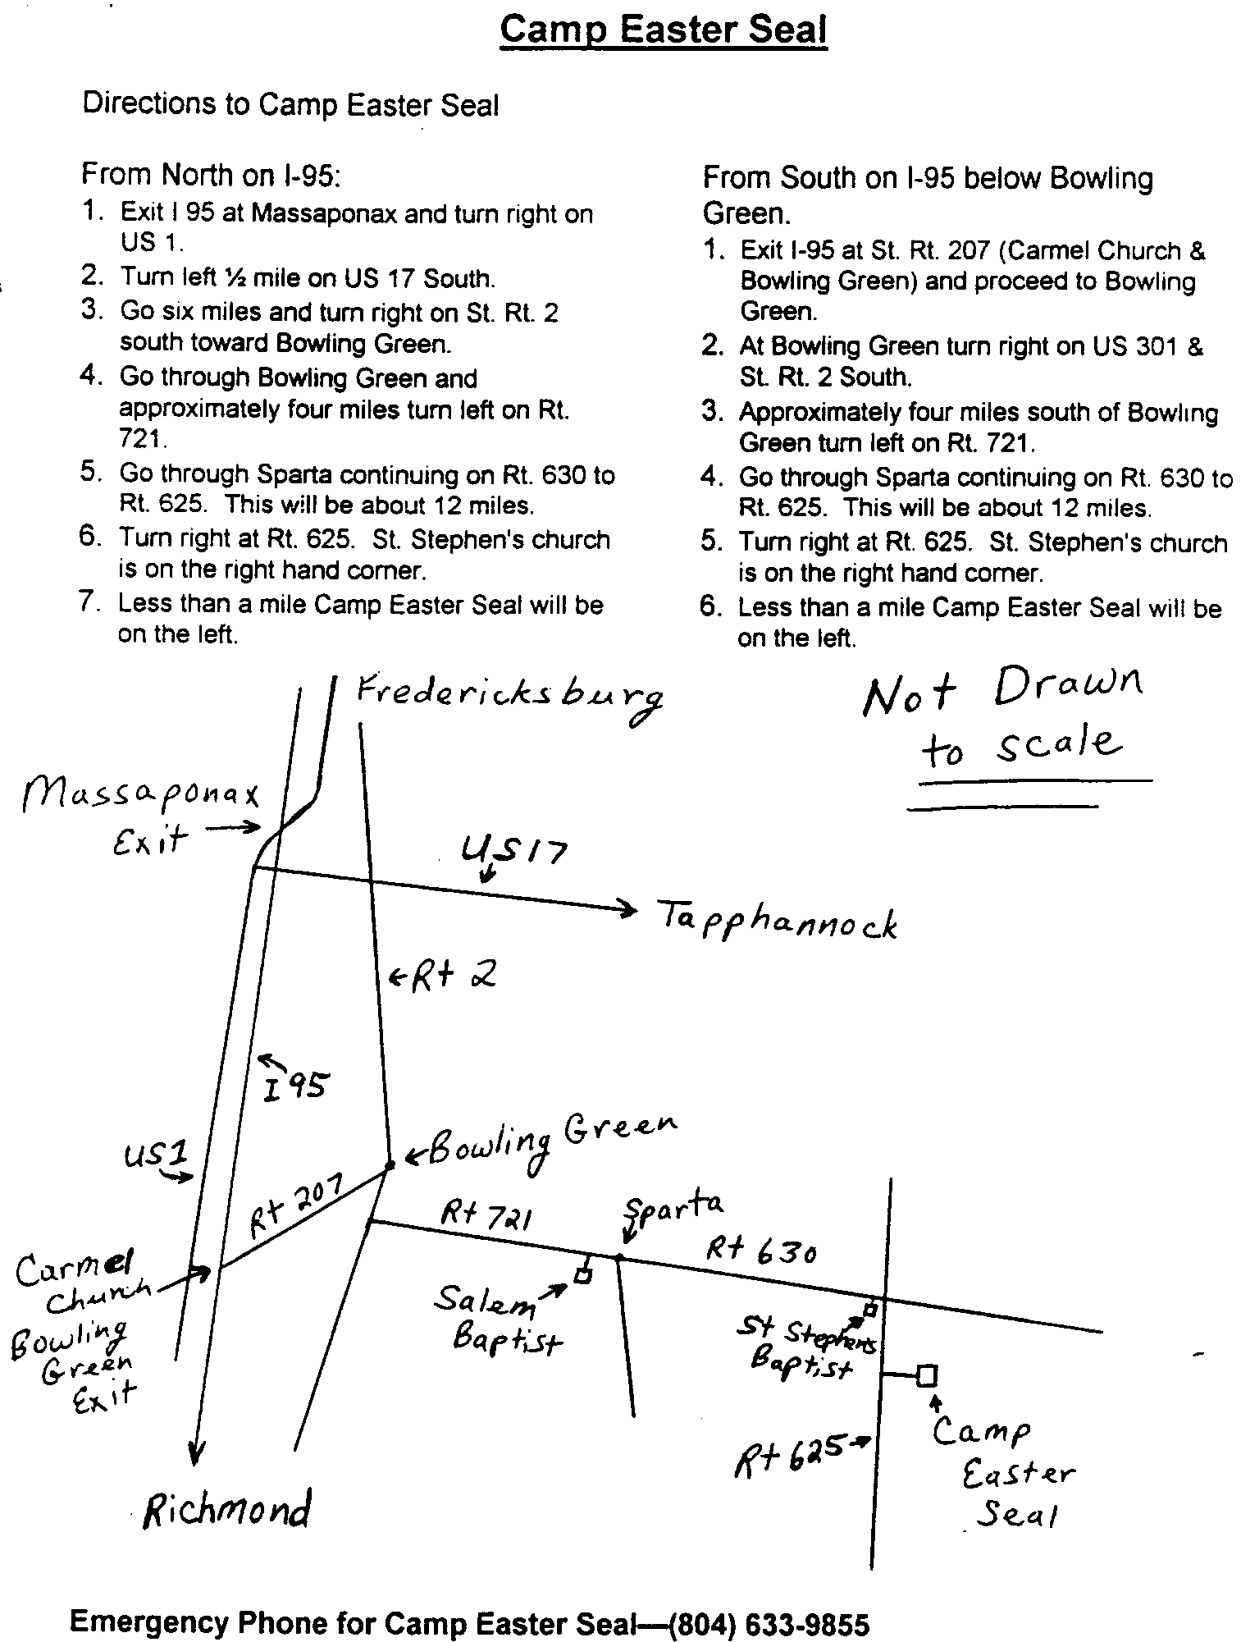

Chrysalis
Corner

Dear Brothers and Sisters,

How many times do we ask God how we can further His kingdom and when he gives us the answer, we say “No” or “that’s not what I meant?” By doing what He has asked means we must step outside our comfort zone. We then find if we take that step of faith, we are truly blessed for answering His call.

That is what I am asking you to do – I am asking that you prayerfully consider how God can use you to strengthen the young people in our churches and community.

As mentioned in last month’s newsletter, we are beginning the preparations for a girls’ weekend to be held in April 1999 at Camp High Road. While April may seem far into the future, it will be here before we know it! That is why we are seeking your support – we need to start preparing the team and that isn’t possible without applications. Applications are available at the Gatherings or you may contact any member of the Board to request one.

While we are currently focusing our attention on the upcoming girls’ weekend, please keep in mind that we will be preparing for a boys’ weekend to be held in 1999. We have not yet set a date for this weekend, but will keep you informed of our progress.

As Emmaus is an avenue in which to uplift and strengthen adult church members, Chrysalis is a way in which we can strengthen the youth of our churches. If you have questions concerning Chrysalis – its focus or impact on Christian youth – please call me or any board member. We will be happy to answer your questions.

Think about our future leaders – Is there a young person in your congregation that comes to mind? Then consider offering them the gift of an opportunity to grow closer in their walk with God. Applications for both young women and young men are being accepted.

The Chrysalis Board has made the decision to be sure that we are operating in compliance with the outline provided by Nashville. In keeping with this decision, we will be presenting the revised By-Laws for our community at the November Gathering. The proposed revision is included in this newsletter for your review.

As many of you have heard, last March the International Director of Chrysalis, Donna Farr, disappeared. In May the family decided to hold memorial services while her body had not yet been found. Donna was declared legally dead in June so her estate could be probated and the custody of her two sons was given to her mother.

On Monday, October 5, surveyors found a woman’s body in a remote area about 15 minutes from Donna’s home. With the use of dental records, a forensic dentist was able to positively identify the body as Donna Farr. I ask that you raise her family in prayer as they deal with the renewed grief and anger over their loss.

May the grace of God fill you with peace.

Fly With Christ!!

FREDERICKSBURG CHRYSALIS
BOARD OF DIRECTORS

Olds, Barbara - Lay Director
Landweer, Phil - Secretary
Mike Dunn - Treasurer
Turbyfill, Margie - Spiritual Director

Benefield, Jamie Fulkerson, Robert Sr.
Boyette, Keith Graham, Malcolm
Davis, Bob Morrow, Nathan
Edsall, Gena Ritter, Jim
Fulkerson, Angel Wooten, Warren

Barbara Olds
The Chrysalis Board will meet at 3:00 p.m. the day of the Gathering at First Christian Church.

