
The Upper Room
Emmaus

April 1999 | of the Greater Fredericksburg Area

From the Lay Director . . .

Dear Brothers and Sisters in Christ,

Do you remember waiting to go on your walk? You may have been asking yourself questions like: Why is my sponsor so insistent that I go on this weekend and what kind of change has come over him or her? Why can't
anyone explain to me what this is all about? Please read Pastor Gary Staddan's article in this newsletter, "Each Person Must Experience God Uniquely."

What a wonderful time to be a Christian! Spring is in the air with budding trees and nests full of baby birds. The air is getting warmer and the snow and ice are finally behind us. There are two Emmaus walks only weeks away with almost 72 pilgrims waiting to experience the unconditional love of "The Walk To Emmaus!"

I was studying my bible today, and I read 1 Corinthians 12:12-31 where Paul wrote about the Body of Christ. As I read this passage, I began to think about an Emmaus weekend and the importance of unity. It takes so many parts for an Emmaus weekend to take place, and God calls everyone of us to pull together. I am not just talking about the team. It takes the community in prayer, writing agape, attending candlelight, attending closing, sending food agape, serving as chas, making placemats, and sewing agape bags. It takes families that support the daughter, son, spouse, mother, or father. It takes churches and sponsors that prayerfully send their leaders on a weekend. God pulls us all together in unity to serve His people, chosen to experience His bountiful love and grace. If one part of
this body doesn't serve, the entire body suffers. All parts are important without one part being more or less important than the other. We all have something different to offer the body. It takes all of us, one body, united in Christ Jesus serving as vessels of His love. Hallelujah! Praise God!

We often remind ourselves that an Emmaus weekend is for the pilgrims, which is true. Yet look at the way God renews the spirits all of the participants. God has called us all together to share in His feast. We
are His children playing at His feet sharing the unending blessing that knowing Him brings.

I am looking forward to seeing and serving with the teams, sponsors, churches, families, and the community in the upcoming Emmaus walks. In other words, I praise God for calling me to serve as part of and in the Body of Christ. De Colores!

Your brother in Christ,

Dennis Perkins

1999 Weekends

Men’s April 15-18
WLD: Curt Edsall

October 7-10
WLD: Ken Roark

Women’s May 13-16
WLD: Susan Perkins

November 4-7
WLD: Angel Fulkerson

Pastor’s Corner. . .

Each Person Must Experience God Uniquely

Some people are fortunate enough to have an overwhelming spiritual experience at some time in life. This could happen in church, at a retreat, alone in the mountains or elsewhere. A few will have several over the years. This experience usually brings a combination of: greater awareness of God, certainty of being saved, really knowing God loves you, assurance of the forgiveness of sin, an inner certainty of the resurrection and heaven, and a desire to live for Him. People feel different and look at life differently after this experience. Their awareness of God is greater and
they see things more from His point of view. Life has new meaning, the Bible is more alive and one has a sense of mission. This could be called: a filling of the Holy Spirit, a deeper life experience, a renewal of faith or some particular term. Praise the Lord!

However, there is a problem with all of this. Trying to convey what you went through is nearly impossible. You tell people but they don't get it. If you have gone through such an experience, remember it is your experience and not your spouse's or your best friend's. It happened to you but not to him or her. No one can totally enter the experience of another. You can't re-create the setting, feelings, and chain of events. The experience was meant by God to be uniquely for you and perhaps for a few others who were actually there. Therefore, be patient and understanding in
sharing your experience. By all means share it. If or when a loved one or friend goes through the experience then he or she will truly see from the "inside." Also remember that others are not second class citizens because they did not go through your experience. God may have other plans and experiences for them. Again you have changed but the world hasn't.

Perhaps you are the loved one or friend who has not had the experience. How do you view and handle the new found dimension and enthusiasm of your relative or friend? Please realize this person has had a genuine experience of God. It is not your fault nor theirs that this cannot be fully transmitted in all it's awe and power. Try to understand and
accept but realize that without being there the full impact is impossible. Don't feel like a second class citizen as God may be preparing something just ahead of you. When you have your mountain top experience with God, then seek this person out again and rejoice together. In the mean time, serve God faithfully and draw close to Him in holiness.

The first twelve apostles went through many experiences with Jesus that could be labeled "Mountain Top" or Deeper Life." They heard His teachings as people sat in awe, watched in amazement as many were healed, were overwhelmed by the raising of the dead and witnessed the transformation of their own lives. Amazingly even then one of them betrayed Him prior to His crucifixion.

These experiences as well as His death, resurrection and the Day of Pentecost, prepared eleven of them to go out and change the world as He worked through them. The eleven went out to preach the gospel and share their experiences of Jesus Christ. Millions have been converted through nearly twenty centuries of proclaiming the gospel.

As many times as we read the gospels and tell the stories, we cannot fully know what it was like to walk with Christ in Galilee and Judea listening to His teachings and watching His miracles. We have a good idea but we weren't there.

The good news is that God loves each of us and has special experiences uniquely designed for each of us. Our desire should not be to have someone else's experience but to seek our own.

Be Ready and Expect the Best,

Gary Staddan

The Next Fredericksburg

Gathering

When: April 10, 1999

Where: Woodbridge Christian

Devotion: Joe Reed

4th Day: Wayne Welsh

Fellowship at 6:00 p.m. Please bring snacks and refreshments to share.

The board will meet at 4:00 p.m. at the church.

Upcoming Gatherings

May 8, 1999 Woodbridge Christian
June 12, 1999 Lake of the Woods
July 10, 1999 Lake of the Woods



AN OPPORTUNITY TO SERVE

If you would like to serve on Fredericksburg Emmaus 32 as a CHA please call Barbara Larson (540-972-1928). There are opportunities to serve on Friday (5/14) and Saturday(5/15) during the day (7 A.M. - 3 P.M.) and
evening (3 P.M. - ???).

Saturday evening CHAs should plan to serve through candlelight until all tasks are completed. Friday evening CHAs should be finished shortly after dinner.

"Close friends, family members or sponsors of Pilgrims should either avoid being on the kitchen team or should stay completely behind scenes in order to allow the Pilgrims to have their own experience."
Emmaus Handbook pg. 62.


If you enjoyed the colorful placemats on your Walk, why not pass on the joy to others? Help is needed to prepare placemats for the upcoming weekends. Approximately 65 placemats are used at each mealtime. If you would like to help decorate, etc., please contact Tina Cooper at 540-310-0865.


"NEEDED: BRIGHT RAINBOW-HUED FABRIC AND CORDING. Call Diana Farrar at 540-372-7535 to say you'll help.

FREDERICKSBURG EMMAUS
BOARD OF DIRECTORS

Perkins, Dennis - Lay Director
Barnett, Dick - Asst. Lay Director
Larson, Barbara - Secretary
Olds, David - Treasurer
Ogren, Mark - Spiritual Director

Cooper, Joe Perkins, Susan
Garfield, Cathy Roark, Ken
Libby, Pat Smith, Gary
Morgenstern, Larry Tessier, Patti
Olds, Barbara

“The Fredericksburg and Chrysalis Communities do not encourage or sanction the use of Community directories for profit use.”

Prayers and Praises. . .


_ Men & Women Overseas
_ Glen & Diane Tanner
_ Physical Healing
_ Pilgrims #31 & #32
_ Prayers for my grandfather
_ Prayers for my wife; son; job
_ Ann
_ Teams #31 & #32
_ Friend of Iden Family
_ Praise for my twin grandchildren!
_ Prayers for all teens and parents
_ Lola McDonald’s father -postponed heart surgery
_ National Capital Men’s Weekend taking place 3/13
_ Bette Cinoburg – recently diagnosed with cancer
_ Continued healing for Bob Davis
_ Prayer for my mother undergoing knee surgery (both
knees) in April
_ Praise God for the amazing miracle he performed in
my recovery thus far!
_ Pray for me as I seek where the Lord wants me to work
_ Prayer for healing for all marriages that are being
attacked by Satan’s demons
_ Wilderness Community Church
_ Praise for answered prayers for a house
_ Prayers for Lee Roark in Bosnia with the Army
_ 12-month Okinawa missions tour – Joe Reed
_ Pray for me as I give the meditation talk in April
_ Praise for our Lord Jesus!
_ Prayers that Fredericksburg to be whole supportive
community
_ Emmaus 83 in NCAC
_ Prayers for tests Wednesday and possible surgery in
April
_ Spiritual leaders of our churches
_ Prayer for the youth and Chrysalis
_ Homeless in our Community
_ Praise for answer to a life-long prayer
_ Prayers for safety for my daughter
_ Pray for sister who has found several lumps in throat –
pray for her healing
_ For safe travels – Barkley & Emily
_ Prayer for balance
_ Praise for good test results
_ Pray for Katie (90) – cancer/pneumonia
_ Salvation for our children and grandchildren
_ Brother-in-law with aggressive cancer
_ Prayers for graduating class at Westlake in Maryland
_ Prayer for Betty Buckle recovering from heart surgery
_ Praise for continued healing of Wayne Welsh’s uncle
Joe
_ Pray for parents of strong-willed children

THE 2nd TEN COMMANDMENTS

1. Thou shall not worry, for worry is the most unproductive of all human activities.

2. Thou shall not be fearful, for most of the things we fear never come to pass.

3. Thou shall not cross bridges before you come to them, for no one yet has succeeded in accomplishing this.

4. Thou shall face each problem as it comes. You can only handle one at a time anyway.

5. Thou shall not take problems to bed with you, for they make very poor bedfellows.

6. Thou shall not borrow other people's problems. They can better care for them than you can.

7. Thou shall not try to relive yesterday for good or ill, it is forever gone. Concentrate on what is happening in your life and be happy now!

8. Thou shall be a good listener, for only when you listen do you hear different ideas from your own. It is hard to learn something new when you are talking, and some people do know more than you do.

9. Thou shall not become "bogged down" by frustration, for 90% of it is rooted in self-pity and will only interfere with positive action.

10. Thou shall count thy blessings, never overlooking the small ones, for a lot of small blessings add up to a big one.
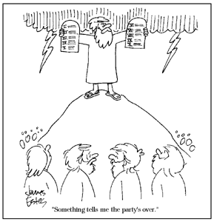

Reunion Groups . . .

We would like to list the Reunion Groups active in the Fredericksburg Emmaus Community. If you are a member of a reunion group, please send the information to Barbara Olds, Editor. Please provide the name, meeting time, place, and contact with phone number.

Great Is Thy Faithfulness Emmaus Reunion Group
Meets 7:30 PM Tuesdays
Prince Of Peace United Methodist Church
6299 Token Forest Drive
Manassas, Virginia
Contact: Lloyd Biller (703) 590-1512

Pastor's Weekly Meeting
Meets 8:00 PM Thursdays
Bowie Curry's Home
1415 Stafford Ave.
Fredericksburg, Va.
Contact: Mark Dunn (540) 786-4025

Lakeside Reunion Group (Men)
Meets 8:00 PM Tuesdays
Lake Of The Woods Church
Contact : Vic Larson (540) 972-1928

Rainbow Reunion Group (Women)
Meets 9:00 AM Fridays
Lake Of The Woods Church
Contact : Barbara Miller (540) 972-7418

“Amazing Grace” Reunion Group
Meets 8:15 PM Thursdays
Chancellor Christian Church
Contact : Joe Cooper (540) 310-0865

Son Rise Reunion Group
Meets 7:15 a.m. Thursdays
Melrose United Methodist
Contact: Ruth Ash (804) 529-6448 or
Patsy Bayse (804) 529-6101

(Men)
Meets 7:30 p.m. Tuesdays
Bethel United Methodist Church
13506 Minnieville Road
Woodbridge, Va.
Contact: Brian Lewis (703) 590-9343
e-mail to bb3253@AOL.com

Monday's Makeovers Reunion Group
Meets 8:00 p.m. Mondays
Denny's Restaurant in Dale City
Dale Blvd. & I-95
Contact: Lois Myrick 703-680-0577 or
Sandy Crossley 703-221-6977

God Bearers
Meets 8:00 am Sundays
Melrose United Methodist Church
Contact: Laurie Basye (804) 529-6953 or 580-5135
e-mail basye@crosslink.net
Alice Harding (804) 529-7854
e-mail archardcl@pen.k12.va.us

To the Board and Community,

I came to the Gathering tonight. I got there early so I went into the “Social” time. One person said hello and gave me a hug. That person had things to do. So, after chatting with her a couple of minutes, she had to go.

I walked around and didn’t recognize anyone. I smiled and went to say hello and was looked right through like I wasn’t there. I went out and walked around the church. The minister talked with me and showed me around a little and then went about his business.

I went back into the social area again and the same thing happened.

What if I were Jesus?

In the future, I will come to the Gathering to praise our Lord, but I will not put myself in the position to be hurt and ignored again. Remember – we are a
family with God as our Father – there are no strangers.
DEADLINE for the May newsletter is April 17. Please send your articles to editor, Barbara Olds. Mail to 343 Longwood Drive, Stafford, VA 22554; fax to 540-286-2663; or e-mail to dolds@erols.com. For the timely delivery of our newsletter, it is important to get those articles in on time!

Fredericksburg Emmaus #31
“The Lord is my Strength and my Song”
Team Assignments

Sean Bonner Music Team
Donnie Cross Music Team
Robert Davis Table Leader Changing Our World Sunday, 8:50 a.m.
Greg Day Music Team
Steve Ecklund Asst Table Leader
Curt Edsall Lay Director Perseverance Sunday, 1:05 p.m.
Wil Floyd Asst Table Leader
Malcolm Graham Asst Table Leader
Mike Iden Asst Lay Director Priorities Friday, 9:15 a.m.
Brian Lewis Asst Table Leader
John Mathis Asst Table Leader Growth Through Study Saturday, 8:55 a.m.
Mark Ogren Asst Spiritual Director Prevenient Grace Friday, 11:15 a.m.
Sanctifying Grace Sunday 10:00 a.m.
Dennis Perkins Asst Cha Coordinator
Gene Philipp Music Director
Wes Pryce Table Leader Life in Piety Friday, 7:30 p.m.
Joe Reed Table Leader Discipleship Saturday, 8:00 p.m.
Jim Ritter Lead Spiritual Director Means of Grace Saturday, 10:15 a.m.
Justifying Grace Friday, 3:00 p.m.
Ken Roark Asst Lay Director Fourth Day Sunday, 2:45 p.m.
Peter Schatz Cha
Harlan Schertz Table Leader
Tony Schroth Table Leader Christian Action Saturday, 2:35 p.m.
Derek Sharp Asst Table Leader
Gary Smith Asst Spiritual Director Obstacles to Grace Saturday, 4:00 p.m.
Shane Smith Cha
Larry Tubbs Table Leader Body of Christ Sunday, 11:10 a.m.
Richard Warner Head Cha Coordinator
Greg Weakley Cha
Roger Wood Asst Lay Director Priesthood of All Believers Friday, 1:30 p.m.

The Team Chapel is open to the Community during the various talks. Each speaker will have a team member in the chapel as their prayer partner. A speaker’s grouping members, family or others who have attended a weekend are invited and welcomed to be a part of this special time. Chapel Prayer Partners should be discreet in arriving and departing from Camp Easter Seal and should be in the prayer chapel 30 minutes prior to “Talk Time” listed above.

Fredericksburg Emmaus #31
“The Lord is my Strength and my Song”
Pilgrims

Phil Ayer | Calvary United Methodist | Marvin Johnson | Zion Baptist Church
Carl Bruno | Fredericksburg United Methodist | John Kirby | First Christian Church
Ed Chance | Calvary United Methodist | Gregg Lamb | Fredericksburg United Methodist
John Clark | First United Methodist | Bill Mabe | Fredericksburg United Methodist
Charles Doyal | St. Matthias United Methodist | Steve McCoy | Fredericksburg United Methodist
Dan Farrell | Fredericksburg United Methodist | Mike McLaughlin | Waters Memorial United Methodist
Nick Finamore | Calvary United Methodist | Dave Meixner | First United Methodist
John Gay | St. Matthias United Methodist | Chad Plucker | Fairview Baptist Church
Mark Goodpasture | Fredericksburg United Methodist | Steve Rainwater | First Baptist Church
Reuben Greene | Rehoboth United Methodist | Phillip Rice | Mt. Ararat Baptist Church
Jason Gregory | St. Elizabeth Ann Seton | Wally Rich | Remington United Methodist
Joe Hannahs | Hope First Church of God | Jarrod Smith | Fredericksburg Baptist Church
Randy Harding | Melrose United Methodist | Eric Sotolongo | Strong Tower Penecostal
Stanley Harrell | Corkran Memorial United Methodist | Dave Tynes | Bethel United Methodist Church
Glenn Horstmann | Lake of the Woods Church | Alan Weakley | Fredericksburg United Methodist
Kris Indseth | Rock Church | Junior Wenrich | Mechanicsville Christian Center
Rich Jackman | Calvary United Methodist | M.P. White | North Umberland Charge
Mark Johnson | Fredericksburg United Methodist | Jeff Woosley | Lake of the Woods Church

Schedule - Fredericksburg # 31 - April 15-18, 1999

The team for Fredericksburg Men’s Walk #31 invites sponsors, families and community participation in the following events:

WHEN WHERE WHAT
Thurs., Apr 15 7:00 P.M. Camp Easter Seal Pilgrim check-in/Fellowship followed by Sponsor’s Hour

Sat., Apr 17 7:45 P.M. Camp Easter Seal Candlelight - Please bring flowers for the team to use Sunday morning!!! Community will gather for Praise, Fellowship and Communion.

Sun., Apr 18 3:30 P.M. Camp Easter Seal Closing - Gather at 3:30 for Closing Service at 4:00 P.M. Closing
will be held in the new gym.

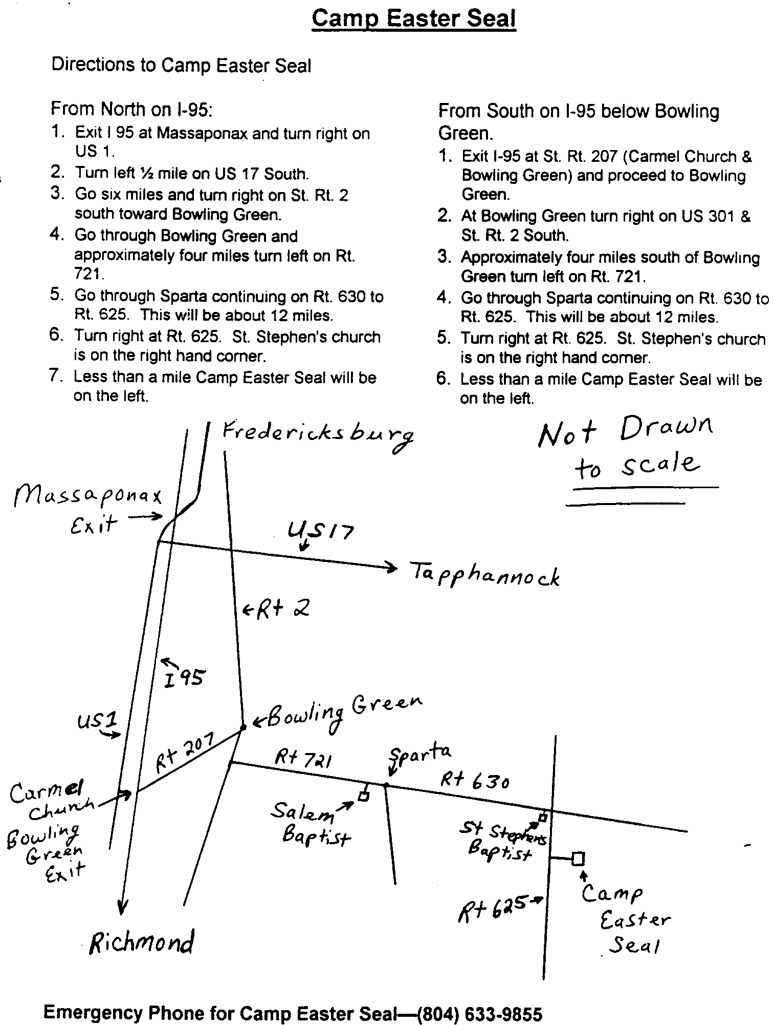

Corner
Chrysalis

Dear Brothers and Sisters,
Remember when, as children, we would ask our parents to visit a friend, go the park, or play outdoors and they would say – “Not now, wait till later, in a little while?” If you were like me, you’d ask why, beg, plead, anything to get your parents to change their mind. Waiting was NOT fun!

As adults, we’ve mastered (or so we tell ourselves) the appearance of tolerance when we are told we have to wait for something. It doesn’t mean we like it. Maybe we have even tried to change the person’s mind.

In today’s “instant” society, we find ourselves wanting instant answers, instant gratification, instant service, instant everything – even instant food!! We do not want to wait. Yet, our Lord calls us to seek his leadership, to follow his guidance and that means we must wait for his answers. We find that sometimes the answer is “Not now, wait till later, in a little while.”

This is the answer that Chrysalis has been given for the Flight that was scheduled for April. We have deferred the Flight till July 29-August 1 at Camp High Road. While it is difficult for us to do this, we believe we must follow God’s leading.

We are not saying which gender this weekend will be – we are allowing the response to God’s calling of the community to answer. Whether this is a girls’ or boys’ flight OR if there is a flight at all will be determined by the response of applications received in the next month.

We have been able to get some of the caterpillars on the upcoming Southside Chrysalis Girls’ flight being held the weekend of May 6-9, 1999 in Blackstone, Virginia (southwest of Richmond) at the Methodist Retreat Center. This is a wonderful facility in a beautiful setting. I ask that you plan to support these young women and Fredericksburg Chrysalis by attending candlelight and closing. This is our opportunity to welcome these young women into our community and show our support of Chrysalis. If you need directions, please contact me.

May the peace and grace of God be with you.

Fly With Christ,

Barbara
The Chrysalis Board will meet at 3:00 p.m. the day of the Gathering at Woodbridge Christian Church.

Board Members Needed

You may wonder, “Why are they asking now?” That’s because we know that it takes time to find those who are willing to serve God in this capacity. To find adults who have a willingness and commitment to work with AND for the youth in our Community. To find youth who are willing to commit to helping the community grow.

We are a working board – everyone has a “job” to do. It is a privilege to serve on the board – the privilege is working to provide a way for the young people of our churches and community to grow closer in their daily walk with God.

We have several openings on our board – both adult and youth. Elections for the new board will be held in September. Please consider making the commitment to providing an avenue for the young people of our community to grow closer to God.

If you have questions, comments, or concerns, please contact any member of the Chrysalis Board.

