The Upper Room
Emmaus

May 1999 | of the Greater Fredericksburg Area

From the Lay Director . . .

Dear Brothers and Sisters in Christ,

"I can do all things through Christ who strengthens me," was God's banner of love that the team of E-32 shared with the pilgrims, each other, and the community. On behalf of the Fredericksburg Emmaus community and
myself, I would like to thank Susan Perkins and the team for being faithful to God's call and being vessels of His love.

Have you ever thought about the difference between happiness and joy? I believe that joy is deeper and stronger than happiness. Joy is that confident assurance of God's love and work in our lives, that he will always be there no matter what! Happiness depends on happenings, but joy depends in our faith in Jesus Christ. This is what I think each pilgrim that walked
on Fredericksburg Emmaus 32 left knowing in their hearts.

Did I ever tell you about my little red wagon? Well it was a Radio Flyer! It was wonderful. It would carry anything from sisters to toy soldiers. I hauled all of my pet dogs: Kinker (He looked like a little pig), King (A floppy eared German Shepherd/Collie Mix), and Snoopy (A Cocker Spaniel). Sometimes King would even pull the wagon. My mom, my sister, and I would pull this marvelous crafted piece of machinery up to Bill's Super
Market to pick up the weekly groceries. We would park it outside, next to the front door, under the sale signs. I am not sure how much we helped our mom, because all I can remember about the inside of the store was the bubble gum machines that held many miniature treasures. We would walk all around those machines time and again wondering how we could obtain some of the contents.

Soon, our Mom would be done with her shopping and would split her loose change between my sister and me. It didn't take long to put the coins into the slots and hold out our hands for the little plastic eggs filled with surprises. Most of the time we would be disappointed, but we still dreamed about what would fall down the chute next time. We would then take turns pulling the wagon full of grocery bags back home.

As I grew older, I realized that I could pull that wagon with my bicycle. That put a whole new dimension on how I could utilize the wagon. It held my GI Joe, my Green Hornet bubble gum cards, and my Shoot-Around- The Corner Rifle. I can remember so many awesome times that I had playing with that wagon.

One day I was working at my Dad's gas station, and a man came in needing a wheel for his lawn mower. No store in town had a wheel that size. I thought about my wagon and knew that they were the perfect size. I sold
two of my beautiful red wagon wheels to that man so he could repair his lawn mower. I did not realize the effect of what I had done at that time. Later, my Dad asked what happened to my wagon and a flood of pain and
disappointment came over me. How could I have sold a part off of my favorite toy?

I will never forget how sad that wagon looked without the two rear wheels. Or was it me that was sad because of the loss of my best toy. I was so broken hearted and disappointed at what I had done. Would my father ever forgive me? Would I ever forgive myself?

My father did forgive me, and he never mentioned it again. This story reminds me of God's love. I wonder how Peter felt when he realized that he had betrayed Jesus, his friend, his teacher, his Lord and himself. Peter must have been broken hearted and disappointed in what he had done. Peter had already experienced the love of Jesus but didn't completely understand the depth of that love. Peter soon learned that Jesus died on the cross for his sins, too! Paul wrote in Romans 5:8, "But God
demonstrates His own love for us in this: While we were still sinners, Christ died for us." Praise God! Thank You Lord!

This is my last article in the Emmaus Newsletter, as Community Lay Director. I praise God for calling me to serve this wonderful Emmaus Community that I believe has been sanctioned by Him to develop spiritual
leaders for His church. God has blessed me in so many ways with a renewed faith of my own and fellowship with other Christians. "For I am already being poured out like a drink offering, and the time has come for my
departure. I have fought the good fight, I have finished the race, I have kept the faith." 2 Timothy 4:6-7

I would like to remind you once again to please remember the joy of your Emmaus walk closing ceremony. Keep the celebration of your new life in
Jesus Christ alive as you share this joy with others. Amen.

In His service,

Dennis Perkins


The Next Fredericksburg
Gathering

When: June 12, 1999

Where: Lake of the Woods

Devotion: Theresa Davis

4th Day: Larry Tubbs

Fellowship at 6:00 p.m. Please bring snacks and refreshments to share.

The board will meet at 2:30 p.m. at the church.

Upcoming Gatherings

July 10, 1999 Lake of the Woods
August 14, 1999 Rehoboth UMC
September 11, 1999 Rehoboth UMC

If you enjoyed the colorful placemats on your Walk, why not pass on the joy to others? Help is needed to prepare placemats for the upcoming weekends. Approximately 65 placemats are used at each mealtime. If you would like to help decorate, etc., please contact Tina Cooper at 540-310-0865.



"NEEDED: BRIGHT RAINBOW-HUED FABRIC AND CORDING. Call Diana Farrar at 540-372-7535 to say you'll help.

Men’s October 7-10
WLD: Ken Roark

Women’s May 13-16
WLD: Susan Perkins

November 4-7
WLD: Angel Fulkerson

1999 Weekends

FREDERICKSBURG EMMAUS
BOARD OF DIRECTORS

Perkins, Dennis - Lay Director
Barnett, Dick - Asst. Lay Director
Larson, Barbara - Secretary
Olds, David - Treasurer
Ogren, Mark - Spiritual Director

Cooper, Joe Perkins, Susan
Garfield, Cathy Roark, Ken
Libby, Pat Smith, Gary
Morgenstern, Larry Tessier, Patti
Olds, Barbara

A Note From Angel . . .

Hello Community & Praise the Lord!

Concerning praise: Behold the fowls of the air: for they sow not, neither do they reap, nor gather into barns; yet your Heavenly Father feedeth them. Are ye not much better than they? Matthew 6:26 (KJV)

I shared in my last writing about praise and how we must acknowledge truth to come to a place of praise, and how we must choose to draw near to one another and to God to get to know them better enabling us to praise. It may not be an easy task but it is possible. I pray that you
have not only drawn near to God and to others but also allowed God and others to draw near to you.

This month, I feel led to share more about praise. Every morning I go to the park to walk and pray. It is like an appointment with God that I keep. I walk and talk but God walks and talks with me, too. At precisely 7:10 every morning, the birds go crazy around the pond flying off towards the railroad tracks. There squeals sound like some type of song they sing and as they fly off to a certain direction, they do turns and flips somewhat like a dance in the air. It is an amazing thing to observe. Now, understand that at 7, they birds are quietly sitting around the pond with little interaction. Occassionally, someone might walk up to them with some bread and they fight with one another who will
get the prize (they think) given to them, but at 7:10, they flock together as if they have suddenly became a team to rush in a direction and...

Across the park, coming from the railroad tracks, comes a small little man carrying a very large trash bag. He is hurrying in their direction with a huge smile on his face, speaking something that is so quiet that as I pass him, I cannot hear him... but the birds continue their songs and their dances in flight around the man until he reaches his destination, a bench right next to the pond. He sets his bag down on the bench and waits as all the birds come back to the place they started, settling down all around him yet still full of song, awaiting what he has
to offer them. It wasn't always like this, the birds have come to depend on this man coming to see him, and to receive from him. Once they are all settled down, he opens the bag and they start squealing even louder
and he starts tossing out bread to them, lots and lots of bread.

Can you see where I am going with this? Someone comes into our lives, Jesus, and as we get to know Him we come to depend on Him. We come to know that He has something for us and we draw near with excitement waiting... but we are not alone, there are many of us who
have come to know this new friend. Sometimes we get so excited waiting for a visit with him that we fight with one another when a visitor comes but when the visitor is truly Him, we come together in an act of praise to Him and He fellowships with each of us equally, giving us all that we need. When He is with us, there is no room for conflict because the many become one in praise to Him and He reaches out where we all receive just what we need. Am I making sense?

Look inside of yourself this month. Watch your actions and reactions and see where you are in this place of praise. Are you receiving from a visitor who gives just enough to satisfy your tastebuds causing you to fight with your brothers and sisters to get your portion or is your visitor, your friend, and the one you depend on causing you to come together with your brothers and sisters in praise because you know this friend and He has enough for each of you and fulfillment is granted to all.

May you truly begin to praise the Lord, and praise one another, and PRAISE THE LORD TOGETHER this month and always. Oh, magnify the Lord with me, and let us exalt His name together. Psalm 34:3

Love in Jesus,

Angel

DEADLINE for the June newsletter is May 15. Please send your articles to editor, Barbara Olds. Mail to 343 Longwood Drive, Stafford, VA 22554; fax to 540-286-2663; or e-mail to dolds@erols.com. For the timely delivery of our newsletter, it is important to get those articles in on time!

“The Fredericksburg and Chrysalis Communities do not encourage or sanction the use of Community directories for profit use.”

Prayers and Praises. . .


_ Prayers for Gary Smith’s dad
_ For the unsaved
_ My family and my health
_ Prayers for our churches
_ Prayer for our youth everywhere
_ Tina Randolph
_ Homeless in our Community
_ Praise for the Emmaus team experience
_ Prayers for the Pilgrims of Emmaus #31 & #32
_ Prayers for our troops with NATO
_ Prayers for our friends, the Jackmans
_ Praise for the successful teaming of Emmaus #31
_ Prayer for Fredericksburg Chrysalis
_ Praise! I’m going to be a grandma again!
_ Pray for a youth trip to ATF - Day One in Michigan
_ Family care givers – support and wisdom
_ Richmond Emmaus #49 Men’s Walk
_ For our son, Michael, at Marine recruit training
_ For continued healing for Bob Davis from neck injury
_ Praise! My son’s graduating from high school!
_ For our military, particularly those in harm’s way in
Europe, and for the three soldiers being held
prisoner and for their families
_ Prayer to be used by God in a powerful way on
Emmaus #32 Weekend
_ 12-month Okinawa missions tour – Joe Reed
_ Praise for a God who never leaves my side!
_ Daughter & Son-in-Law in trouble financially; their
marriage is in jeopardy
_ My mother going through knee surgery
_ God is just good & faithful all the time
_ For daughter’s choice to marry before graduation
_ Pray for daughter and possible miscarriage
_ Praise - daughter received full scholarship for her
Senior year of college
_ For the Chrysalis weekend and that my sons get re-
involved with the community
_ Prayer for Emmaus #32 Team and Pilgrims
_ Praise – my Brothers in Christ on Emmaus #31

_ Pray for wise & God-fearing leadership from our
national leaders
_ David (prayer for a willing heart)
_ Pray for son-in-law overseas & other service people
_ Praise – daughter’s engagement & fiancé_
_ Barbara’s mother is a tough lady! God has blessed her
to witness yet another day!
_ Pray for the youth and young adults of this world –
their decisions are many – their witness vast –
Share your love God with them!

Negative to Positive

For all the negative things we have to say to ourselves,
God has a positive answer for it.....

You say: "It's impossible."
God says: All things are possible (Luke 18:27)

You say: "I'm tired."
God says: I will give you rest (Matthew 11:26-30)

You say: "Nobody really loves me."
God says: I love you (John 3:16 & John 13:34)

You say: " I can't go on."
God says: My grace is sufficient (11 Corinthians 12:9 & Psalms 91:15)

You say: "I can't figure things out."
God says: I will direct your steps (Proverbs 3:5-6)

You say: "I can't do it."
God says: You can do all things (Philippians 4:13)

You say: "I'm not able."
God says: I'm able (11 Corinthians 9:8)

You say: "It's not worth it."
God says: It will be worth it (Romans 8:28)

You say: "I can't forgive myself."
God says: I FORGIVE YOU ( l John 1:9 & Romans 8:1)

You say: "I can't manage."
God says: I will supply all your needs (Philippians 4:19)

You say: "I'm afraid."
God says: I didn't give you a spirit of fear (11 Timothy 1:7)

You say: "I'm always worried and frustrated."
God says: Cast all your cares on ME ( l Peter 5:7)
You say: "I don't have enough faith."
God says: I've given everyone a measure of faith (Romans 12:3)

You say: "I'm not smart enough."
God says: I give you wisdom ( l Corinthians 1:30)

You say: "I feel all alone."
God says I will never leave you or forsake you (Hebrews 13:5)

Reunion Groups . . .

We would like to list the Reunion Groups active in the Fredericksburg Emmaus Community. If you are a member of a reunion group, please send the information to Barbara Olds, Editor. Please provide the name, meeting time, place, and contact with phone number.

Great Is Thy Faithfulness Emmaus Reunion Group
Meets 7:30 PM Tuesdays
Prince Of Peace United Methodist Church
6299 Token Forest Drive
Manassas, Virginia
Contact: Lloyd Biller (703) 590-1512

Pastor's Weekly Meeting
Meets 8:00 PM Thursdays
Bowie Curry's Home
1415 Stafford Ave.
Fredericksburg, Va.
Contact: Mark Dunn (540) 786-4025

Lakeside Reunion Group (Men)
Meets 8:00 PM Tuesdays
Lake Of The Woods Church
Contact : Vic Larson (540) 972-1928

Rainbow Reunion Group (Women)
Meets 9:00 AM Fridays
Lake Of The Woods Church
Contact : Barbara Miller (540) 972-7418

“Amazing Grace” Reunion Group
Meets 8:15 PM Thursdays
Chancellor Christian Church
Contact : Joe Cooper (540) 310-0865

Son Rise Reunion Group
Meets 7:15 a.m. Thursdays
Melrose United Methodist
Contact: Ruth Ash (804) 529-6448 or
Patsy Bayse (804) 529-6101

(Men)

Meets 7:30 p.m. Tuesdays
Bethel United Methodist Church
13506 Minnieville Road
Woodbridge, Va.
Contact: Brian Lewis (703) 590-9343
e-mail to bb3253@AOL.com

Monday's Makeovers Reunion Group
Meets 8:00 p.m. Mondays
Denny's Restaurant in Dale City
Dale Blvd. & I-95
Contact: Lois Myrick 703-680-0577 or
Sandy Crossley 703-221-6977

God Bearers
Meets 8:00 am Sundays
Melrose United Methodist Church
Contact: Laurie Basye (804) 529-6953 or 580-5135
e-mail basye@crosslink.net
Alice Harding (804) 529-7854
e-mail archardcl@pen.k12.va.us

Nominations for Emmaus Board

Elections for the Board of Directors will be held at the June Gathering. There are openings for two women, one man and two clergy. Nominations from the floor will be accepted at the Gathering on June 12.

Requirements for serving on the Board:

1. Must have attended a DDU. (There’s one on June 12, which is open to everyone who has walked in any community.)

2. Must have teamed.

If you are not able to attend the Gathering, an absentee ballot is included in this newsletter. Please complete and return prior to June 12.

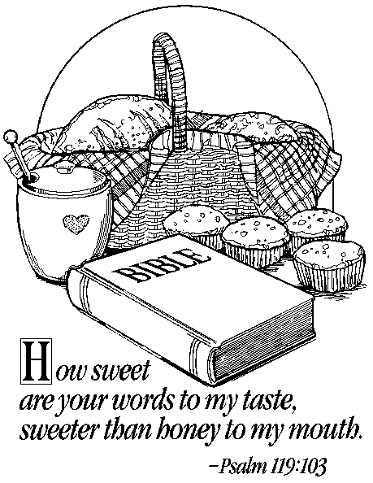

Fredericksburg Emmaus Volunteer Chairpersons
1998-1999

Community Lay Director - Dennis Perkins
Gathering Coordinator
Sponsor's Hour Coordinator
Candlelight Coordinator

Assistant Community Lay Director - Dick Barnett
Transportation Coordinator
Supply Coordinator - Tom Frank

Community Spiritual Director - Mark Ogren
Gathering Coordinator
Sponsor's Hour Coordinator
Candlelight Coordinator

Treasurer - Dave Olds
Childcare Coordinator (Gatherings & DDU) - Bob Davis

Secretary - Barbara Larson
Manuals Coordinator
By-Laws Historian
Reunion Group Coordinator - Barbara Simpson
Emmaus "Store" Coordinator - Vonnie Hinkle / Vic Larson

Communications Coordinator - Barbara Olds
Newsletter / Database Coordinator - Barbara Olds
Chrysalis Liaison - Bob Davis
Pilgrim / Team Registrar - Janet Dunn

Agape Coordinator - Patty Tessier
General Agape Coordinator - Christine Schroth
Prayer Vigil Coordinator - Debbie McKeen
Placemat Coordinator - Tina Cooper
Snack Agape Coordinator - Patti Tessier
Agape Bag Coordinator - Diana Farrar

DDU Coordinator - Susan Perkins
Community Baker - Betty Gray Thompson
DDU Pot Luck Dinner Coordinator

Fredericksburg Emmaus #32
“I Can Do All Things through Christ Who Strengthens Me”
Team Assignments

Edwin Clever Lead Spiritual Director Prevenient Grace Friday, 11:15 a.m.
Sanctifying Grace Sunday 10:00 a.m.
Sandy Crossley Table Leader Readings
Theresa Davis Asst Agape & Cha Coord Body of Christ Sunday, 11:10 a.m.
Readings
Angel Fulkerson Floater Readings
Vonnie Hinkle Asst Lay Director Fourth Day Sunday, 2:45 p.m.
Phyllis Howze Table Leader Readings
Carolyn Jenkins Music Director
Karen King Agape Coordinator
Marilynne Landweer Table Leader Changing Our World Sunday, 8:50 a.m.
Barbara Larson Cha Coordinator Readings
Cheryl Leahy Asst Table Leader Growth Through Study Saturday, 8:55 a.m.
Mari Lloyd Asst Table Leader Readings
Sharon McCloud Asst Table Leader Life in Piety Friday, 7:30 p.m.
Lola McDonald Co-Music Director
Linda McMoran Asst Table Leader Readings
Susan Perkins Lay Director Perseverance Sunday, 1:05 p.m.
Dianne Philipp Asst Table Leader Readings
Ellen Schertz Table Leader Priesthood of All Believers Friday, 1:30 p.m.
Anita Schmidt Table Leader Christian Action Saturday, 2:35 p.m.
Christine Schroth Asst Lay Director Priorities Friday, 9:15 a.m.
Florence Smith Asst Lay Director Discipleship Saturday, 8:00 p.m.
Gary Staddan Spiritual Director Obstacles to Grace Saturday, 4:00 p.m.
Rosemary Welch Spiritual Director Means of Grace Saturday, 10:15 a.m.
Pat Wink Asst Table Leader Readings
Bob Winston Spiritual Director Justifying Grace Friday, 3:00 p.m.

The Team Chapel is open to the Community during the various talks. Each speaker will have a team member in the chapel as their prayer partner. A speaker’s grouping members, family or others who have attended a weekend are invited and welcomed to be a part of this special time. Chapel Prayer Partners should be discreet in arriving and departing from Camp Easter Seal and should be in the prayer chapel 30 minutes prior to “Talk Time” listed above.

Fredericksburg Emmaus #32
“I Can Do All Things through Christ Who Strengthens Me”
Pilgrims

Karen Anderson | Faith Bible Church | Pam Latvala | Lexington Park United Methodist
Susan Barr | Fairmount Memorial Baptist | Janet McCaslin | Fredericksburg United Methodist
Susan Bruno | Fredericksburg United Methodist | Susan McCoy | Fredericksburg United Methodist
Darlene Carey | Cornerstone Chapel | Drucilla McLaughlin | Waters Memorial UMC
Debbie Clark | First United Methodist | Kathryn Mann | Fredericksburg United Methodist
Mary Diedrich | Calvary United Methodist | Karen Mann | Fredericksburg United Methodist
Trinette Duncan | Chancellor Christian Church | Betsy Miles | Hopewell United Methodist
Karla Ecklund | Calvary United Methodist | Carole Morris | Fredericksburg United Methodist
Maria Fortune | Rappahannock Baptist | Teresa Oley | St. Stephens Church
Virginia Garnett | Fairview Baptist Church | Holly Plucker | Fairview Baptist Church
Sharon Hansen | Calvary United Methodist | Kimberly Rogers | Fredericksburg United Methodist
Julie Hart | Lexington Park United Methodist | Angela Rose | Spotsylvania Assembly of God
Katie Haywood | Fredericksburg United Methodist | Martha Shelton | Fairview Baptist Church
Tammy Hedge | Hopewell United Methodist | Christina Smith | Fredericksburg Baptist Church
Diane Howard | Fredericksburg United Methodist | Heather Uhlick | Fairview Baptist Church
Diane Jackman | Calvary United Methodist | Kim Weakley | Fredericksburg United Methodist
Donna Johnson | Fredericksburg United Methodist | Carolanne Whiteside | First Christian Church
Linda Lambert | Grace Baptist Church | Tammy Wilkins | Melrose United Methodist



Schedule - Fredericksburg # 32 - May 13-16, 1999

The team for Fredericksburg Women’s Walk #32 invites sponsors, families and community participation in the following events:

WHEN WHERE WHAT
Thurs., May 13 7:00 P.M. Camp Easter Seal Pilgrim check-in/Fellowship followed by Sponsor’s Hour

Sat., May 15 7:45 P.M. Camp Easter Seal Candlelight - Please bring flowers for the team to use Sunday morning!!! Community will gather for Praise, Fellowship and Communion.

Sun., May 16 3:30 P.M. Camp Easter Seal Closing - Gather at 3:30 for Closing Service at 4:00 P.M. Closing
will be held in the new gym.

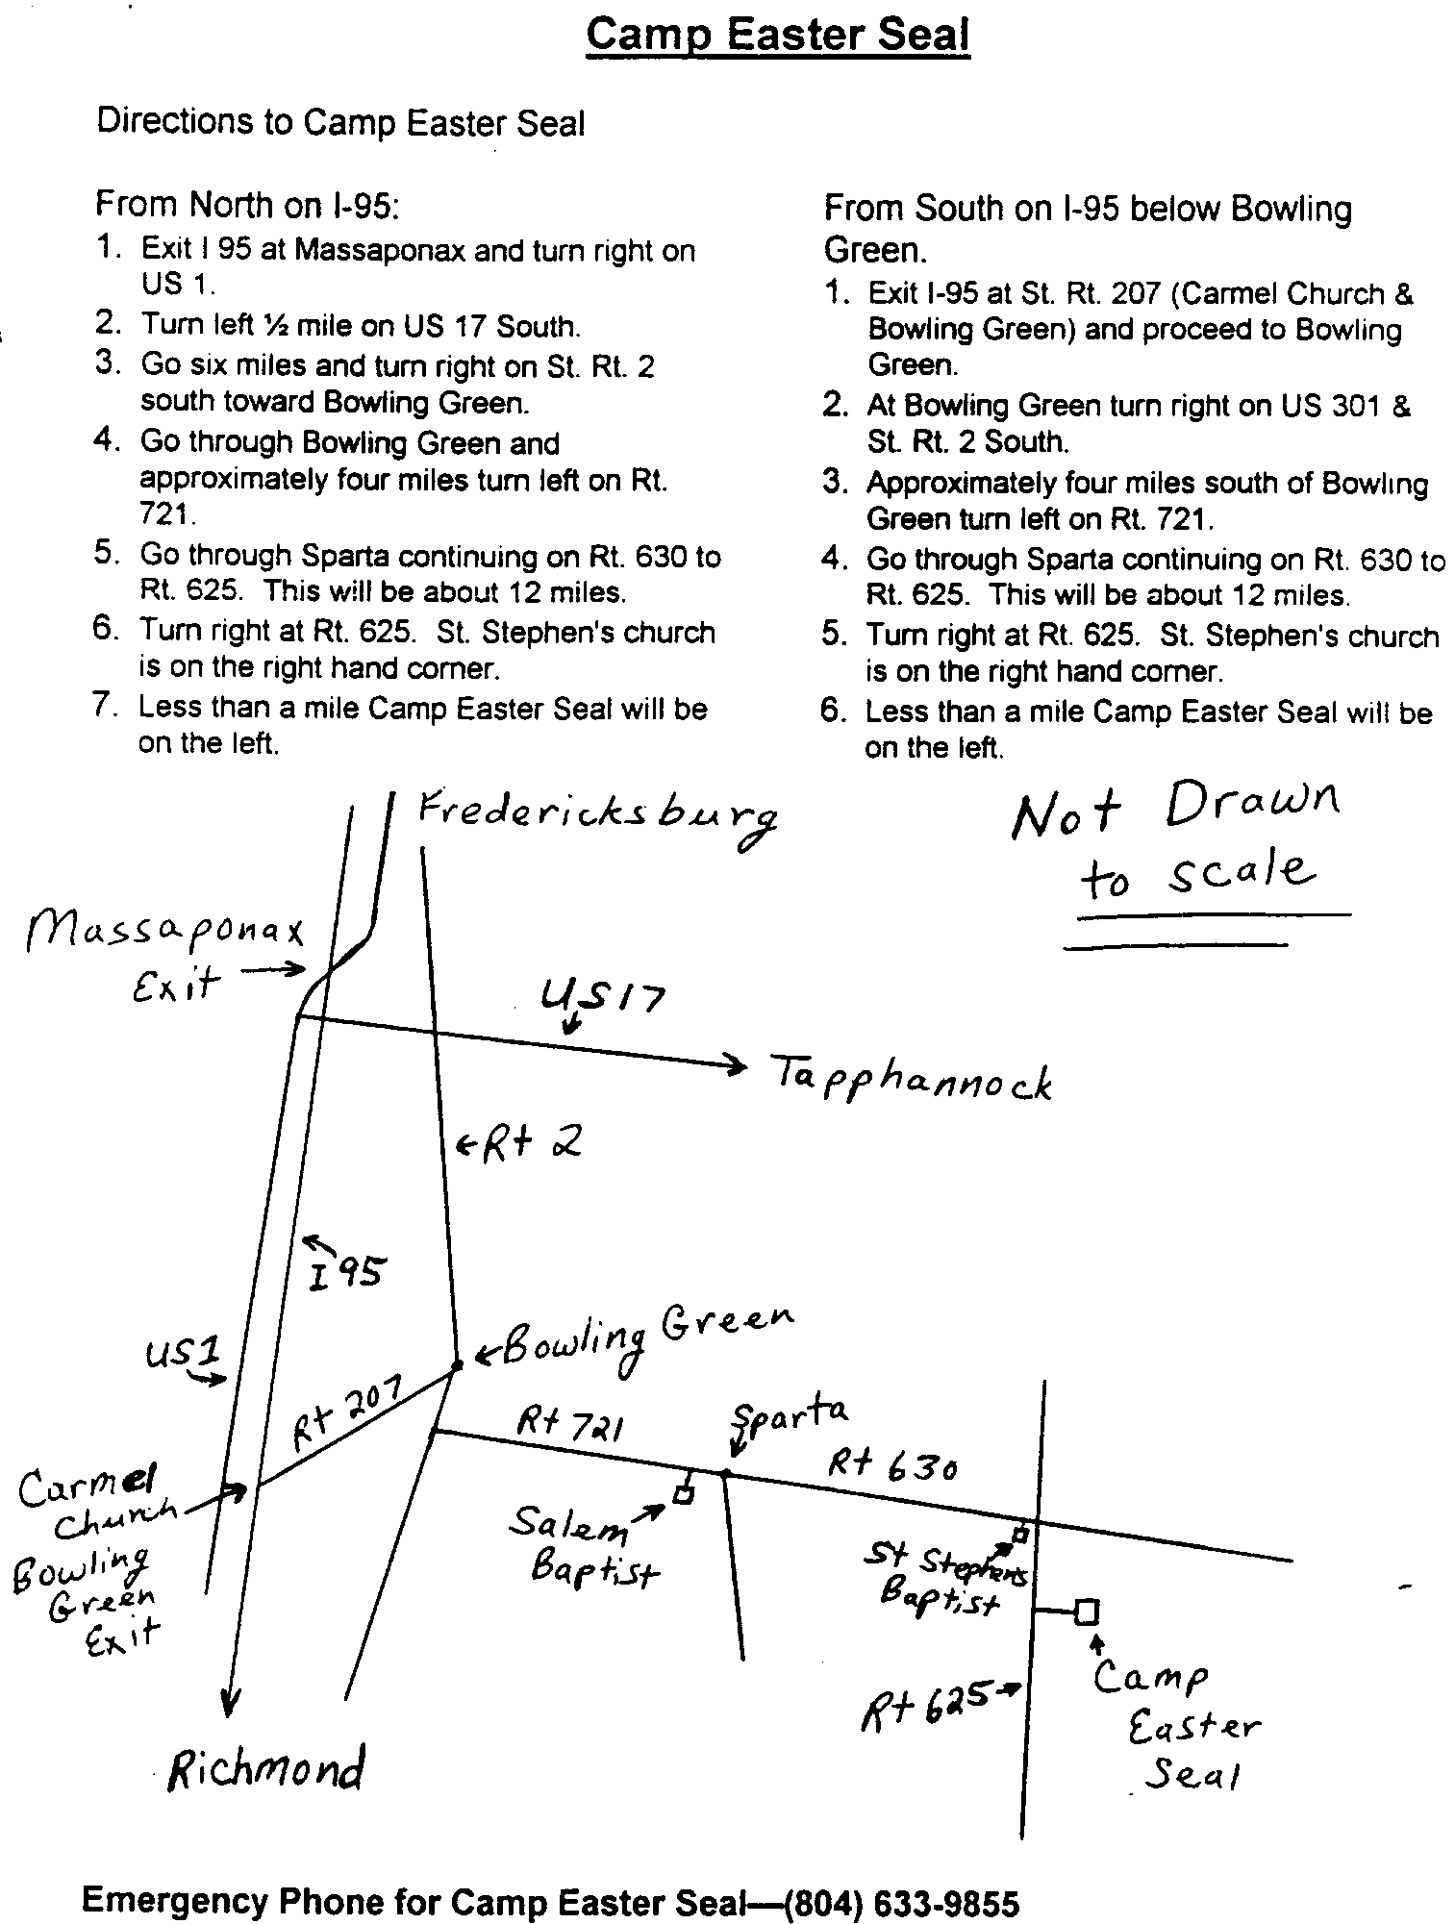

Chrysalis

Corner

Dear Brothers and Sisters,
We have been able to get four young women from our community on the Southside Chrysalis Girls’ flight being held the weekend of May 6-9, 1999 at the Methodist Assembly Center in Blackstone, Virginia (southwest of Richmond). Directions are included in this newsletter.

I ask that you pray for the caterpillars and team on this flight. There are 31 caterpillars and 28 team members planning to participate. Several in our community will be attending all facets of this weekend, including Candlelight (begins at 7:45 p.m.) and Closing Sunday afternoon (3:30 p.m.). General agape will be given on Friday afternoon. Bed agape will be on Saturday night only. If you wish to prepare agape for this flight, please contact me or any Board member to make arrangements for getting it to the weekend.

The Board of Directors will not be meeting this month so we may focus on these young ladies and the Chrysalis Flight. This is our opportunity to welcome these young women into our community and show our support of Chrysalis.

May the peace and grace of God be with you.

Fly With Christ,
Barbara
FREDERICKSBURG CHRYSALIS
BOARD OF DIRECTORS

Olds, Barbara - Lay Director
Edsall, Gena - Asst Lay Director
Landweer, Phil - Secretary
Davis, Bob - Treasurer
Turbyfill, Margie - Spiritual Director

Boyette, Keith Graham, Malcolm
Fulkerson,Angel Morrow, Nathan
Fulkerson, Robert Sr. Wooten, Warren

Directions to United Methodist Assembly Center

- Travel I-95 South to Petersburg, Virginia
- Take Exit 51, I-85 South/US-460 West toward DURHAM /ATLANTA – Merge onto I-85 South
- Travel approx 7 miles to Exit 61, US-460 West toward BLACKSTONE / LYNCHBURG
- Keep RIGHT at the fork in the ramp
- Merge onto US-460 West
- Travel approximately 28 Miles on US-460 West
- Turn LEFT Business Route US-460 toward BLACKSTONE / FORT PICKETT
- Travel approximately 4 Miles into Blackstone
- Turn RIGHT onto Fourth Street
- Travel approximately 6 blocks (to second 4-way stop)
- The Assembly Center will be visible from the 4-way stop
- Address is 707 Fourth Street, Blackstone, VA
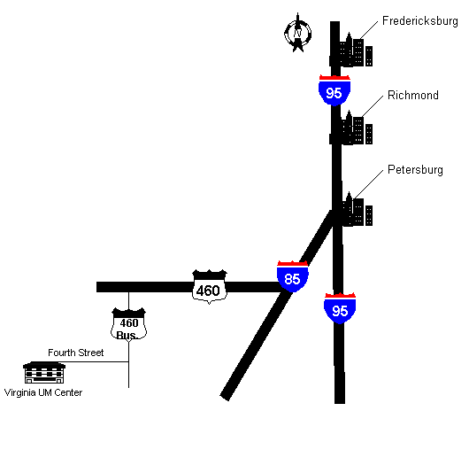
The Chrysalis Board will NOT meet this month.

Ballot for the Fredericksburg Emmaus
Board of Directors

1. Certification of membership. I am a member of Fredericksburg Emmaus / Chrysalis, eligible to vote by virtue of attending a Walk to Emmaus sponsored by the Fredericksburg Emmaus Community, or a Walk to Emmaus, Chrysalis, or other Cursillo based weekend in another area.

2. Men (vote for one)
Brian Lewis ( )
Larry Morgenstern ( )
Tom Smith ( )
(write in) ( )

4. Clergy (vote for two)
Tom Barnard ( )
(write in) ( )
(write in) ( )
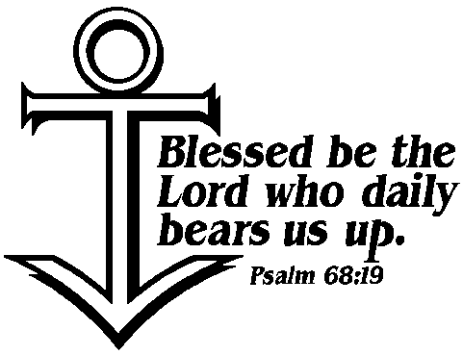

3. Women (vote for two)
Sandy Crossley ( )
Vonnie Hinkle ( )
Phyllis Howze ( )
Christine Schroth ( )
(write in) ( )

5. Each member of an Emmaus family who has attended an Emmaus, Chrysalis or other Cursillo based weekend is entitled to a separate ballot. To be counted, proxy ballot(s) must be submitted at the June Gathering or mailed to
Fredericksburg Emmaus
P.O. Box 42094
Fredericksburg, VA 22404

All mail-in entries must be received prior to the June12, 1999 Gathering.

