
The Upper Room
Emmaus

June 1999 | of the Greater Fredericksburg Area

From the Lay Director . . .

Dear Brothers and Sisters in Christ,

"I can do all things through Christ who strengthens me," was God's banner of love that the team of E-32 shared with the pilgrims, each other, and the community. On behalf of the Fredericksburg Emmaus community and
myself, I would like to thank Susan Perkins and the team for being faithful to God's call and being vessels of His love.

Have you ever thought about the difference between happiness and joy? I believe that joy is deeper and stronger than happiness. Joy is that confident assurance of God's love and work in our lives, that he will always be there no matter what! Happiness depends on happenings, but joy depends in our faith in Jesus Christ. This is what I think each pilgrim that walked
on Fredericksburg Emmaus 32 left knowing in their hearts.

Did I ever tell you about my little red wagon? Well it was a Radio Flyer! It was wonderful. It would carry anything from sisters to toy soldiers. I hauled all of my pet dogs: Kinker (He looked like a little pig), King (A floppy eared German Shepherd/Collie Mix), and Snoopy (A Cocker Spaniel). Sometimes King would even pull the wagon. My mom, my sister, and I would pull this marvelous crafted piece of machinery up to Bill's Super
Market to pick up the weekly groceries. We would park it outside, next to the front door, under the sale signs. I am not sure how much we helped our mom, because all I can remember about the inside of the store was the bubble gum machines that held many miniature treasures. We would walk all around those machines time and again wondering how we could obtain some of the contents.

Soon, our Mom would be done with her shopping and would split her loose change between my sister and me. It didn't take long to put the coins into the slots and hold out our hands for the little plastic eggs filled with surprises. Most of the time we would be disappointed, but we still dreamed about what would fall down the chute next time. We would then take turns pulling the wagon full of grocery bags back home.

As I grew older, I realized that I could pull that wagon with my bicycle. That put a whole new dimension on how I could utilize the wagon. It held my GI Joe, my Green Hornet bubble gum cards, and my Shoot-Around- The Corner Rifle. I can remember so many awesome times that I had playing with that wagon.

One day I was working at my Dad's gas station, and a man came in needing a wheel for his lawn mower. No store in town had a wheel that size. I thought about my wagon and knew that they were the perfect size. I sold
two of my beautiful red wagon wheels to that man so he could repair his lawn mower. I did not realize the effect of what I had done at that time. Later, my Dad asked what happened to my wagon and a flood of pain and
disappointment came over me. How could I have sold a part off of my favorite toy?

I will never forget how sad that wagon looked without the two rear wheels. Or was it me that was sad because of the loss of my best toy. I was so broken hearted and disappointed at what I had done. Would my father ever forgive me? Would I ever forgive myself?

My father did forgive me, and he never mentioned it again. This story reminds me of God's love. I wonder how Peter felt when he realized that he had betrayed Jesus, his friend, his teacher, his Lord and himself. Peter must have been broken hearted and disappointed in what he had done. Peter had already experienced the love of Jesus but didn't completely understand the depth of that love. Peter soon learned that Jesus died on the cross for his sins, too! Paul wrote in Romans 5:8, "But God
demonstrates His own love for us in this: While we were still sinners, Christ died for us." Praise God! Thank You Lord!

This is my last article in the Emmaus Newsletter, as Community Lay Director. I praise God for calling me to serve this wonderful Emmaus Community that I believe has been sanctioned by Him to develop spiritual
leaders for His church. God has blessed me in so many ways with a renewed faith of my own and fellowship with other Christians. "For I am already being poured out like a drink offering, and the time has come for my
departure. I have fought the good fight, I have finished the race, I have kept the faith." 2 Timothy 4:6-7

I would like to remind you once again to please remember the joy of your Emmaus walk closing ceremony. Keep the celebration of your new life in
Jesus Christ alive as you share this joy with others. Amen.

In His service,

Dennis Perkins

The Next Fredericksburg

Gathering

When: June 12, 1999

Where: Lake of the Woods

Fellowship at 6:00 p.m. Please bring snacks and refreshments to share.

The board will meet at 2:30 p.m. at the church.

Upcoming Gatherings

July 10, 1999 Lake of the Woods
August 14, 1999 Rehoboth UMC
September 11, 1999 Rehoboth UMC

Thank You!

After several years of faithful service as the Community’s registrar, Janet Dunn has decided to step down from this position. The Community would like to extend its heartfelt gratitude for the many hours of service Janet has given. We sometimes overlook the “behind the scenes” efforts that go into putting a weekend together. THANK YOU, JANET, FOR ALL YOU’VE DONE!

Barbara Olds and Christine Schroth will be fulfilling this role effective immediately. Please keep them in your prayers during this time of transition.

1999 Weekends

Men’s October 7-10
WLD: Ken Roark

Women’s November 4-7
WLD: Angel Fulkerson

FREDERICKSBURG EMMAUS
BOARD OF DIRECTORS

Perkins, Dennis - Lay Director
Barnett, Dick - Asst. Lay Director
Larson, Barbara - Secretary
Olds, David - Treasurer
Ogren, Mark - Spiritual Director

Cooper, Joe Perkins, Susan
Roark, Ken
Libby, Pat
Morgenstern, Larry Tessier, Patti
Olds, Barbara

A Note From Angel . . .

Hello Community & Praise the Lord!

God is Good... All The Time!

Well, I want to finish up with praise by sharing with you a thought. Remember when you met that special person that you just knew you would marry one day? The excitement? The way you always talked about them to others? The way you somehow overlooked any faults and failings and just shared about how wonderful they were with everyone? Everything reminded you of them. You looked forward to every moment you could spend with them and everything you talked about included them. This is praise!

Webster's Dictionary shares that praise is the express approval or admiration of; to glorify...
Imagine that! So again, I ask you: Are you walking in a life of praise? Praise of the awesome God we serve? Praise of a Savior Jesus? Praise of a family God has placed us in, His family? May the Father teach each
of us to be Praisers, Amen!

Okay, so this was just a step I have learned and wanted to share so that as the year continues, we might all draw nearer to the Most High God and to one another. The next step, key, that I want to share about is BLESS. One may wonder what is the difference between Praise and Bless. In some ways the two are intertwined but in other ways, oh the difference. If we desire an intimate relationship of any kind, we learn more about what we can do to enhance the relationship.

I ask that you pray about what Bless would mean in your relationship with God, and with your brothers and sisters. See what the Lord would reveal to you this month and then, next month I will share with you my
thoughts.

Remember that each of us have relationships and they are not the same. I write to encourage you, to stir something in you, praying that your relationships with others will flourish and enhance your relationship with the Father. As my mentors grow in the Lord, they share
with me and I grow, and so it is with each of us. This is what one might call building the Body of Christ. If we never shared the truth about our relationships, we could never grow and that would also cause a lack of growth in others. God is real and the work He does is real and His Word is alive. He doesn't need us to lie to make Him look good. He needs us to draw near, to be real and accepting. Remember where in the Word someone says, "But Lord, Lord, I am... I did..." (Angel paraphrase)
And He says: "I never knew you."

Maybe we have thought that we were worshiper but were we only praisers? Do we talk about God and Jesus and church all the time but maybe forget sometimes to talk with God? He wants to talk with you, to walk with you, and with me... and with all of us together. Ah, unity in the Body of Christ. Wouldn't that be wonderful? And it will happen, one day.

Consider praise, and bless this month. I pray that we each receive an awesome revelation as we seek the Lord, as we strive towards that intimate relationship He has called us to... with Him, and with one another.

Love in Jesus,

Angel

Day of Deeper Understanding

A Day of Deeper Understanding will be held on Saturday, June 12, 1999 beginning at 4:30 p.m., at Lake of the Woods Church. Sponsors and their Pilgrims who have walked and not yet attended a DDU are encouraged to attend. Please remember that you cannot sponsor a Pilgrim or Team if you have not attended a Day of Deeper Understanding.

A pot luck supper will be held after the DDU (before the Gathering). Please bring a dish to share. Don’t miss this time of fellowship!

“The Fredericksburg and Chrysalis Communities do not encourage or sanction the use of Community directories for profit use.”

Reunion Groups . . .

We would like to list the Reunion Groups active in the Fredericksburg Emmaus Community. If you are a member of a reunion group, please send the information to Barbara Olds, Editor. Please provide the name, meeting time, place, and contact with phone number.

Great Is Thy Faithfulness Emmaus Reunion Group
Meets 7:30 PM Tuesdays
Prince Of Peace United Methodist Church
6299 Token Forest Drive
Manassas, Virginia
Contact: Lloyd Biller (703) 590-1512

Pastor's Weekly Meeting
Meets 9:00 AM Thursdays
Bowie Curry's Home
1415 Stafford Ave.
Fredericksburg, Va.
Contact: Mark Dunn (540) 786-4025

Lakeside Reunion Group (Men)
Meets 8:00 PM Tuesdays
Lake Of The Woods Church
Contact : Vic Larson (540) 972-1928

Rainbow Reunion Group (Women)
Meets 9:00 AM Fridays
Lake Of The Woods Church
Contact : Barbara Miller (540) 972-7418

“Amazing Grace” Reunion Group
Meets 8:15 PM Thursdays
Chancellor Christian Church
Contact : Joe Cooper (540) 310-0865

Son Rise Reunion Group
Meets 7:15 a.m. Thursdays
Melrose United Methodist
Contact: Ruth Ash (804) 529-6448 or
Patsy Bayse (804) 529-6101

(Men)
Meets 7:30 p.m. Tuesdays
Bethel United Methodist Church
13506 Minnieville Road
Woodbridge, Va.
Contact: Brian Lewis (703) 590-9343
e-mail to bb3253@AOL.com

Monday's Makeovers Reunion Group
Meets 8:00 p.m. Mondays
Denny's Restaurant in Dale City
Dale Blvd. & I-95
Contact: Lois Myrick 703-680-0577 or
Sandy Crossley 703-221-6977

God Bearers
Meets 8:00 am Sundays
Melrose United Methodist Church
Contact: Laurie Basye (804) 529-6953 or 580-5135
e-mail basye@crosslink.net
Alice Harding (804) 529-7854
e-mail archardcl@pen.k12.va.us

Nominations for Emmaus Board

Elections for the Board of Directors will be held at the June Gathering. There are openings for two women, one man and two clergy. Nominations from the floor will be accepted at the Gathering on June 12.

Requirements for serving on the Board:

1. Must have attended a DDU. (There’s one on June 12, which is open to everyone who has walked in any community.)

2. Must have teamed.

If you are not able to attend the Gathering, an absentee ballot is included in this newsletter. Please complete and return prior to June 12.



Fredericksburg Emmaus Volunteer Chairpersons
1998-1999

Community Lay Director - Dennis Perkins
Gathering Coordinator
Sponsor's Hour Coordinator
Candlelight Coordinator

Assistant Community Lay Director - Dick Barnett

Transportation Coordinator
Supply Coordinator - Tom Frank

Community Spiritual Director - Mark Ogren
Gathering Coordinator
Sponsor's Hour Coordinator
Candlelight Coordinator

Treasurer - Dave Olds
Childcare Coordinator (Gatherings & DDU) - Bob Davis

Secretary - Barbara Larson
Manuals Coordinator
By-Laws Historian
Reunion Group Coordinator - Barbara Simpson
Emmaus "Store" Coordinator - Vonnie Hinkle / Vic Larson

Communications Coordinator - Barbara Olds
Newsletter / Database Coordinator - Barbara Olds
Chrysalis Liaison - Bob Davis
Pilgrim / Team Registrar - Barbara Olds
Assistant Registrar - Christine Schroth

Agape Coordinator - Patty Tessier
General Agape Coordinator - Christine Schroth
Prayer Vigil Coordinator - Debbie McKeen
Placemat Coordinator - Tina Cooper
Snack Agape Coordinator - Patti Tessier
Agape Bag Coordinator - Diana Farrar

DDU Coordinator - Susan Perkins
Community Baker - Betty Gray Thompson
DDU Pot Luck Dinner Coordinator

26th Annual Prayer & Bible Conference

National Gathering of Emmaus & Chrysalis Communities
July 18 - 22, 1999
Lake Junaluka, North Carolina

For information, contact:

Mr. Steven L. Bryant
Prayer & Bible Conference Coordinator
Upper Room Program Section
P.O. Box 189
Nashville, TN 37202-0189

or check out Upper Room Web Site at:

www.upperroom.org

Calling All Old Buffalos!!

Carolyn Jenkins is trying to document all Themes and Theme Songs for previous walks. Please call her ASAP at 540-659-1538 or e-mail at praizjc@aol.com
DEADLINE for the July newsletter is June 19. Please send your articles to editor, Barbara Olds. Mail to 343 Longwood Drive, Stafford, VA 22554; fax to 540-286-2663; or e-mail to dolds@erols.com. For the timely delivery of our newsletter, it is important to get those articles in on time!

Day! Twenty-eight beautiful butterflies ready to fly home and share the bounty of God’s love that had been poured out to them. These are the butterflies from Southside Chrysalis #7!!

Three young women from the Fredericksburg Community participated in this flight. How awesome it was to hear their words of testimony as to what this weekend had meant to them. Let us be sure to welcome them into our Community!

Many of you may have been wondering about the status of the Flight planned for July. It is with heavy heart that I share this flight will not take place. There has not been a sufficient response to move forward with these plans. I implore you to please pray for the Chrysalis Board as we determine our next steps.

May the peace and grace of God be with you.

Fly With Christ,

Barbara
FREDERICKSBURG CHRYSALIS
BOARD OF DIRECTORS

Olds, Barbara - Lay Director
Edsall, Gena - Asst Lay Director
Landweer, Phil - Secretary
Davis, Bob - Treasurer
Turbyfill, Margie - Spiritual Director

Boyette, Keith Graham, Malcolm
Fulkerson,Angel Morrow, Nathan
Fulkerson, Robert Sr. Wooten, Warren

The Chrysalis Board will meet at 3:30 p.m. the day of the Gathering at Lake of the Woods Church.

The Truth About Failure

Failure doesn't mean you are a failure...
...it does mean you haven't succeeded yet.

Failure doesn't mean you have accomplished nothing...
...it does mean you have learned something.

Failure doesn't mean you have been a fool...
...it does mean you had a lot of faith.

Failure doesn't mean you have been disgraced...
...it does mean you were willing to try.

Failure doesn't mean you don't have it...
...it does mean you have to do something in a different way.

Failure doesn't mean you are inferior...
...it does mean you are not perfect.

Failure doesn't mean you've wasted your life...
...it does mean you've a reason to start afresh.

Failure doesn't mean you should give up...
...it does mean you should try harder.

Failure doesn't mean you'll never make it...
...it does mean it will take a little longer.

Failure doesn't mean God has abandoned you...
...it does mean God has a better idea!

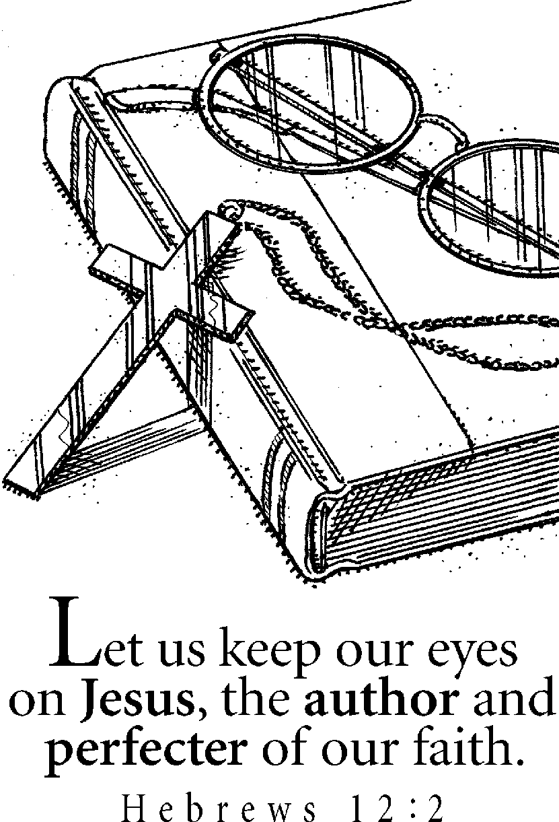

Ballot for the Fredericksburg Emmaus
Board of Directors

1. Certification of membership. I am a member of Fredericksburg Emmaus / Chrysalis, eligible to vote by virtue of attending a Walk to Emmaus sponsored by the Fredericksburg Emmaus Community, or a Walk to Emmaus, Chrysalis, or other Cursillo based weekend in another area.

2. Men (vote for one)
Brian Lewis ( )
Larry Morgenstern ( )
Tom Smith ( )
(write in) ( )

4. Clergy (vote for two)
Tom Barnard ( )
(write in) ( )
(write in) ( )
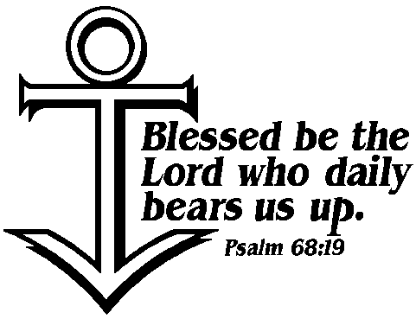

3. Women (vote for two)
Sandy Crossley ( )
Vonnie Hinkle ( )
Phyllis Howze ( )
Christine Schroth ( )
(write in) ( )

5. Each member of an Emmaus family who has attended an Emmaus, Chrysalis or other Cursillo based weekend is entitled to a separate ballot. To be counted, proxy ballot(s) must be submitted at the June Gathering or mailed to
Fredericksburg Emmaus
P.O. Box 42094
Fredericksburg, VA 22404

All mail-in entries must be received prior to the June12, 1999 Gathering.

