
The Upper Room
Emmaus

October 1999 | of the Greater Fredericksburg Area

From the Lay Director . . .

We have had two wonderful Gatherings at Rehoboth Methodist Church. Let’s all express our gratitude for the use of their facility and all the work that had to be done by Rehoboth members to make our Gatherings there possible.

I am pleased to announce that 13 Emmaus Board members were present last Saturday to conduct Community business – only 2 absentees! Your Board was able to conduct the following business:

Reviewed and approved both Emmaus #33 and #34 teams as reported by their respective Weekend LDs.
Reviewed and approved the Team and Pilgrim selection process – subject to the Selection Committee further refining for future walks it’s process for linking husband and wife attendance, and resolving what constitutes receipt of an application when critical information is missing. The Board also re-affirmed the need for Pastor support for weekend participation of both teamers and Pilgrims.
Approved the motion to accept trusteeship of Chrysalis material assets (subject to an inventory during September 1999) and agreed to establish a Chrysalis Steering Committee to get a Fredericksburg Chrysalis Chapter going again as soon as possible. The Community Lay Director was tasked to recommend committee members and chairman to the Board in October 1999.

There was discussion by the Board, but no action taken, regarding a third women’s walk, Board job descriptions and assignments, and Board member responsibilities for supporting the upcoming Weekends.

Since I am in my third month of my 12 month tenure as your Community Lay Director, let me share briefly what my areas of focus will be for the remainder of my service year. First, to work with our SDs, Board, and Community to reflect to the Fredericksburg area churches that Emmaus exists to support them by motivating their lay leaders for Christian service in their local body. Second, to work with the SDs and Board to document the support processes and tasks that are essential for the conduct of a successful Weekend experience – by the Team, the Board, and the Community. This effort is well underway with the help of several Board members. Third, to continue to develop motivation for His work and a sense of community in the Emmaus Body through Gatherings that are an extension of our Weekend experience. Please let your SDs and Board members know how we are doing serving Him and you in the work of Emmaus.

How about you? What can you be doing? Well, you can Team, sponsor Pilgrims, and you can attend and participate in our Gatherings and Weekend events. But most important, you need to reflect the Emmaus experience in your church life and in your grace life. Remember, God’s mercy is freely given to you, your discipleship is freely given to God. Life in Grace. Get a life. Get a grace life!

De Colores,

Dick Barnett

1999 Weekends

Men’s October 7-10
WLD: Ken Roark

Women’s November 4-7
WLD: Angel Fulkerson

Fredericksburg Emmaus Volunteer Chairpersons
1999-2000

Community Lay Director - Dick Barnett
Gathering Coordinator
Sponsor's Hour Coordinator
Candlelight Coordinator

Assistant Community Lay Director - Ken Roark
Transportation Coordinator
Supply Coordinator - Tom Frank

Community Spiritual Director - Mark Ogren
Gathering Coordinator
Sponsor's Hour Coordinator
Candlelight Coordinator

Treasurer - Dave Olds
Childcare Coordinator (Gatherings & DDU) - Bob Davis

Secretary - Barbara Larson
Manuals Coordinator
By-Laws Historian
Reunion Group Coordinator - Barbara Simpson
Emmaus "Store" Coordinator - Vonnie Hinkle

Communications Coordinator - Barbara Olds
Newsletter / Database Coordinator - Barbara Olds
Chrysalis Liaison
Pilgrim Registrar - Christine Schroth

Agape Coordinator - Patty Tessier
General Agape Coordinator - Barbara Wood
Prayer Vigil Coordinator - Debbie McKeen
Placemat Coordinator - Tina Cooper
Snack Agape Coordinator - Patti Tessier
Agape Bag Coordinator - Diana Farrar

DDU Coordinator - Susan Perkins
Community Baker - Betty Gray Thompson
DDU Pot Luck Dinner Coordinator
Upcoming Gatherings

November 13, 1999 Fairview Baptist

The Next Fredericksburg

Gathering

When: October 2, 1999

Where: Fairview Baptist Church

Fellowship at 6:00 p.m. Please bring snacks and refreshments to share.

The board will meet at 4:00 p.m. at the church.

Fredericksburg Emmaus #33 Team
DEADLINE for the November newsletter is October 9. Please send your articles to editor, Barbara Olds. Mail to 343 Longwood Drive, Stafford, VA 22554; fax to 540-286-2663; or e-mail to dolds@erols.com. For the timely delivery of our newsletter, it is important to get those articles in on time!

Tom Barnard Matt Lohr
Dick Barnett John Mann
Sean Bonner Larry Morgenstern
Herman Brock Gene Philipp
Donnie Cross Paul Prewitt
Robert Davis Wes Pryce
John DeJong Steve Rainwater
Steve Ecklund Ken Roark
Malcolm Graham Peter Schatz
Stanley Harrell Tony Schroth
Ken Hinkle Bill Simpson
Greg Howard Larry Tubbs
Mike Iden Richard Warner
Mark Lawrence Wayne Warren
Brian Lewis

Prayer and Praises . . .
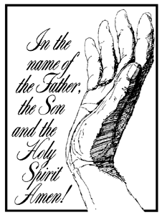

_ My marriage
_ Praise for my family
_ Betty and Mo
_ Prayer for wife’s health
_ Prayer for daughter’s marriage
_ Prayer for Team #33
_ Prayers for upcoming Walks
_ Prayers for Helen dying of
cancer
_ Friend’s health and new school year
_ Strength for Ken with teaming, work & school
_ Prayers for all who feel they don’t know they need
Christ
_ Praise for climbing to a new mountaintop experience
_ Pray for me to hear clearly the Lord’s guidance
_ Prayer for Lauren Collier, a 2yr old, with lump on back
of her neck
_ Prayer for continued healing for Verna
_ Praise and thanks that my wife Karen is free of cancer
afer the August 17th operation
_ Daughter in college to stay strong in Christ
_ Pray for those who don’t know Christ yet
_ Praise for our new grandchild (expected)
_ Prayer for God’s work & will be done; His servants
raised; in starting a youth ministry in Wilderness
Community Church
_ Prayer for boss & friend – health matters
_ Prayer & Praise for daughter (7) giving her life to the
Lord
_ Prayers for quick recovery from shoulder surgery for
Herman Brock
_ Prayer for mother’s heart to be softened
_ Praise and Thanksgiving for the presence of his Holy
Spirit at work. May His spirit continue to grow
in our co-workers and management.
_ Prayer for National Day at the Flag Pole (9/15/99)
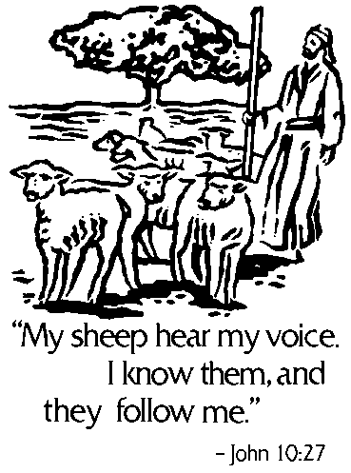

Reunion Groups . . .

We would like to list the Reunion Groups active in the Fredericksburg Emmaus Community. If you are a member of a reunion group, please send the information to Barbara Simpson. Please provide the name, meeting time, place, and contact with phone number.

Great Is Thy Faithfulness Emmaus Reunion Group
Meets 7:30 PM Tuesdays
Prince Of Peace United Methodist Church
6299 Token Forest Drive
Manassas, Virginia
Contact: Lloyd Biller (703) 590-1512

Pastor's Weekly Meeting
Meets 9:00 AM Thursdays
Rotates - call for location
Contact: Mark Dunn (540) 786-4025

Lakeside Reunion Group (Men)
Meets 8:00 PM Tuesdays
Lake Of The Woods Church
Contact : Vic Larson (540) 972-1928

Rainbow Reunion Group (Women)
Meets 9:00 AM Fridays
Lake Of The Woods Church
Contact : Barbara Miller (540) 972-7418

“Amazing Grace” Reunion Group
Meets 8:15 PM Thursdays
Chancellor Christian Church
Contact : Joe Cooper (540) 310-0865

Son Rise Reunion Group
Meets 7:15 a.m. Thursdays
Melrose United Methodist
Contact: Ruth Ash (804) 529-6448 or
Patsy Bayse (804) 529-6101

(Men)
Meets 7:30 p.m. Tuesdays
Bethel United Methodist Church
13506 Minnieville Road
Woodbridge, Va.
Contact: Brian Lewis (703) 590-9343
e-mail to bb3253@AOL.com

“The Fredericksburg and Chrysalis Communities do not encourage or sanction the use of Community directories for profit use.”

A Note from Angel . . .

Dear Community

Bless the Lord, O my soul, O Lord my God, thou art very great; thou art clothed with honour and majesty. Hallelujah!

Forgive me for not writing last month but praise the Lord, that gave us time to meditate more on our opportunities to Bless. Amen!

Although rare today, when a man would go to a woman asking her to marry him, he would on bended knee present himself to her with his request. When someone would go before a king, they would bow before him, or again on bended knee present themselves to be heard. These are examples of "Bless." One presents themselves fully yielded to the one whom they want to be accepted by. Guess what? Jesus did this to you! God sent Him,
His only Son, to walk this earth as a man and Jesus came and served us and through his examples began teaching us. When he hung on that cross, it was as if His final words were: "Here I am, for you, will you accept me?" Of course, He was saying this all along but it is at that cross where we each make a decision and it is a place of Bless. He laid His own life down, not just bowing before us, not just on bended knee, but laid His LIFE down, saying I give it for you. Now, in this place of Bless, what will you choose to do. Will you come before Him, on bended knee presenting yourself fully to Him? Think about this.

In 1 Samuel 1 & 2, we can read about a woman named Hannah. She could not have children and came to a point where she wanted a child so badly, she knew God could give her one. What did she do? She set herself down
before Him, making her petition before Him and also Blessing Him by dedicating herself and this child (not even in her womb yet) to the Lord. Not only was her petition granted but she also followed through with what she had said to the Lord. Awesome!

This is somewhat the same, when we choose to team. We seek the Lord, then commit to Him all of who we are, to this work (an unborn child) and follow through with this work to the end. Remember that when we bless the Lord, we are blessing all who are a part. To Bless takes two sides: the giver of bless and the receiver of bless. If we are the giver then we give our best. If we are the receiver, we receive with open arms. God takes care of the rest.

Back to the man presenting himself asking the woman to marry him. He gives all of who he is, to bless. The woman receiving, does so with open arms and knowing that it may not be easy all of the time. There will be good times and rough times. The act of Bless brings them together and in remembering to keep this place of Bless available, they can draw closer to one another and to God enduring whatever comes their way.

Can we ponder these things? Consider our place of Bless, giver or receiver, in every area of our lives enduring the rough times and rejoicing in the good times? Can we trust God to take care of the rest? On bended knee I present myself to God proclaiming: Bless the Lord, O my soul, and all that is within me, Bless His Holy name. Amen!

Have a wonderful month!

With love in Jesus,

Angel



Fredericksburg Emmaus #33
“Not by Might, nor by Power, but by My Spirit”
Pilgrims

NAME | CHURCH
Bobby Atkins | St. Stephens Baptist
A. Purnell Bailey | Fredericksburg UMC
James David Barr | Fairmount Mem. Baptist
Robert Billingsley | Fredericksburg UMC
Art Blankenship | Fairview Baptist
George Brown | Liberty UMC
Ron Colby | Calvary UMC
Joe Conlin | Fredericksburg UMC
Stephen Cooley | Fredericksburg UMC
Frank Deierhoi | Lake of the Woods
Mark Earnesty | Fredericksburg UMC
Anthony Fortune | Shepherds UMC
John Gay | St. Matthias UMC
Mark Goodpasture | Fredericksburg UMC
Kris Indseth | Rock Church
Steve Judy | Fredericksburg UMC
Lawrence Malone | Liberty UMC
Sam Mc Cartney | Chancellor Christian
Walter Oley | St. Stephens Baptist
Stan Sokolowski | Word of Life Assembly of God
Darrell Swanigan | Lake of the Woods
Charles Tillapaugh | Wrights Chapel UMC
Joe Uhlick | Fairview Baptist
Charlie Vernon | Fredericksburg UMC
Dennis Walsh | Freedom Fellowship
Ralph Williams | Fairview Baptist
Russ Wiss | Fairview Baptist

Schedule - Fredericksburg # 33 - October 7-10, 1999

The team for Fredericksburg Women’s Walk #32 invites sponsors, families and community participation in the following events:

WHEN WHERE WHAT
Thurs., Oct 7 7:00 P.M. Camp Easter Seal Pilgrim check-in/Fellowship followed by Sponsor’s Hour

Sat., Oct 9 7:45 P.M. Camp Easter Seal Candlelight - Please bring flowers for the team to use Sunday morning!!! Community will gather for Praise, Fellowship and Communion.

Sun., Oct 10 3:30 P.M. Camp Easter Seal Closing - Gather at 3:30 for Closing Service at 4:00 P.M. Closing
will be held in the new gym.

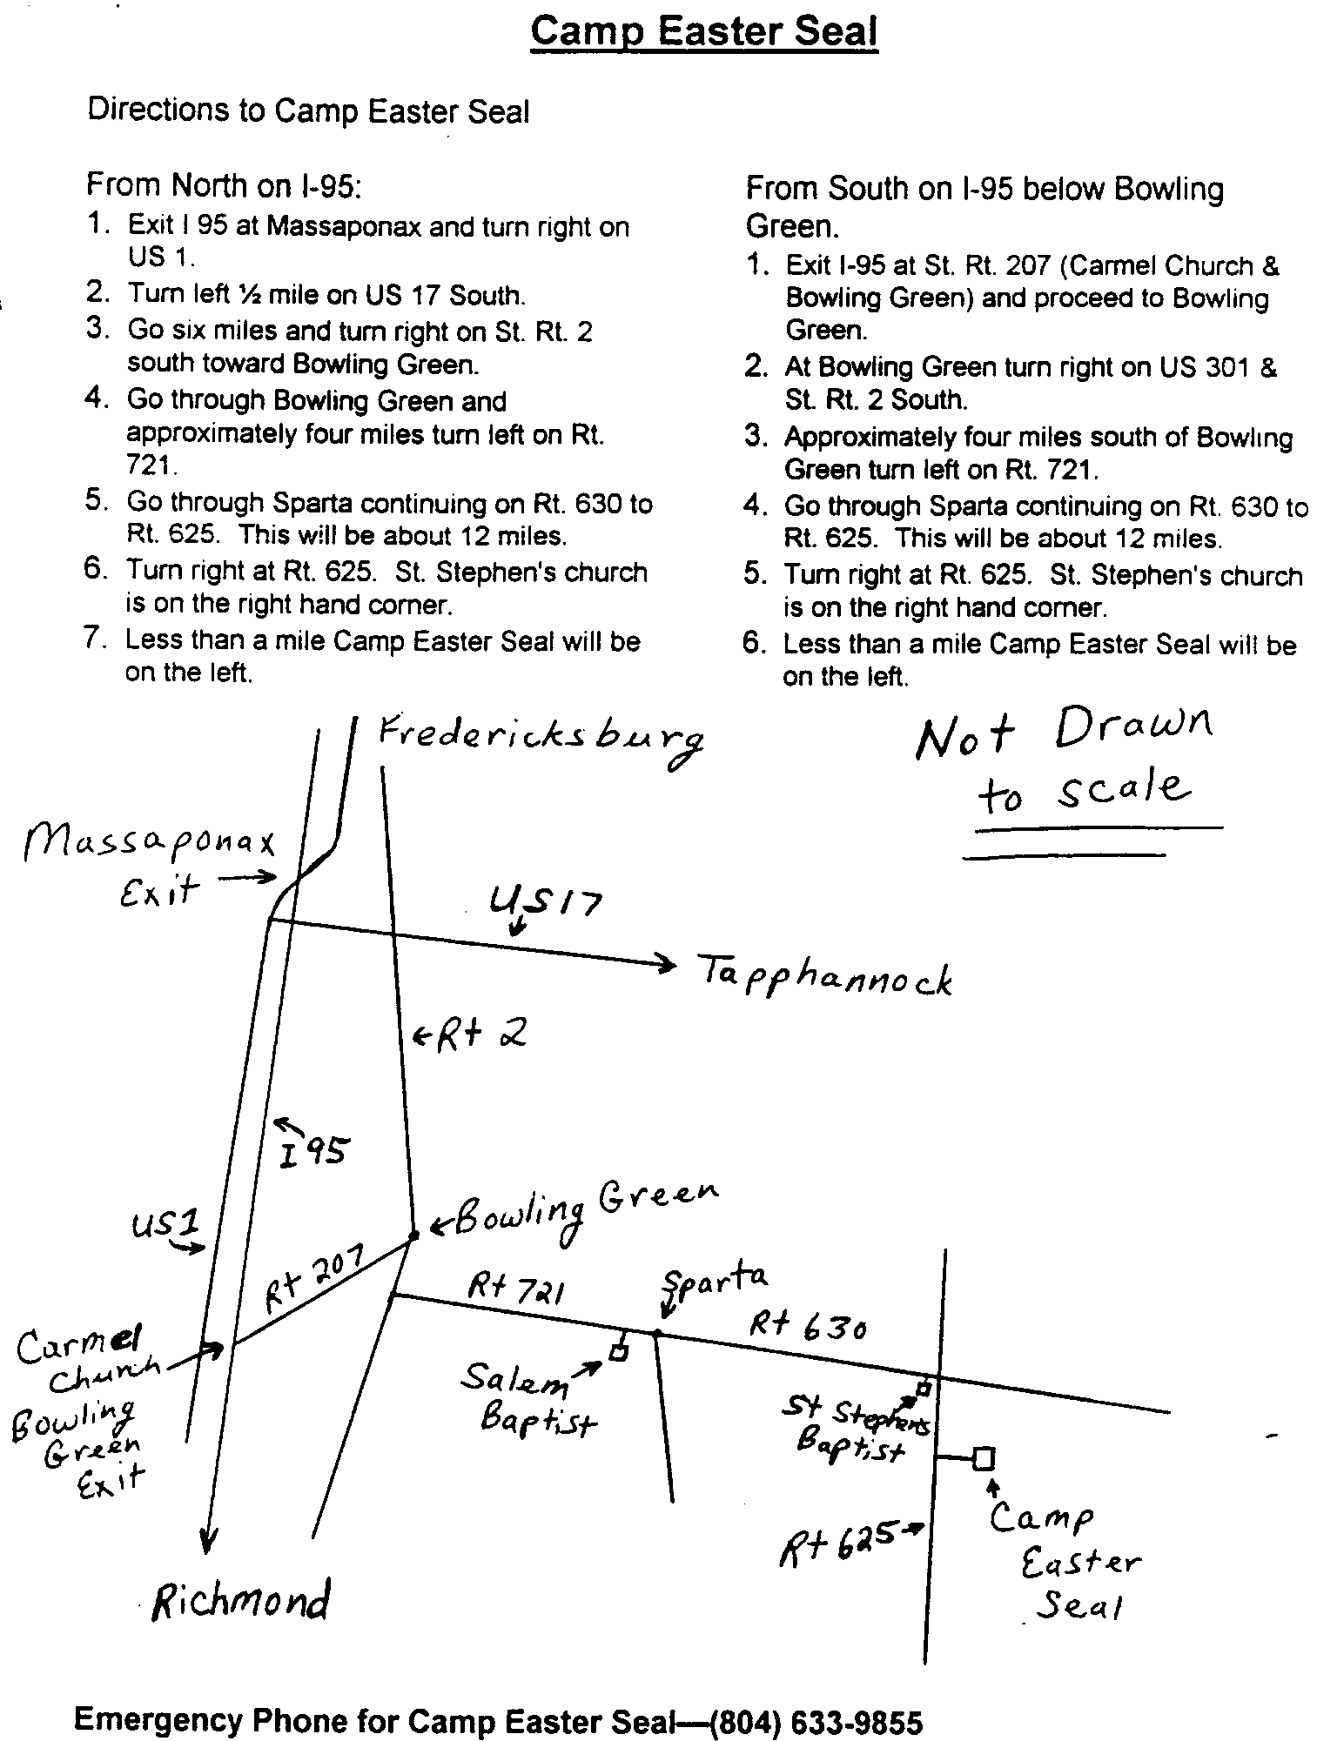

Fredericksburg Emmaus #34
“The Kingdom of Heaven is Like Unto a Small Child”
Team Assignments

Susan Barr Asst Table Leader
Millie Brock Table Leader
Paul Campbell Spiritual Director Prevenient Grace Friday, 11:15 a.m.
Jen Curtis Asst Table Leader
Theresa Davis Table Leader Changing Our World Sunday, 8:50 a.m.
Debbie Devine Asst Agape Coordinator Body of Christ Sunday, 11:10 a.m.
Trinette Duncan Table Leader
Mark Dunn Spiritual Director Obstacles to Grace Saturday, 4:00 p.m.
Angel Fulkerson Lay Director Perseverance Sunday, 1:05 p.m.
Vonnie Hinkle Table Leader Discipleship Saturday, 8:00 p.m.
Phyllis Howze Table Angel Fourth Day Talk @ DDU
Melanie Lee Table Leader Life in Piety Friday, 7:30 p.m.
Lola McDonald Music Team Priesthood of All Believers Friday, 1:30 p.m.
Debbie McKeen Music Director
Sandy Morgenstern Asst Lay Director Grouping Talk @ DDU
Betty Moses Agape Coordinator Christian Action Saturday, 2:35 p.m.
Kathy Neiswander Asst Table Leader
Barbara Olds Asst Lay Director Priorities Friday, 9:15 a.m.
Dianne Philipp Asst Cha Coordinator
Trina Roark Asst Table Leader
Ellen Schertz Cha Coordinator Growth Through Study Saturday, 8:55 a.m.
Barbara Simpson Asst Lay Director Fourth Day Sunday, 2:45 p.m.
Sharon Smith Asst Table Leader
Michael Snider Spiritual Director Justifying Grace Friday, 3:00 p.m.
Patti Tessier Asst Table Leader
Margie Turbyfill Lead Spiritual Director Means of Grace Saturday, 10:15 a.m.
Sanctifying Grace Sunday 10:00 a.m.
Melanie Walz Table Leader

The Team Chapel is open to the Community during the various talks. Each speaker will have a team member in the chapel as their prayer partner. A speaker’s grouping members, family or others who have attended a weekend are invited and welcomed to be a part of this special time. Chapel Prayer Partners should be discreet in arriving and departing from Camp Easter Seal and should be in the prayer chapel 30 minutes prior to “Talk Time” listed above.

Reunion Groups continued. . .

Monday's Makeovers Reunion Group
Meets 8:00 p.m. Mondays
Denny's Restaurant in Dale City
Dale Blvd. & I-95
Contact: Lois Myrick 703-680-0577 or
Sandy Crossley 703-221-6977

God Bearers
Meets 8:00 am Sundays
Melrose United Methodist Church
Contact: Laurie Basye (804) 529-6953 or 580-5135
e-mail basye@crosslink.net
Alice Harding (804) 529-7854
e-mail archardcl@pen.k12.va.us

The Fredericksburg Emmaus community is considering starting a web site. If any of you have experience in this area (or not) and have a heart to undertake this opportunity to set up the web site please contact our coordinator:

Brian Lewis
11804 Lenox Lane
Woodbridge, Va. 22192
e-mail: Bb3253@aol.com

We are looking for a means of disseminating information about our community and our ongoing activities, weekend dates, Chrysalis concerns, prayer
requests, and whatever other 'things' might be of interest to our members and to members of other communities and Christians surfing the net.
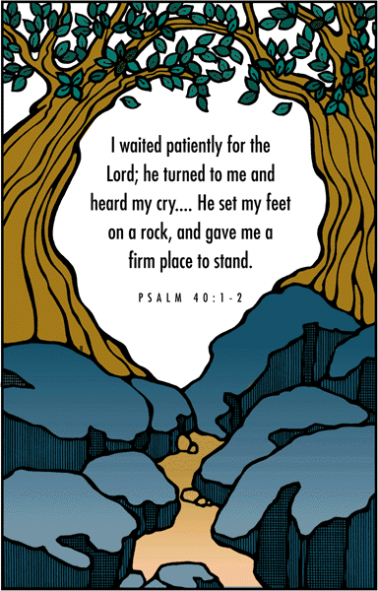

FREDERICKSBURG EMMAUS
BOARD OF DIRECTORS

Barnett, Dick - Lay Director
Roark, Ken - Asst. Lay Director
Larson, Barbara - Secretary
Olds, David - Treasurer
Ogren, Mark - Spiritual Director

Barnard, Tom Perkins, Dennis
Cooper, Joe Perkins, Susan
Hinkle, Vonnie Schroth, Christine
Lewis, Brian Tessier, Patti
Olds, Barbara Warren, Wayne

Community Directory Update

We will be issuing an updated directory in January. In order to bring our data up to date, we are asking members of the community to complete the following form and return it to Barbara Olds, 343 Longwood Drive, Stafford, Virginia 22554, no later than November 13, 1999.

Thank you.

Directory Information

Name |  | Walk
Spouse’s Name (if applicable) |  | Walk (if applicable)
Address |  | Home Telephone
City |  | Work Telephone (his)
State / Zip |  | Work Telephone (hers)
Church Name |  | E-mail
Church City / State
Wish to Receive Newsletter?
Chrysalis Member in Home?
Name |  | Walk
Name |  | Walk

