
The Upper Room
Emmaus

November 1999 | of the Greater Fredericksburg Area

From the Lay Director . . .

I would like to share some of my reflections on the recent Emmaus #33 men’s weekend. After three years of weekend ALD and LD experience, I yearned to be a table leader again working with the Pilgrims and being a teamer. God had other plans for me – “Agapeman” and assistant Cha. It was a whole new experience. I had never been a Cha or helped with agape before.

All weekend, I worked with three other Cha’s waiting tables, setting up rooms, moving furniture, running supplies in and out of the team room, and responding to requests for help from ALDs. In between I collected, sorted, and distributed Community Agape to the Pilgrims and Team. All the while, the weekend activities swirled around me and mostly I could only watch from a distance – speakers, chapel, special events, and singing. Not what I had planned for my weekend at all. From time to time I would slip away for Community activities – Sponsor’s Hour on Thursday night, and other surprises throughout the weekend. Whew – what an experience!

I am sharing all this in order to make a critical point – the Emmaus weekend experience is a way for God’s love to shine through us. Jesus told us that God is Spirit and God is love. His love finds expression His way by His Spirit working in us and through us on the Emmaus weekend only if we have an obedient servant heart. When we apply to team on a weekend, we are submitting to Him in service as He wishes, not as we wish. In most cases, God’s will for each team member is not known until the Cadre meets together during the teaming process to seek His will for team assignments.

I learned a wonderful lesson about serving Him on this past weekend. Please remember, when you apply to team be open to His will for you and serve joyously as He directs your path. Don’t apply to serve on a team with a particular assignment in mind or the attitude that you can’t give a talk or aren’t “ready” for leadership or fellowship. Let God speak to the Cadre about you and pray for a servant’s heart when His will for you is revealed.
Get your team applications in as soon as possible for the Spring 2000 walks. We will learn later this month when the Walk Weekend dates are from Camp Easter Seal. After receiving guidance at the last Board meeting, Mark Ogren and I met to select possible weekend dates. We hope to have three – one men’s walk in late February or early March, one women’s walk in mid to late March, and a second women’s walk in early to mid May. Camp Easter Seal was encouraging that we can get the dates that we requested. Our Team and LD Selection Committees will meet in November to begin the team selection process and, if things work out, select an LD for the second Spring 2000 walk.

ALL OUR NEW “4th DAYERS” - COME TO DDU ON NOVEMBER 13th THEN APPLY TO TEAM!

De Colores,

Dick Barnett
FREDERICKSBURG EMMAUS
BOARD OF DIRECTORS

Barnett, Dick - Lay Director
Roark, Ken - Asst. Lay Director
Larson, Barbara - Secretary
Olds, David - Treasurer
Ogren, Mark - Spiritual Director

Barnard, Tom Perkins, Dennis
Cooper, Joe Perkins, Susan
Hinkle, Vonnie Schroth, Christine
Lewis, Brian Tessier, Patti
Olds, Barbara Warren, Wayne

Fredericksburg Emmaus Volunteer Chairpersons
1999-2000

Community Lay Director - Dick Barnett
Gathering Coordinator
Sponsor's Hour Coordinator
Candlelight Coordinator

Assistant Community Lay Director - Ken Roark
Transportation Coordinator
Supply Coordinator - Tom Frank

Community Spiritual Director - Mark Ogren
Gathering Coordinator
Sponsor's Hour Coordinator
Candlelight Coordinator

Treasurer - Dave Olds
Childcare Coordinator (Gatherings & DDU) - Bob Davis

Secretary - Barbara Larson
Manuals Coordinator
By-Laws Historian
Reunion Group Coordinator - Barbara Simpson
Emmaus "Store" Coordinator - Vonnie Hinkle

Communications Coordinator - Barbara Olds
Newsletter / Database Coordinator - Barbara Olds
Chrysalis Liaison
Pilgrim Registrar - Christine Schroth

Agape Coordinator - Patty Tessier
General Agape Coordinator - Barbara Wood
Prayer Vigil Coordinator - Debbie McKeen
Placemat Coordinator - Tina Cooper
Snack Agape Coordinator - Patti Tessier
Agape Bag Coordinator - Diana Farrar

DDU Coordinator - Susan Perkins
Community Baker - Betty Gray Thompson
DDU Pot Luck Dinner Coordinator
1999 Weekends

Women’s November 4-7
WLD: Angel Fulkerson

The Next Fredericksburg

Gathering

When: November 13, 1999

Where: Fairview Baptist Church

Fellowship at 6:00 p.m. Please bring snacks and refreshments to share.

The board will meet at 2:30 p.m. at the church.

Fredericksburg Emmaus #34
Team
“The Kingdom of Heaven is Like Unto a Small Child”

Susan Barr Sandy Morgenstern
Upcoming Gatherings

December 11, 1999 Peace UMC
January 8, 2000 Peace UMC
February 12, 2000 Hillcrest UMC
March 11, 2000 Hillcrest UMC

Millie Brock Betty Moses
Paul Campbell Kathy Neiswander
Jen Curtis Barbara Olds
Theresa Davis Dianne Philipp
Debbie Devine Trina Roark
Trinette Duncan Ellen Schertz
Mark Dunn Barbara Simpson
Angel Fulkerson Sharon Smith
Vonnie Hinkle Michael Snider
Phyllis Howze Patti Tessier
Melanie Lee Margie Turbyfill
Lola McDonald Melanie Walz
Debbie McKeen

Reunion Groups . . .

We would like to list the Reunion Groups active in the Fredericksburg Emmaus Community. If you are a member of a reunion group, please send the information to Barbara Simpson. Please provide the name, meeting time, place, and contact with phone number.

Great Is Thy Faithfulness Emmaus Reunion Group
Meets 7:30 PM Tuesdays
Prince Of Peace United Methodist Church
6299 Token Forest Drive
Manassas, Virginia
Contact: Lloyd Biller (703) 590-1512

Pastor's Weekly Meeting
Meets 9:00 AM Thursdays
Rotates - call for location
Contact: Mark Dunn (540) 786-4025

Lakeside Reunion Group (Men)
Meets 8:00 PM Tuesdays
Lake Of The Woods Church
Contact : Vic Larson (540) 972-1928

Rainbow Reunion Group (Women)
Meets 9:00 AM Fridays
Lake Of The Woods Church
Contact : Barbara Miller (540) 972-7418

“Amazing Grace” Reunion Group
Meets 8:15 PM Thursdays
Chancellor Christian Church
Contact : Joe Cooper (540) 710-6268
e-mail to jtjh4givn@juno.com

Son Rise Reunion Group
Meets 7:15 a.m. Thursdays
Melrose United Methodist
Contact: Ruth Ash (804) 529-6448 or
Patsy Bayse (804) 529-6101

(Men)
Meets 7:30 p.m. Tuesdays
Bethel United Methodist Church
13506 Minnieville Road
Woodbridge, Va.
Contact: Brian Lewis (703) 590-9343
e-mail to bb3253@AOL.com

“The Fredericksburg and Chrysalis Communities do not encourage or sanction the use of Community directories for profit use.”
Reunion Groups continued. . .

Monday's Makeovers Reunion Group
Meets 8:00 p.m. Mondays
Denny's Restaurant in Dale City
Dale Blvd. & I-95
Contact: Lois Myrick 703-680-0577 or
Sandy Crossley 703-221-6977

God Bearers
Meets 8:00 am Sundays
Melrose United Methodist Church
Contact: Laurie Basye (804) 529-6953 or 580-5135
e-mail basye@crosslink.net
Alice Harding (804) 529-7854
e-mail archardcl@pen.k12.va.us

The Fredericksburg Emmaus community is considering starting a web site. If any of you have experience in this area (or not) and have a heart to undertake this opportunity to set up the web site please contact our coordinator:

Brian Lewis
11804 Lenox Lane
Woodbridge, Va. 22192
e-mail: Bb3253@aol.com

We are looking for a means of disseminating information about our community and our ongoing activities, weekend dates, Chrysalis concerns, prayer
requests, and whatever other 'things' might be of interest to our members and to members of other communities and Christians surfing the net.

Schedule - Fredericksburg # 34 - November 4-7, 1999

The team for Fredericksburg Women’s Walk #32 invites sponsors, families and community participation in the following events:

WHEN WHERE WHAT
Thurs., Nov 4 7:00 P.M. Camp Easter Seal Pilgrim check-in/Fellowship followed by Sponsor’s Hour

Sat., Nov 6 7:45 P.M. Camp Easter Seal Candlelight - Please bring flowers for the team to use Sunday morning!!! Community will gather for Praise, Fellowship and Communion.

Sun., Nov 7 3:30 P.M. Camp Easter Seal Closing - Gather at 3:30 for Closing Service at 4:00 P.M. Closing
will be held in the new gym.

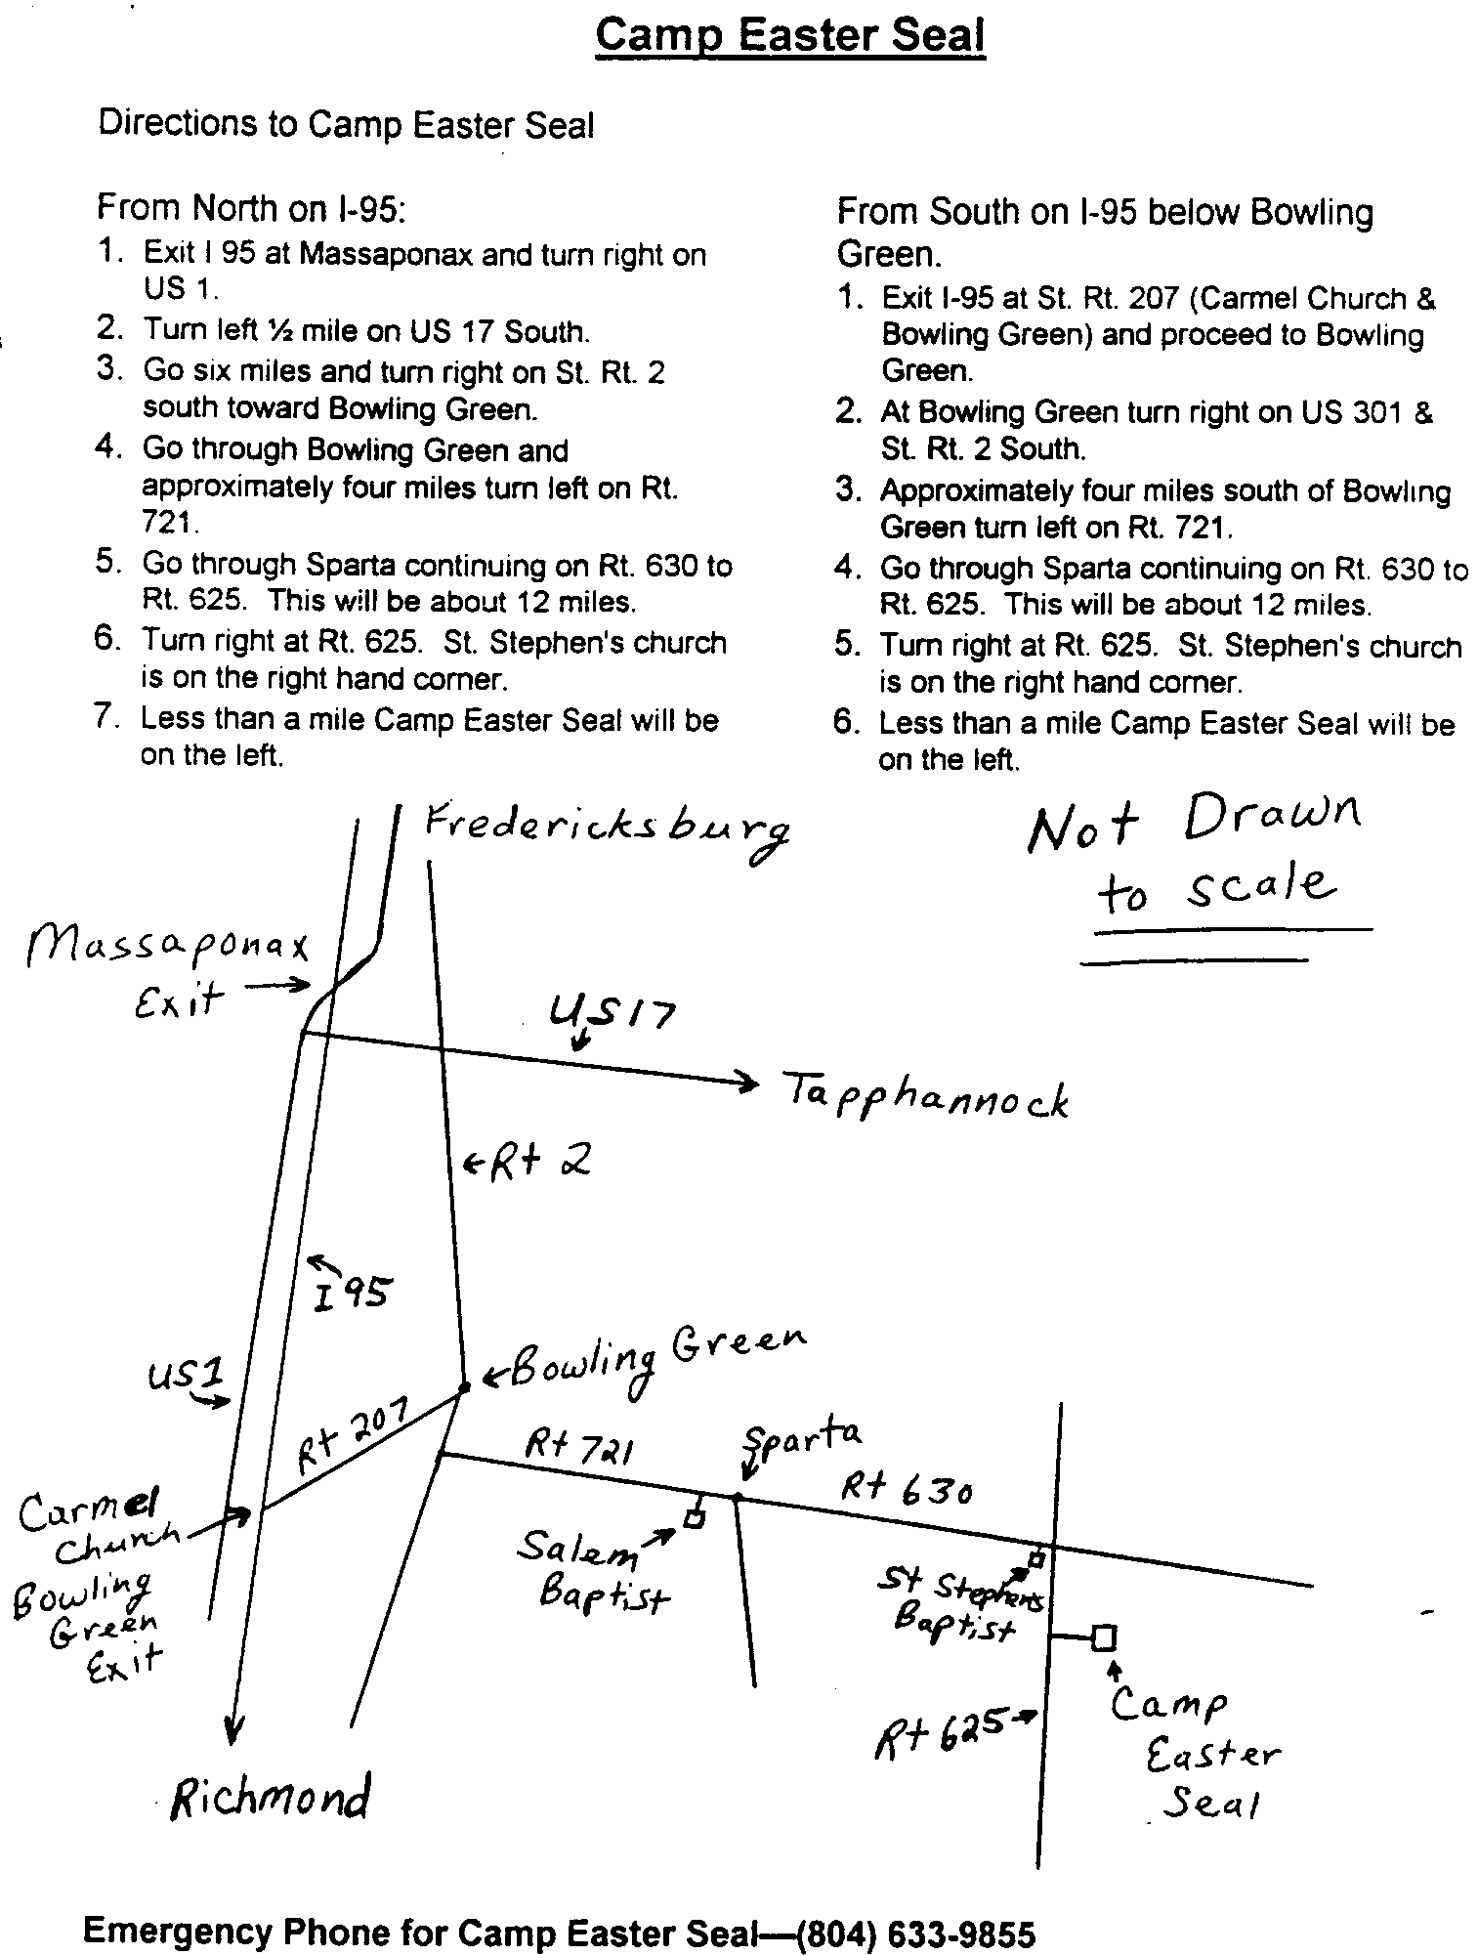

Fredericksburg Emmaus #34
“The Kingdom of Heaven is Like Unto a Small Child”
Pilgrims

NAME | CHURCH | NAME | CHURCH
CHRISTINE ANDERSON | REMINGTON UMC | GLADYS JORDON | MESSIAH LUTHERAN
ROSEMARY BLANKENSHIP | FAIRVIEW BAPTIST | MONA LAMB | FREDERICKSBURG UMC
NICOLE BLOSSER | FREDERICKSBURG UMC | KATHRYN MABE | FREDERICKSBURG UMC
WILMETA CHANCE | CALVARY UMC | MICHELLE MC CARTNEY | CHANCELLOR CHRISTIAN
LINDA CONLIN | FREDERICKSBURG UMC | DEBORAH McMICHEAUX | FIRST CHRISTIAN CHURCH
ELLEN COWART | MELROSE UMC | CAROLYN NELSON | DAHLGREN UMC
PAMELA DANNAF | MORRISVILLE UMC | SHARON NUZMAN | CROWN OF LIFE
JOYCE FAIRBANKS | FREDERICKSBURG UMC | FLORENCE RIDDERHOF | FREDERICKSBURG UMC
BARBARA GALLAHAN | FIRST CHRISTIAN | NANCY SAUCERMAN | MELROSE UMC
SUSAN GOODPASTURE | FREDERICKSBURG UMC | MICKEY SHARP | ROCK CHURCH
SHARON GRIFFIN | MESSIAH LUTHERAN | JUDY SINKOVITZ | FIRST UMC
LUCY HARRELL | CORKRAN MEMORIAL UMC | MARTA SOTOLONGO | STRONG TOWER MINISTRIES
MARGARET HOGUE | PRINCE OF PEACE UMC | SUSAN STEPHENSON | PINEKIRK PRESBYTERIAN
RENEE HOLLAND | BETHEL UMC | NOVELLA TRAGESER | ST. STEPHENS BAPTIST
SONDRA HOLMBERG | MELROSE UMC | SHERI TYNES | BETHEL UMC
MELISSA HOWARD | CROWN OF LIFE | VIRGINIA WEBB | MELROSE UMC
DIANE JACKMAN | CALVARY UMC | SANDRA WILLIAMS | FAIRVIEW BAPTIST
KAREN JOHNSON | FRIENDSHIP BAPTIST | VALERIE WISS | FAIRVIEW BAPTIST
DONNA JONES | REHOBOTH UMC

A Note from Wes Pryce. . .

"The team and pilgrims of Fredericksburg Emmaus Walk #33 were blessed by the experience of the power of the Holy Spirit and the Love of Jesus Christ throughout the whole weekend.

It is hard to believe that it is time to prepare for the next men's walk, EM-35, which will take place sometime between late February and the latter part of March. The dates will be set in the near future.

I encourage all you men, especially those of you who just walked on EM-33, to prayerfully consider submitting a team application. Remember, to be able to team you have to attend the Day of Deeper Understanding on 13 November and make sure your team application is signed by your pastor.

Teaming is an opportunity to respond to God's call to serve Him with a servant's heart. All who team should be able to come with the desire to serve on the team in whatever role God has for each man, whether it be
serving at a table or as a Cha or through any of the other assignments that He may give.

The teaming experience truly is one of joy in the indwelling of the Holy Spirit.


De Colores

Wes Pryce

Day of Deeper Understanding

A Day of Deeper Understanding will be held on Saturday, November 13, 1999 beginning at 4:30 p.m., at Fairview Baptist Church. Sponsors and their Pilgrims who have walked and not yet attended a DDU are encouraged to attend. Please remember that you cannot sponsor a Pilgrim or Team if you have not attended a Day of Deeper Understanding.

A pot luck supper will be held after the DDU (before the Gathering). Please bring a dish to share. Don’t miss this time of fellowship!

Community Directory Update

We will be issuing an updated directory in January. In order to bring our data up to date, we are asking members of the community to complete the following form and return it to Barbara Olds, 343 Longwood Drive, Stafford, Virginia 22554, no later than November 13, 1999.

Thank you.

Directory Information

Name |  | Walk
Spouse’s Name (if applicable) |  | Walk (if applicable)
Address |  | Home Telephone
City |  | Work Telephone (his)
State / Zip |  | Work Telephone (hers)
Church Name |  | E-mail
Church City / State
Wish to Receive Newsletter?
Chrysalis Member in Home?
Name |  | Walk
Name |  | Walk

