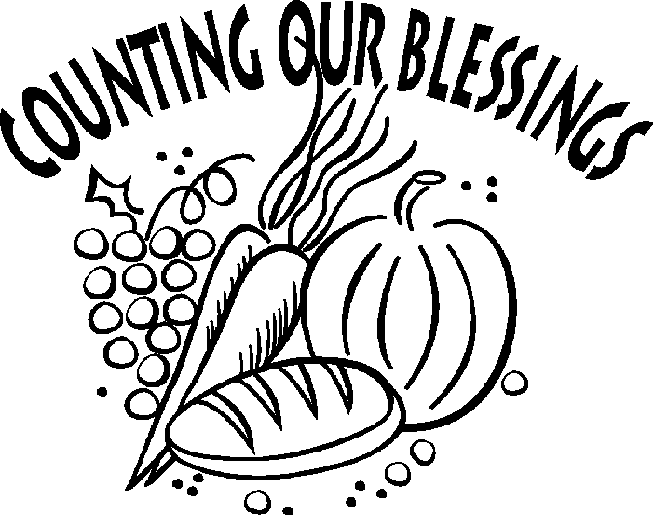
The Upper Room
Emmaus

November 2000 | of the Greater Fredericksburg Area

From the Lay Director . . .

"Then he [Jesus] selected twelve of them to be his regular companions . .." -- Mark 3:14

De Colores my brothers and sisters in Christ. I greet you in the name of our risen savior Jesus Christ. May he bless the work you do for our Lord.

Where would we be today if we did not have any relationships. I bet we would be lonely, devastating lonely. Well I know for sure that our Lord does not want us to be lonely. He wants us to have relationships. He is constantly seeking a relationship with us. If we would just slow down and take the time to develop this relationship we would never be alone even if there were no people around, because he is always with us.

I realized this fact on the last men’s walk when the Lord placed me in a captive audience with 59 other men. We sat and listened to talks, we grew in the knowledge of how to build our relationship with God. We listened to guidance and praised His name through song. We prayed and as we prayed in silence searching for items we needed to get rid of in our lives, we found that Jesus had already been there to clean up the messy sin we kept. All we have to do is repent, change our lives to show the love of Christ and let Jesus guide our lives.

As we live our daily lives, go through the paces of this world it is up to us to help each other through. It is important to have a sole mate to share in confidence with, our problems, our joys, our praise and our love. I have such a friend. We get together from time to time and share. We share our concerns and talk through possible solutions. We share past experiences so we can laugh and reminisce.

While we were sharing in our last meeting I discovered how much a special person in our life means. It’s like having Jesus sit down in person and talk over your problems and Him showing you a solution or at least the next step in which to travel. It’s sharing a piece of your heart and not worrying about where or if you will hear it again from someone else. When ever I need to talk with someone he is always ready to listen and help. It always amazes me how much we have in common when we just share and how it cleans our soles.

I realized that between teaming and the support of my friend, that Jesus uses both of them to slow my life down and refocus me so I can start building that relationship with him stronger, which in turns strengthens me to work for Him daily.

One last praise to the Lord (for this article). One of my prayers has been for the Lord to use me and not let me know until it’s too late. Well here is one that was answered.

Two years ago at one of the many contracts I work on, one of my coworkers and I usually had an early morning discussion about the Lord or some Scripture. One of the men in the office over heard us and started casually happening by about the time we started our discussion. He would stick around for a while but never would engage in the conversations. Well about two weeks ago I meet the coworker from the previous contract in the hallway. He told me that I need to go see the gentlemen that use to come by and visit in the mornings. Of course I ask why. He informed me that there was rejoicing in heaven because he had accepted Christ. He shared that because of those early morning conversations the Lord started working on him. He started attending church and Jesus spoke to him. He is now in the Book of the Life. Praise the Lord.

I leave you with this these questions: How is you relationship with Christ? What are you doing about it? Who is listening to your conversations?

May the peace, love and joy of Christ be with you always.

De Colores

Ken Roark
Wright’s Chapel UMC
F’burg Emmaus #13, Table of Paul

2000 Weekends

Women’s November 9 - 12
WLD: Vonnie Hinkle

From the Spiritual Director. . .

Dear Community,

I’m overdue in introducing myself as the community spiritual director so let me do so now. I’m the pastor of Chancellor Christian Church and have been involved with the community since the spring of 1992. I walked on Fredericksburg Emmaus #3 and sat at the table of Matthew. I have been blest with having the opportunity to see this community grow both numerically as well as spiritually. I want to commend those who have and are serving this community in such a wonderful way. I am enjoying the blessing of seeing things move along in such a godly manner. I have said from the beginning that as long as Christ is the central focus of this community God will bless it.

By the time you read this, the men’s walk will have been completed and the women will be ready to goon their weekend. At the time I’m writing this we’re in the midst of the men’s weekend and it is off to a great start. I know that God is going to do a great work though this team for the glory of His Kingdom. I continue to marvel at what God does on these weekends. I do have a challenge for us as a community, though. We need to make sure that we carry the blessing, impact and power of this weekend with us into every area of our daily lives. We all know this but how effective are we in doing it? Each one has to evaluate this on his own, but often I find that people are disappointed with the results. This is where I think we need to drill into our mentality something very fundamental to our daily Christian walk.

Right now I’m preaching through a series entitled “The Servant Driven Church.” This concept is fundamental to the kind of disciple we are to become. Once when Jesus was responding to a request by the mother of James and John, he made this point to his disciples, “You know that the rulers of the Gentiles lord it over them, and their high officials exercise authority over them. Not so with you. Instead, whoever wants to become great among you must be your servant, and whoever wants to be first must be your slave—just as the Son of Man did not come to be served, but to serve, and to give his life as a ransom for many.” (Matthew 20:25-28) Probably we are all very familiar with this verse, but here is a question, how are you doing is fulfilling this mandate? On the weekend you were challenged to go back to your pastor and find a way to serve him in your church. What are you doing to fulfill that charge?

You may respond that you are being a better servant to you family and on your job and that is certainly a priority and to be commended. But you have another responsibility as well; that is the work of the ministry in the Lord’s church. I have found over the years that people like to be noticed and they often want to be in control of certain things, but how are you excelling in actually serving others in the church? This by the way is a priority. The apostle Paul said, “Therefore, as we have opportunity, let us do good to all people, especially to those who belong to the family of believers. (Galatians 6:10)

Well there you have it. You want to be considered great in the Lord’s kingdom then you must become the slave of others and especially in the church. This is exactly the example Jesus set. Remember his words, “The Son of Man did not come to be served, but to serve, and to give his life as a ransom for many.” (Matthew 20:28) How are you giving your life in service to others in the Lord’s church?

In The Master’s service,
Mark Dunn

The Next Fredericksburg

Gathering

When: November 18, 2000

Where: Hillcrest United Methodist

Time: 7:00 p.m.

Fellowship at 6:00 p.m. The board will meet at 2:30 p.m.

Upcoming Gatherings

December 9, 2000 Hillcrest UMC
January 13, 2001 Chancellor Christian
February 10, 2001 Lake of the Woods
March 10, 2001 Lake of the Woods

SEW AGAPE BAGS for future Emmaus walks. Or you can help out by donating bright rainbow colored fabric or cording or brightly colored shoelaces. Call Diana Farrar 540-372-7535 or e-mail farrardiana@juno.com to say you'll help!


A few more sets of placemats are needed for E-39. If you would be interested in coloring placemats or, if you took placemats from recent Gatherings, please call or e-mail us so we can arrange to get them to you or pick them up. Shane and Sharon Smith 540-891-6304 or donaldsmith@erols.com

Prayers & Praises. . .


_ Sharp Family; Micki’s recovery
_ Praise & Prayer for our Board
_ Elwood Campbell and his family
_ Praise for my brothers on E-38 team
_ Pray for Olen Carter - lung cancer
_ Pray for peace in the Middle East
_ My son that he recovers from depression
_ People who need special healing of heart & body
_ Prayers for a work situation and wisdom to know God’s will
_ Prayer for being a good table leader following God’s Holy
Spirit
_ Praise for the presence of the Holy Spirit at our places of
employment. May everyone be open to accept His grace.
_ Guidance for my daughter in her decisions for her future
_ Prayers for the pilgrims as they prepare for E-39
_ Prayer that a loved one will overcome in addiction and that
Christ uses this situation to reveal himself
_ Bring Your light where darkness dwells
_ Praise and Glory to God the Father and all he has done for us!!
_ Prayer for Cal Cooper who has brain tumor
_ Prayers for safe travel & spiritually fruitful time with family
_ Jamie Finlayson–trust factor, Godly decisions, perseverance and
His personal and private needs
_ Prayers for our grandson Cory and his parents, teachers, etc.
_ Prayers for the fallen sailors on the USS Cole and prayers that
the crew is able to sail the ship back home and justice will
be done
_ Renewal - spiritual growth
_ For a son to draw closer to you Lord
_ Praise for the birth of twin grandsons 2 weeks old
_ For my friend, Boyce Wray, whose brother went to be with God–
his name is Edsal Wray
_ John Weinhardt scheduled for bypass surgery October 18th
_ Pray for my 83 yr old mother, Ruth Gority – salvation
_ Pray for a teenage son to be led to team on Chrysalis
_ Prayers for team #39
_ Pray for gospel choir
_ Praise for a great job!!
_ Prayer for baby Arrielle, 2 mos old and needing surgery to
remove damaged kidney or pray for a miracle of healing if it
be His will
_ Pray for a teenage son who is having a difficult time
_ Pray for Dave Tynes
_ Praise for 21 years of marriage!!
_ Prayers for healing
_ Prayers for son, Alex, who leaves for the Navy next week
and for our other son, Mike, in the Marine Corp and
for the youngest of our three sons, Brandon, who is
already missing both
_ Pray for Rebecca to find new job so she wont’ go to NY
_ Pray for uncle who is in ICU for 3 weeks from heart surgery
_ Praise for successful surgery
_ Thank you Jesus! Thank you Father God!!

Reunion Groups . . .

We would like to list the Reunion Groups active in the Fredericksburg Emmaus Community. If you are a member of a reunion group, please send the information to Barbara Olds. Please provide the name, meeting time, place, and contact with phone number.

Great Is Thy Faithfulness Emmaus Reunion Group
Meets 7:30 PM Tuesdays
Prince Of Peace United Methodist Church
6299 Token Forest Drive
Manassas, Virginia
Contact: Lloyd Biller (703) 590-1512

Pastor's Weekly Meeting
Meets 9:00 AM Thursdays
Rotates - call for location
Contact: Mark Dunn (540) 786-4025

Lakeside Reunion Group (Men)
Meets 8:00 PM Tuesdays
Lake Of The Woods - call for location
Contact : Vic Larson (540) 972-1928

Rainbow Reunion Group (Women)
Meets 2:30 PM Tuesdays
Lake Of The Woods - call for location
Contact : Barbara Miller (540) 972-7418

“Amazing Grace” Reunion Group
Meets 8:15 PM Thursdays
Chancellor Christian Church
Contact : Joe Cooper (540) 710-6268
e-mail to jtjh4givn@juno.com

Son Rise Reunion Group
Meets 7:15 AM. Thursdays
Melrose United Methodist
Contact: Ruth Ash (804) 529-6448 or
Patsy Bayse (804) 529-6101

(Men)
Meets 7:30 PM Tuesdays
Bethel United Methodist Church
Contact: Brian Lewis (703) 590-9343
e-mail to bb3253@AOL.com

Koinonia Women’s Reunion Group
Meets 9:00 AM Fridays
Lake of the Woods - call for location
Contact: Barbara Larson (540) 972-1928

Monday's Makeovers Reunion Group
Meets 8:00 PM Mondays
Denny's Restaurant in Dale City
Dale Blvd. & I-95
Contact: Lois Myrick 703-680-0577 or
Sandy Crossley 703-221-6977

God Bearers
Meets 8:00 AM Sundays
Melrose United Methodist Church
Contact: Laurie Basye (804) 529-6953 or 580-5135
e-mail basye@crosslink.net
Alice Harding (804) 529-7854
e-mail archardcl@pen.k12.va.us

Wilderness Reunion Group
Meets 5:00 PM Thursdays
Ukrops upper room - Fredericksburg
Contact: Patti Tessier (540-786-4721)
e-mail to pattitessier@aol.com

FREDERICKSBURG EMMAUS
BOARD OF DIRECTORS

Roark, Ken - Lay Director
Simpson, Barbara - Asst. Lay Director
Moses, Betty - Secretary
Hinkle, Vonnie - Treasurer
Dunn, Mark - Spiritual Director

DeJong, John Reed, Joe
Lewis, Brian Schroth, Christine
McCaslin, Hank Tubbs, Larry
McKeen, Debrina Warren, Wayne
Prewitt, Paul Weinhardt, Pat

Fredericksburg Web Site
www.fredericksburgemmaus.org

Emmaus Volunteer Chairpersons 2000-2001

Community Lay Director - Ken Roark
Lead Gatherings & Candlelight
Host Weekend Sponsors’ Hour & Closing
Chair Emmaus Board
Pilgrim/Team Selection Committee
Board Nominating Committee
Assistant Community Lay Director -Barbara Simpson

Community Spiritual Director - Mark Dunn
Gathering Location Coordinator

Treasurer - Vonnie Hinkle

Secretary - Betty Moses
Manuals Coordinator - Barbara Larson
Records & By-Laws Historian - Barbara Larson

Communications Coordinator - Barbara Olds
Newsletter - Barbara Olds
Database Coordinator - Barbara Olds
Team Registrar -
Pilgrim Registrar - Christine Schroth

Agape Coordinator - Brian Lewis
General Agape Coordinator - Phyllis Howze
Prayer Vigil Coordinator - Sandy Crossley & Jane Carwell
Placemat Coordinator - Sharon Smith
Snack Agape Coordinator - Janice Williams
Agape Bag Coordinator - Diana Farrar

Gathering & DDU Support Coordinator - Vonnie Hinkle
Community Music Director - Curt Edsall
DDU Coordinator - Susan Perkins
DDU Pot Luck Dinner Coordinator -
Childcare Coordinator & Greeter - Bob Davis

Transportation & Supplies Coordinator -
Transportation Coordinator - Kris Indseth
Supplies Coordinator - Derek Sharp

Weekend Support Coordinator - Brian Lewis
Community Cha Coordinator - Richard Warner
Sponsors’ Hour Coordinator -
Candlelight Coordinator -
Closing Coordinator -

Fourth Day Coordinator -
Reunion Group Coordinator - Barbara Simpson
Emmaus “Store” Coordinator - Millie Brock

Nominating Committee Coordinator - Barbara Simpson

FREDERICKSBURG EMMAUS #39
“Woman, Behold”
Pilgrims

Michelle Bevan Immanuel Baptist
Nancy Lee Bowen Waters Memorial UMC
Jean Bowie First Christian Church
Paulette Brown Mt Zion FGBC
Terry Clark Wilderness Community
Pixie Cleaver Fredericksburg Baptist
Terry Cook Wilderness Community
Lisa Crossman Hillcrest UMC
Annette Davis Reconciliation Comm Church
Mabel Dempsey First Christian Church
Chris Embrey Wilderness Community
Carole Freeman Liberty UMC
Sylvia Gensimore Grace Presbyterian Church
Fran Hall Fredericksburg UMC
Doris Hance Water Memorial UMC
Sandi Hauenstein Lexington Park UMC
Linda Holland Hillcrest UMC
Martha Jones Memorial Baptist
Sherry Lacy First Christian Church
Heather Lape Fairview Baptist
Barbara Marshall Naval Surface Warfare Center Chapel
Brenda Mills Fredericksburg UMC
Judi Parker Fairview Baptist
Patricia Prater One Way Ministries
Pamela Quade Waters Memorial UMC
Julie Rivnak-McAdam Hillcrest UMC
Diana Sansoti First UMC
Amy Schrader Fairview Baptist
Nancy Sentipal Fredericksburg UMC
Diana Shiflett First Christian Church
Fran Sing Fredericksburg UMC
Nancy Swift Fredericksburg UMC
Kelly Tygrett Lexington Park UMC
Mindi Webster Fredericksburg UMC
Melody Widor Hopewell UMC
Jamie Wiseman First UMC

Schedule - Fredericksburg # 39 - November 9 - 12, 2000

The team for Fredericksburg Men’s Walk #39 invites sponsors, families and community participation in the following events:

WHEN WHERE WHAT
Thurs., Nov 9 7:00 P.M. Camp Easter Seal Pilgrim check-in/Fellowship followed by Sponsor’s Hour

Sat., Nov 11 7:45 P.M. Camp Easter Seal Candlelight - Please bring flowers for the team to use Sunday morning!!! Community will gather for Praise, Fellowship and Communion.

Sun., Nov 12 3:30 P.M. Camp Easter Seal Closing - Gather at 3:30 for Closing Service at 4:00 P.M. Closing will be held in the gym.

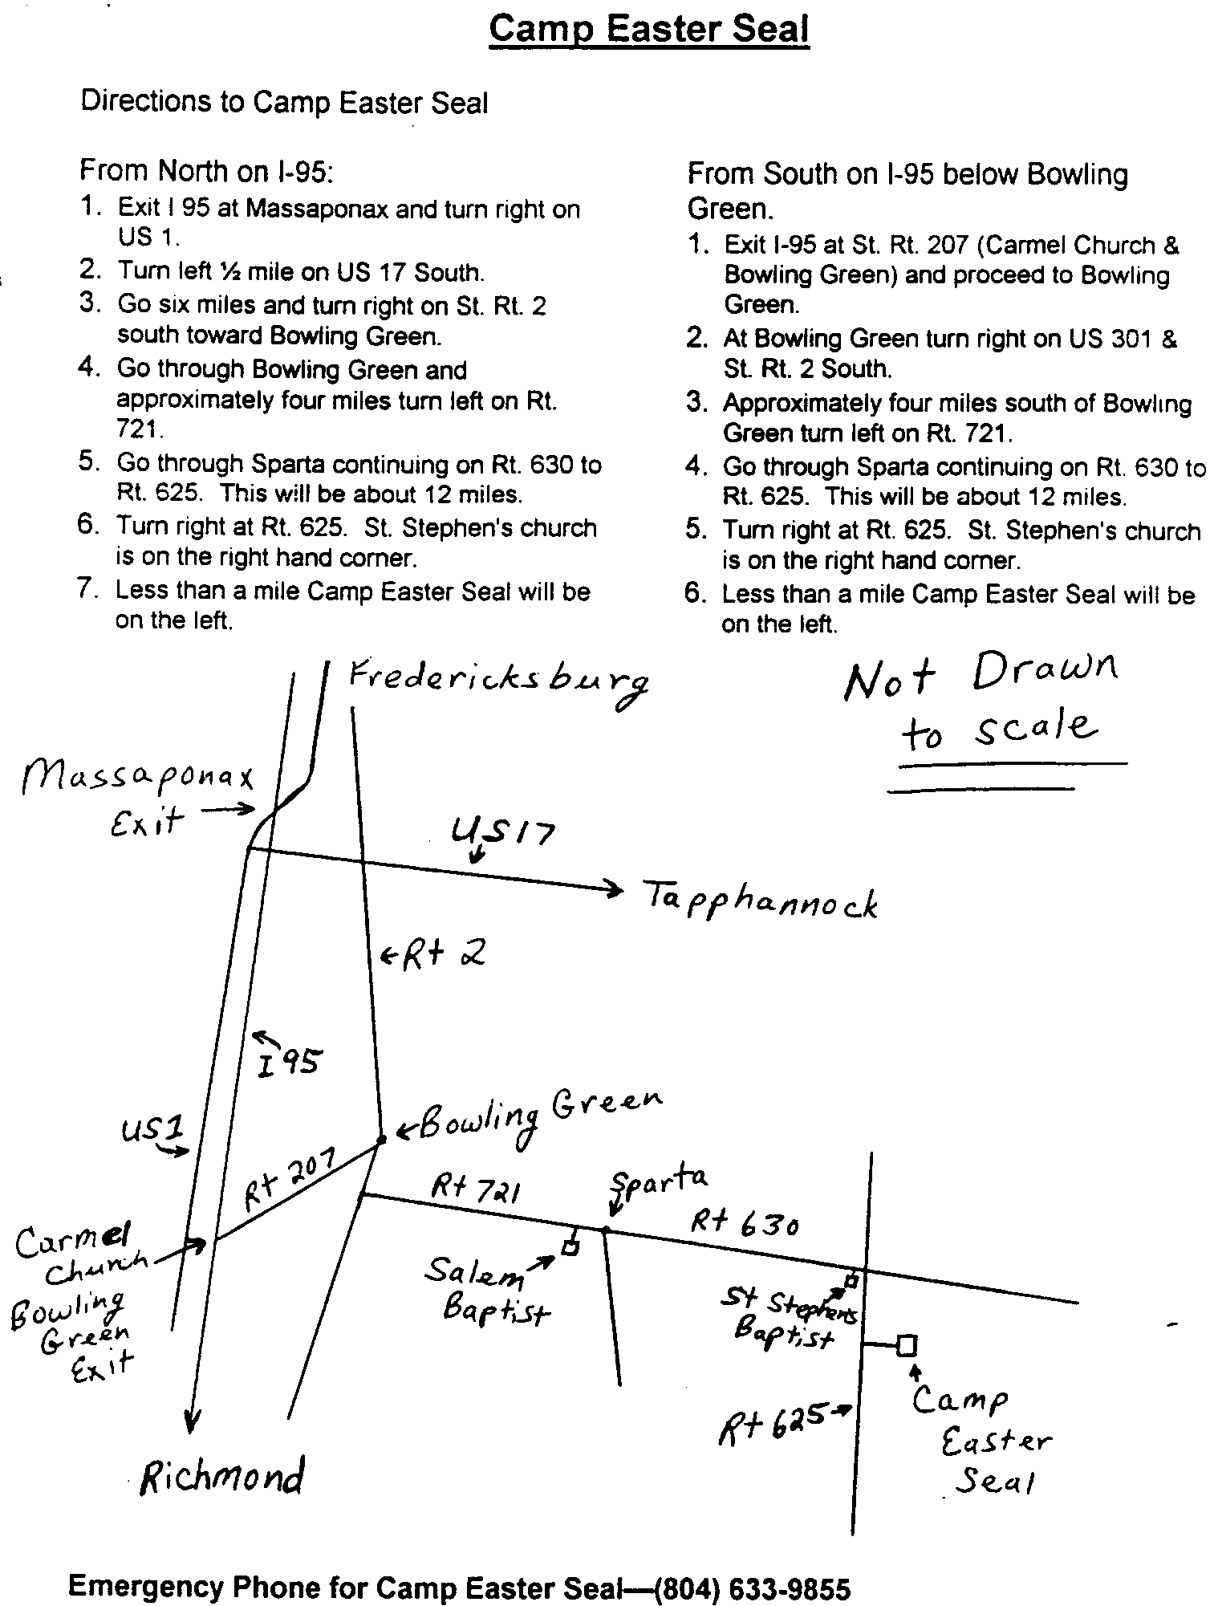

FREDERICKSBURG EMMAUS #39
“Woman, Behold”
Team Assignments

Millie Brock Table Leader Changing Our World Sun., 8:50 am
Debbie Clark Asst Table Leader Growth Through Study Sat., 8:55 am
Bill Clayton Spiritual Director Obstacles to Grace Sat., 4:00 pm
Debbie Devine Agape Coordinator
Lucy Harrell Asst Table Leader
Stanley Harrell Spiritual Director Sanctifying Grace Sun., 10:00 am
Annette Hemming Asst Table Leader Priesthood Fri., 1:30 pm
Vonnie Hinkle Lay Director Perseverance Sun., 1:05 pm
Mona Lamb Table Leader
Barbara Larson Asst Lay Director Fourth Day Sun., 2:45 pm
Vic Larson Cha Coordinator
Jody Lewandowski Table Leader Christian Action Sat., 2:35 pm
Kitti Mann Asst Lay Director Priorities Fri., 9:15 am
Debbie McKeen Music Director Reading
Betty Moses Table Leader Discipleship Sat., 8:00 pm
Mo Moses Cha Coordinator
Kathy Neiswander Music Team Reading
Barbara Olds Asst Lay Director Life in Piety Fri., 7:30 pm
Joan Parnell Table Leader
Dianne Philipp Table Leader
Michelle Philipp Asst Table Leader
Holly Plucker Music Team Reading
Trina Roark Asst Agape Coordinator
Barbara Simpson Asst Table Leader
Gary Staddan Spiritual Director Justifying Grace Fri., 3:00 pm
Wayne Warren Lead Spiritual Director Prevenient Grace Fri., 11"15 am
Means of Grace Sat., 10:15 am
Janice Williams Asst Table Leader Body of Christ Sun., 11:10 am

The Team Chapel is open to the Community during the various talks. Each speaker will have a team member in the chapel as their prayer partner. A speaker’s grouping members, family or others who have attended a weekend are invited and welcomed to be a part of this special time. Chapel Prayer Partners should be discreet in arriving and departing from Camp Easter Seal and should be in the prayer chapel 30 minutes prior to “Talk Time” listed above.

A Note from Angel. . .

Hi Community

If you offend one of these little ones its like...
Matthew 18:6
Owe no man any thing but to love one another...
Romans 13:8
O give thanks unto the Lord...
Psalm 107

Do you know these scriptures? What can they possibly have to do with having an intimate relationship with our Heavenly Father? How do they apply to you and I?

Last month I shared with you about how each of us are responsible for our relationships, for our actions as well as our reactions... About how we are a witness to many others. And about children born...

Yes, like children born of an intimate relationship between a man and woman; children are born into the kingdom of God through an intimate relationship with God. Our actions and reactions teach children more so than our words and that is why we each are encouraged and are to encourage others to get into the Word for themselves, not just preach at someone.

God loves you so much he gave you a way to him, and a way for others also but the invitation must be given. He loves us with an everlasting and unconditional love and draws us with His loving kindness. He corrects us because He loves us and we choose how we react. Others see and learn how to react. How do we treat the children? How do we treat children coming into the kingdom? Do we offend even one...

If we are walking in a place of Worship with the Father, love will flow from us naturally. The truth will spew from our lips because out of the abundance of the heart the mouth speaks. Let us love one another (not just those who love us) for love is of God and everyone who loves knows God. He who does not love, knows not God. (1 John 4:7,8) Ahhhh, thus we are to owe no man anything but to love one another.

Sometimes in our intimate relationship with God, as well as with people, we get too comfortable. We forget, or set on the back burner of our minds, our first love. We neglect to be thankful for the little things because we get caught up in the abundance the growing relationship has brought with it. We get caught up in wanting to have as much as someone else has. We want the best, better than... we forget that love bears all... we forget that forgiveness is a great thing, both ways... we think we have matured above the small and simple things of life but I ask you, are the simple things still there in your life? When was the last time you thanked Him for the roof over your head, the food on your table, the electric that gives supply; and the greatest of all, when was the last time you thanked Him for love? Through many tears, I thank Him today. O give thanks unto the Lord!
Happy Thanksgiving!

Love in Jesus,
Angel
New Emmaus Community
Day of Deeper Understanding

A Day of Deeper Understanding will be held on Saturday, November 18, 2000 beginning at 4:30 p.m., at Hillcrest UMC. Sponsors and their Pilgrims who have walked and not yet attended a DDU are encouraged to attend. Please remember that you cannot sponsor a Pilgrim or Team if you have not attended a Day of Deeper Understanding.

A pot luck supper will be held after the DDU (before the Gathering). Please bring a dish to share. Don’t miss this time of fellowship!
==============
There is an Emmaus Community forming in Southern Maryland! A Steering Committee is in place, and Gatherings are being held on the 3rd Saturday of each month, starting at 7:30 PM. On November 18th, the Gathering will be at Clinton UMC in Clinton. Please contact Kathy Massaro, (410) 257-1953 or EMKM@chesapeake.net, for more information.
DEADLINE for the December newsletter is November 18. Please send your articles to editor, Barbara Olds. Mail to 343 Longwood Drive, Stafford, VA 22554; fax to 540-286-2663; or e-mail to dolds@erols.com. For the timely delivery of our newsletter, it is important to get those articles in on time!

The Treasurer’s Report. . .
Peace and blessings to you in the name of our risen Lord, Jesus the Christ!

This fiscal year the Board has attempted to implement a budget process to help us be good stewards of the funds and responsibilities God has entrusted to us through the Fredericksburg Emmaus Community. Prayerfully, this first year of budgeting will be a base line for future budgets and budget process will be refined as the year progresses. Quarterly reports will continue to be published in the Newsletter.

We ask that each of you pray regarding your giving to the Emmaus Community. Since the income for the walks just covers the expenses of the walks, the day to day operating expenses for the community come from the offerings at the Gatherings, Sponsor Hours, and Candlelight services. A crunch of the “numbers” tells us that if 100 people attend a Gathering and each gives $7.50, then the “budgeted” income for the Gathering will be met. But we all know that numbers mean nothing when we serve a mighty God who meets all our needs.

While we are first called to support our home churches and ministries, Emmaus is a valuable tool to build up our churches and ministries. We are all called to be instruments in this ministry — how are you called in giving? Please pray about this. And pray for the your Board as we strive to be good stewards of the responsibility entrusted to us.

Love in Christ,

Vonnie Hinkle

Upper Room Emmaus of the Greater Fredericksburg Area
Budget Report
July through September 2000
$Over % of
Jul-Sept Budget Budget Budget
------------ ------------ ------------- ---------
INCOME

Gathering $852.50 $2,235.00 -$1,385.50 38.1%
Pilgrim Fees $100.00
Pilgrim Registration $645.00
Team Registration $3,275.00
Miscellaneous Income $96.00
====== ====== ====== ======
TOTAL INCOME $4968.50 $2,235.00 $2,733.50 222.3%

EXPENSES

Bank Charges $65.75
Childcare $160.00 $150.00 $10.00 106.70%
Chrysalis $335.20 $894.00 -$558.80 37.5%
Insurance $770.00 $770.00 0 100%
Miscellaneous $88.04 $104.00 -$15.96 84.7%
Music $156.00
Newsletter $929.13 $991.00 -$361.87 63.5%
Weekend Supplies $90.84
Capital Expenses $1,030.55
====== ====== ====== ======
TOTAL EXPENSES $3,325.51 $2,909.00 $416.51 114.3%

NET INCOME $1,642.99 -$674.00 $2,316.99 -243.8%

Newsletter Mailing

LAST CHANCE!!! Your subscription to the Fredericksburg Emmaus Newsletter will expire after this month!

If you wish to continue receiving the monthly newsletter, please complete this form and return to the address listed below.

If you would like to make a donation to help defray the publishing costs of the newsletter, please make your check payable to Fredericksburg Emmaus. The cost to publish and mail the newsletter each month is approximately $350.

Thank you.

~~~~~~~~~~~~~~~~~~~~~~~~~~~~~~~
Newsletter Acknowledgment

YES! I wish to continue receiving the Fredericksburg Emmaus Newsletter. Please keep my name on the mailing list.

Name:__________________________________________________________

Address:________________________________________________________

City,State,Zip:____________________________________________________

Please return the form to:
Fredericksburg Emmaus
c/o Barbara J. Olds

343 Longwood Drive
Stafford, VA 22554

Please disregard if you have already responded.

