
The Upper Room
Emmaus

February 2001 | of the Greater Fredericksburg Area

From the Lay Director . . .

De Colores, your Community Lay Director greets you in the name of Our Risen Savior, Jesus Christ. I pray that this letter finds you well and searching for a closer relationship with our Lord.

It has been a busy year already with one Chrysalis Flight giving praise and glory to the Lord. Fourteen young men now find their walk with Christ Jesus closer that ever before. It was with the out pouring of love that makes it all happen. All the food agape that was given, the letters and cards to each caterpillar. It all has a special time and place in the weekend. But remember it takes a lot more food to feed those teenagers.

I remember on my weekend how that out pouring of love and how it effected me. How when I read how God loved me, yes me just the way I was, how it turned my cold heart into a warm loving heart, it was just awesome. That out pouring of love just kept coming.

Well since then, back on thirteen, we as a community have started following the model that is set forth by The Upper Room Emmaus on Nashville, Tenn., and added the personal agape on Sunday afternoon for the pilgrims. This is special letters from family and loved ones to help bring the pilgrims back into the world they have been able to leave for three days.

As I have participated in many walks I would like to offer some reminders about agape. Agape is for everyone on the weekend, pilgrims and team. Agape is given on Friday afternoon, Friday night bed, and Saturday night bed for team and pilgrims and Sunday afternoon for pilgrims only. Sunday is for that special personal agape and should be marked personal and from whom, i.e. mom, dad, daughter, son, brother, sister, or friend.

All pilgrims should receive the same thing. If you make something for one pilgrim you should make one for all the pilgrims. This creates an atmosphere of all are being loved equal, Just like Jesus did. If you have full sheets fold them so it is easer to put in the agape bag. If you make something that can tangle easily together, then separate it and put it an envelope so it can be sorted easily. If you put pilgrims names on each item make sure they are in alphabetical order and separate pilgrims and team This speeds up the process of sorting by the team and Chas with less chance of it getting to the wrong person.

If you have presents for a pilgrim these should be given on the way home or at a latter time. Unless you have one for everyone.

As you prepare your agape, pray for the team and pilgrims. Pray that God will guide the team’s heart to do His will on the weekend and be available for the pilgrims that God put them there for. Pray for the pilgrims that God will prepare them to receive the message of the weekend and grow closer to Him. Pray continuously for each other that God’s work and will may be done through us all.

“Now may the Lord of peace himself give you peace at all times in all ways… The grace of our Lord Jesus Christ be with all of you.” 2 Thess. 16a, 18.

In Christ’s army we stand.

De Colores

Ken Roark
Wright’s Chapel UMC
F’burg Emmaus #13, Table of Paul

The Next Fredericksburg

Gathering

When: February 17, 2001

Where: Chancellor Christian Church

Time: 7:00 p.m.

Fellowship at 6:00 p.m. The board will meet at 4:00 p.m.

Men’s March 8 - 11
WLD: David Olds

October 4 - 7 WLD: Dennis Perkins

Women’s April 19 - 22
WLD: Barbara Olds

May 3 -6
WLD: Barbara Larson

November 15 - 18
WLD: Christine Schroth

2001 Weekends

March 17, 2001 Lake of the Woods
April 14, 2001 Lake of the Woods
Upcoming Gatherings

Emmaus Volunteer Chairpersons 2000-2001

Community Lay Director - Ken Roark
Lead Gatherings & Candlelight
Host Weekend Sponsors’ Hour & Closing
Chair Emmaus Board
Pilgrim/Team Selection Committee
Board Nominating Committee

Assistant Community Lay Director -Barbara Simpson

Community Spiritual Director - Mark Dunn
Gathering Location Coordinator

Treasurer - Vonnie Hinkle

Secretary - Betty Moses
Manuals Coordinator - Barbara Larson
Records & By-Laws Historian -

Communications Coordinator - Hank McCaslin
Newsletter - Barbara Olds
Database Coordinator - Barbara Olds
Team Registrar - Debrina McKeen

Pilgrim Registrar - Christine Schroth

Gathering Support Coordinator - Barbara Simpson
Community Music Director - Debrina McKeen
Community Baker -
Childcare Coordinator & Greeter - Bob Davis
Facility Clean Up Coordinator -

Weekend Support Coordinator - Brian Lewis
Community Cha Coordinator - Richard Warner
General Agape Coordinator - Phyllis Howze
Prayer Vigil Coordinator - Sandy Crossley & Jane Carwell
Placemat Coordinator - Sharon Smith
Snack Agape Coordinator - Janice Williams
Agape Bag Coordinator - Diana Farrar
Transportation Coordinator - Kris Indseth
Supplies Coordinator - Derek Sharp
Fourth Day Packets - Tina Cooper

Fourth Day Coordinator - Joe Reed
Reunion Group Coordinator -
Emmaus “Store” Coordinator - Millie Brock

Nominating Committee Coordinator - Larry Tubbs

Reunion Groups . . .

We would like to list the Reunion Groups active in the Fredericksburg Emmaus Community. If you are a member of a reunion group, please send the information to Barbara Olds. Please provide the name, meeting time, place, and contact with phone number.

Great Is Thy Faithfulness Emmaus Reunion Group
Meets 7:30 PM Tuesdays
Prince Of Peace United Methodist Church
6299 Token Forest Drive
Manassas, Virginia
Contact: Lloyd Biller (703) 590-1512

Pastor's Weekly Meeting
Meets 9:00 AM Thursdays
Rotates - call for location
Contact: Mark Dunn (540) 786-4025

Lakeside Reunion Group (Men)
Meets 8:00 PM Tuesdays
Lake Of The Woods - call for location
Contact : Vic Larson (540) 972-1928

Rainbow Reunion Group (Women)
Meets 2:30 PM Tuesdays
Lake Of The Woods - call for location
Contact : Barbara Miller (540) 972-7418

“Amazing Grace” Reunion Group
Meets 8:15 PM Thursdays
Chancellor Christian Church
Contact : Joe Cooper (540) 710-6268
e-mail to jtjh4givn@juno.com

Son Rise Reunion Group
Meets 7:15 AM. Thursdays
Melrose United Methodist
Contact: Ruth Ash (804) 529-6448 or
Patsy Bayse (804) 529-6101

(Men)
Meets 7:30 PM Tuesdays
Bethel United Methodist Church
Contact: Brian Lewis (703) 590-9343
e-mail to bb3253@AOL.com

Koinonia Women’s Reunion Group
Meets 9:00 AM Fridays
Lake of the Woods - call for location
Contact: Barbara Larson (540) 972-1928

Monday's Makeovers Reunion Group
Meets 8:00 PM Mondays
Denny's Restaurant in Dale City
Dale Blvd. & I-95
Contact: Lois Myrick 703-680-0577 or
Sandy Crossley 703-221-6977

God Bearers
Meets 8:00 AM Sundays
Melrose United Methodist Church
Contact: Laurie Basye (804) 529-6953 or 580-5135
e-mail basye@crosslink.net
Alice Harding (804) 529-7854
e-mail archardcl@pen.k12.va.us

Wilderness Reunion Group
Meets 5:00 PM Thursdays
Ukrops upper room - Fredericksburg
Contact: Patti Tessier (540-786-4721)
e-mail to pattitessier@aol.com
DEADLINE for the March newsletter is February 17. Please send your articles to editor, Barbara Olds. Mail to 343 Longwood Drive, Stafford, VA 22554; fax to 540-286-2663; or e-mail to dolds@erols.com. For the timely delivery of our newsletter, it is important to get those articles in on time!

Success

The road to success is Not straight...
There is a curve called failure...
Speed bumps called friends...
Red lights called enemies...
Caution lights called family...
You will have flats called jobs BUT...
If you have a spare called determination...
An engine called perseverance...
Insurance called FAITH...
A driver called Jesus...

You will make it to a place called Success.

Prayers & Praises. . .


_ Pray for Barbara Simpson - surgery
_ Culpeper Epiphany #1
_ Prayers for family
_ Pray for Diane Howard - surgery
_ Chrysalis #7
_ For son, Ken - kidney problem
_ Praise - marriage reconciliation
_ Prayers for upcoming legal problem
_ For Tracy Mann - health concerns
_ Prayers for Fran Dulay - severe pain from compression
of spine
_ Praise God for hearts wanting to seek the truth and be
committed to it; it will set us free
_ Pray for Lucille Johnson - very ill and praying to die
_ Pray for teams for Emmaus 40, 41 & 42
_ For James - Fungus in lungs and kidney transplant
_ Praise God for the hunger for Him that He is making
manifest at Hillcrest UMC!
_ Pray for Steve Carter - does not know the Lord
_ Pray for David Tynes and praise God that his hearing
appeared to have gone so well
_ Sheets Family - pray for loss of husband and father-in-law
_ Prayers for Kelly Hemphill with health problems
_ Pray for new opportunities
_ Praises for our family closeness
_ Safe travel for Mo & Betty Moses
_ Children & choices they make
_ Pray for our church while we search for a new secretary
_ Pray for the new president of this nation
_ Prayers for doors closed; for doors opened
_ Praise God for the dentist I went to see
_ Prayer for Alonzo whose wife & child are coming from
Columbia; need papers & money to get them here
_ Pray for daughter preparing for pending divorce
_ Prayers for healing for friend going through tests
_ Pray for Marine Barracks, Washington, DC, that God
would destroy the strongholds there
_ Prayers for Doug Fairbanks for health concerns
_ Praise for my life which is coming together very well
_ Prayers for my family and our country
_ Prayers for grandchildren, daughter & daughter-in-law
_ Prayers for decision to team on upcoming walks
_ Prayers for nephew, Chad Mahoney, who has to have the
bullet removed after all
_ Pray for family and financial situation
_ Praise God for healing our grandbaby and continued
healing prayers for those who have flu
_ Pray for Mary Louise Jordy - has ruptured disc and
fractured ankle
_ Prayers for sister Betty with her illness and her sister’s
health
_ Praise God for dedication of men on E40. Pray for them
in their preparation for the weekend
_ Prayers for son who is an alcoholic
_ Pray for Marin, niece with stomach ulcer
_ Prayer for Julius Schiller - brain surgery and loss of
mother
_ Praise for Chrysalis Boys’ Flight

SEW AGAPE BAGS for future Emmaus walks. Or you can help out by donating bright rainbow colored fabric or cording or brightly colored shoelaces. Call Diana Farrar 540-372-7535 or e-mail farrardiana@juno.com to say you'll help!


Placemats are needed for E-40, E-41 and E-42. If you would be interested in coloring placemats, please call or e-mail us. Shane and Sharon Smith 540-891-6304 or donaldsmith@erols.com


FREDERICKSBURG EMMAUS
BOARD OF DIRECTORS

Roark, Ken - Lay Director
Simpson, Barbara - Asst. Lay Director
Moses, Betty - Secretary
Hinkle, Vonnie - Treasurer
Dunn, Mark - Spiritual Director

DeJong, John Reed, Joe
Lewis, Brian Schroth, Christine
McCaslin, Hank Tubbs, Larry
Warren, Wayne
Prewitt, Paul Weinhardt, Pat

Fredericksburg Web Site
www.fredericksburgemmaus.org

FREDERICKSBURG EMMAUS #40
“The One enthroned in the Heavens Laughs”
Team Assignments

Mike Chaney Table Leader Discipleship Sat., 8:00 pm
Thom Chittenden Music Team Readings
Donnie Cross Asst Cha Coordinator Readings
Robert Fulkerson Music Director Readings
Malcolm Graham Agape Coordinator Readings
Jason Gregory Asst Table Leader Readings
Bob Hemming Table Leader DDU Talk
Mike Iden Asst Lay Director Fourth Day Sun., 2:45 pm
Vic Larson Asst Lay Director Priorities Fri., 9:15 am
Anthony Lutchman Asst Table Leader Readings
John Mann Asst Table Leader Life in Piety Fri., 7:30 pm
John Mathis Spiritual Advisor Prevenient Grace Fri., 11"15 am
Obstacles to Grace Sat., 4:00 pm
Mac McClafferty Table Leader Christian Action Sat., 2:35 pm
Joe Neiswander Music Team Readings
David Olds Lay Director Perseverance Sun., 1:05 pm
Dennis Perkins Table Leader Readings
Gene Philipp Asst Lay Director Growth Through Study Sat., 8:55 am
Paul Prewitt Asst Table Leader Body of Christ Sun., 11:10 am
Joe Reed Asst Table Leader Changing Our World Sun., 8:50 am
Pete Schatz Asst Table Leader Readings
Derek Sharp Cha Coordinator
Mike Shiflett Floater Readings
Shane Smith Table Leader Readings
DDU Talk
Gary Staddan Spiritual Advisor Justifying Grace Fri., 3:00 pm
Means of Grace Sat., 10:15 am
Sanctifying Grace Sun., 10:00 am
Dennis Warne Table Leader Priesthood Fri., 1:30 pm

The Team Chapel is open to the Community during the various talks. Each speaker will have a team member in the chapel as their prayer partner. A speaker’s grouping members, family or others who have attended a weekend are invited and welcomed to be a part of this special time. Chapel Prayer Partners should be discreet in arriving and departing from Camp Easter Seal and should be in the prayer chapel 30 minutes prior to “Talk Time” listed above.

FREDERICKSBURG EMMAUS #40
“The One enthroned in the Heavens Laughs”
Pilgrims

Ralph Adams Hillcrest UMC
Ron Black Calvary UMC
Ron Blankenship Calvary UMC
Charles Burnett Powhatan UMC
Keith Clark Wilderness Community
Jack Clevenger Spotsylvania Presbyterian
Tim Corner Lake of the Woods Church
Rob Dickinson Hope First Church of God
Keegan Flaugh Woodbridge Christian
Elliott Fox Mt Zion UMC
Bryan Freeman Hillcrest UMC
Poncho Honaker Hope First Church of God
Steve Hughes Ashburn UMC
Tim Jarman Spotsylvania Assembly of God
Vince Klug Lake of the Woods Church
Andy Korbel First Christian Church
Russ Martin Lexington Park UMC
Jimmy Mills Fredericksburg UMC
Mike Remington First Christian Church
Randy Ross Lake of the Woods Church
John Russi First Christian Church
John Shutlock Spotsylvania Presbyterian
Denny Smith Fairview Baptist
Robert Ssajjabi Mt. Olives, UGANDA
John Stevens Fletchers Chapel UMC
Paul Stockman Lakeside UMC
Mark Teasdale First UMC
Alonso Valencia Spotsylvania Assembly of God
Steve Webster Fredericksburg UMC
John Wright Dahlgren UMC
Shane Young Rockhill Baptist

As of Jan 26, 2001
Schedule - Chrysalis #7 - February 8 - 11, 2001

The team for Fredericksburg Boys’ Flight #6 invites sponsors, families and community participation in the following events:

WHEN WHERE WHAT
Thurs., Feb 8 6:30 P.M. Camp Easter Seal Pilgrim check-in/Fellowship followed by Sponsor’s Hour

Sat., Feb 10 7:45 P.M. Camp Easter Seal Candlelight - Please bring flowers for the team to use Sunday morning!!! Community will gather for Praise, Fellowship and Communion.

Sun., Feb 11 3:30 P.M. Camp Easter Seal Closing - Gather at 3:30 for Closing Service at 4:00 P.M. Closing will be held in the gym.

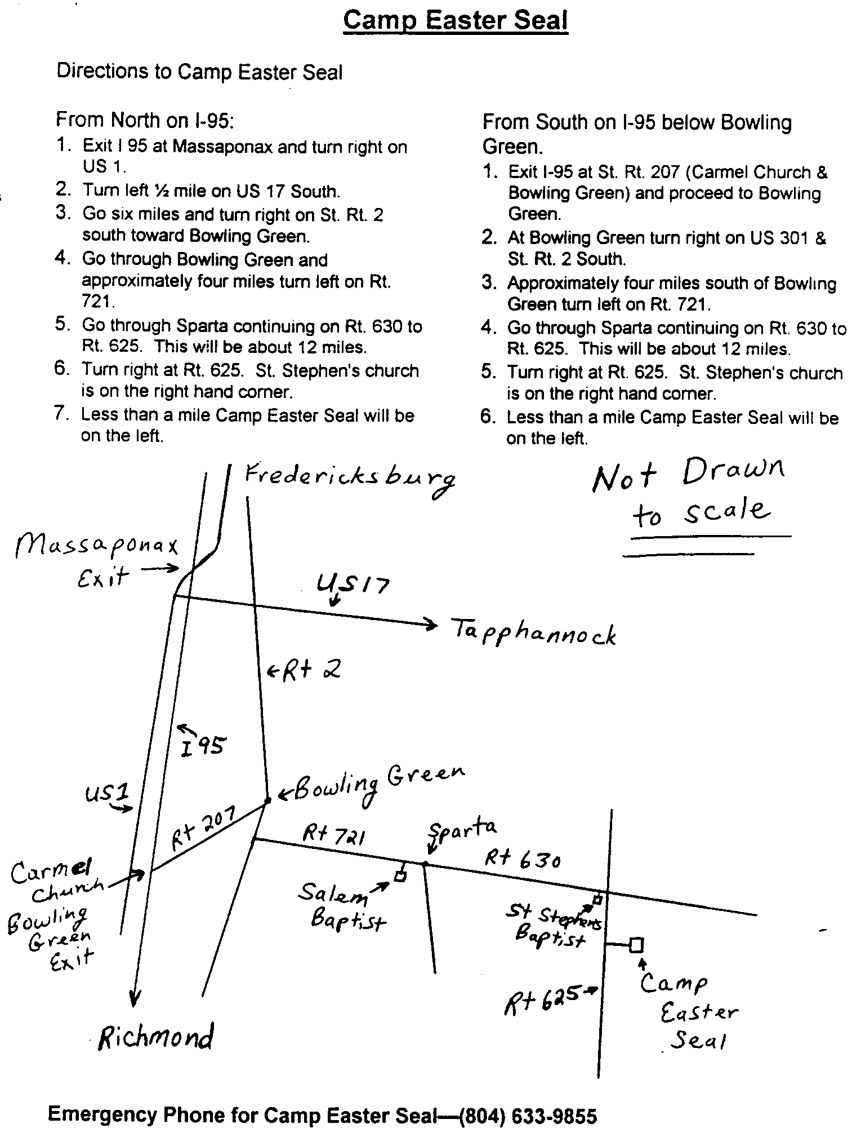

Upper Room Emmaus of the
NON-PROFIT ORG.
U.S. POSTAGE PAID
FREDERICKSBURG, VIRGINIA
PERMIT NO. 347
Greater Fredericksburg Area
PO Box 42094
Fredericksburg, VA 22404


