
The Upper Room
Emmaus

May 2001 | of the Greater Fredericksburg Area

From the Lay Director . . .

Greetings in the name of our Risen Savior Jesus Christ. Easter has come and gone, but the joy and reward still goes on. Jesus Christ died for us on the cross so we would not have to bear our sins. He loves us so much that he was willing to take on our sins even before we commit them. But it seems that we just continue to sin and we keep driving those nails and nailing him back to the cross.

There was a young man whose anger always was getting him into trouble. He would at a drop of hat get mad and cause trouble. Sometimes he would fight and sometimes it was just verbal abuse. But he always was causing pain.

He went to his father and ask him if he knew a way to control his anger. The family lived on a farm and they had a lot of wooden fences. The farther told his son that every time he got anger and wanted to hurt someone to go down to the fence and nail a nail in it. Well the boy did it. At first the boy was down at that fence nailing nails left and right. It seemed he was down there every hour with hammer and nails. There were hundreds and hundreds of nails in that fence. Then one day the boy realized that he was not going down to the fence as very often.

He went back to his father and told how great it was working. The father then told him that was great now every time he was good, did not get angry or helped someone, to go and pull out one of those nails. After a few weeks went by the father ask the soon how he was doing. The son said that a lot of the nails were gone and his anger was under control.

The father ask the son what he had learned. The son look at the fence with all the nail holes in it. He told his father that the wood would never be the same that once a nail went in it left a hole and there were a lot of holes. The father told his son that was right. The nail that you were nailing is just like sin and we hurt someone. Even though the hurt heals there well always be a hole left were the sin was. That hole is what continues to hurt people even after we get over the pain.

Jesus Christ is our healer. Every time we sin He takes that nail and that sin and forgives us. As he forgives us it leaves a hole we must replace the hole with something, that something is Jesus Christ. In Luke 11:24-26 Jesus tells us, “²⁴When an evil spirit comes out of a man, it goes through arid places seeking rest and does not find it. Then it says, ‘I will return to the house I left.’ ²⁵When it arrives, it finds the house swept clean and put in order. ²⁶Then it goes and takes seven other spirits more wicked than itself, and they go in and live there. And the final condition of that man is worse than the first.” We must not leave our hearts empty once they have cleansed them. We must put the love and passion of Jesus in our hearts so evil does not return. We must fill those nail holes with Jesus Christ.

Like the boy nailing the nails, are we putting more holes in our savior? Are we continuing to nail him to the cross? Are you ready to let him reside in your heart and surrender so those evil spirits will have no home?

May our Risen Lord bring peace to your hearts and take residence there. Peace my brothers and sisters in Christ.

De Colores
Ken Roark
Wright’s Chapel UMC
F’burg Emmaus #13, Table of Paul

The Next Fredericksburg

Gathering

When: May 12, 2001

Where: First Christian Church

Time: 7:00 p.m.

Fellowship at 6:00 p.m. The board will meet at 4:00 p.m.

FREDERICKSBURG EMMAUS
BOARD OF DIRECTORS

Roark, Ken - Lay Director
Simpson, Barbara - Asst. Lay Director
Moses, Betty - Secretary
Hinkle, Vonnie - Treasurer
Dunn, Mark - Spiritual Director

DeJong, John Reed, Joe
Lewis, Brian Schroth, Christine
McCaslin, Hank Tubbs, Larry
Warren, Wayne
Prewitt, Paul Weinhardt, Pat

Upcoming Gatherings

June 9, 2001 First Christian Church
July 14, 2001 Fredericksburg UMC
August 11, 2001 Fredericksburg UMC
September 8, 2001 Wright’s Chapel UMC
October 13, 2001 Wright’s Chapel UMC
November 10, 2001 Chancellor Christian
December 8, 2001 Chancellor Christian
2001 Weekends

Men’s October 4 - 7
WLD: Dennis Perkins

Women’s May 3 -6
WLD: Barbara Larson

November 15 - 18
WLD: Christine Schroth

SEW AGAPE BAGS for future Emmaus walks. Or you can help out by donating bright rainbow colored fabric or cording or brightly colored shoelaces. Call Diana Farrar 540-372-7535 or e-mail farrardiana@juno.com to say you'll help!


Placemats are needed for E-42. If you would be interested in coloring placemats, please call or e-mail us. Shane and Sharon Smith 540-891-6304 or donaldsmith@erols.com


DEADLINE for the June newsletter is May 19. Please send your articles to editor, Barbara Olds. Mail to 343 Longwood Drive, Stafford, VA 22554; fax to 540-286-2663; or e-mail to roosterlover@erols.com. For the timely delivery of our newsletter, it is important to get those articles in on time!

Chrysalis
Corner

Chrysalis Hoot May 12th!!

The next Hoot will be held at First Christian Church (on historic Washington Avenue) in Fredericksburg. The Hoot will take place at the same time as the gathering.

Get your team applications in!! The Chrysalis Steering Committee has decided to have two flights in late summer (dates to be announced). Our weekend lay directors will be Renee Palm and Derek Sharp.

Thank you to everyone who has done a talk or devotion at our Hoots. If you would like to do a Next Steps talk or devotion, call Kitti Mann or Keith Boyette and let them know.

Chrysalis will be sponsoring a car wash on May 19th from 10 a.m. to 5 p.m. at the WalMart on Route 3 in Fredericksburg. This is important because it will go toward scholarships for those caterpillars whose sponsors cannot financially afford the cost but feel God is calling them to send youth. We don’t want money to be an issue!
SEE YOU THERE!!

The teaming process will begin very soon. This is a long process that takes about six to eight weeks to complete. The only requirements are that you attended an Emmaus or Chrysalis weekend and attended a Day of Deeper Understanding. If you feel God is calling you in this direction, then get an application completed and turn it in as quickly as possible.

If you would like to serve on the Chrysalis board, our next meeting will be held at Fredericksburg United Methodist Church on May 7th at 7:00 p.m.

Fly With Christ!

Reunion Groups . . .

We would like to list the Reunion Groups active in the Fredericksburg Emmaus Community. If you are a member of a reunion group, please send the information to Barbara Olds. Please provide the name, meeting time, place, and contact with phone number.

Great Is Thy Faithfulness Emmaus Reunion Group
Meets 7:30 PM Tuesdays
Prince Of Peace United Methodist Church
6299 Token Forest Drive
Manassas, Virginia
Contact: Lloyd Biller (703) 590-1512

Pastor's Weekly Meeting
Meets 9:00 AM Thursdays
Rotates - call for location
Contact: Mark Dunn (540) 786-4025

Lakeside Reunion Group (Men)
Meets 8:00 PM Tuesdays
Lake Of The Woods - call for location
Contact : Vic Larson (540) 972-1928

Rainbow Reunion Group (Women)
Meets 2:30 PM Tuesdays
Lake Of The Woods - call for location
Contact : Barbara Miller (540) 972-7418

“Amazing Grace” Reunion Group
Meets 8:15 PM Thursdays
Chancellor Christian Church
Contact : Joe Cooper (540) 710-6268
e-mail to jtjh4givn@juno.com

Son Rise Reunion Group
Meets 7:15 AM. Thursdays
Melrose United Methodist
Contact: Ruth Ash (804) 529-6448 or
Patsy Bayse (804) 529-6101

(Men)
Meets 7:30 PM Tuesdays
Bethel United Methodist Church
Contact: Brian Lewis (703) 590-9343
e-mail to bb3253@AOL.com

Koinonia Women’s Reunion Group
Meets 9:00 AM Fridays
Lake of the Woods - call for location
Contact: Barbara Larson (540) 972-1928
Monday's Makeovers Reunion Group
Meets 8:00 PM Mondays
Denny's Restaurant in Dale City
Dale Blvd. & I-95
Contact: Lois Myrick 703-680-0577 or
Sandy Crossley 703-221-6977

God Bearers
Meets 8:00 AM Sundays
Melrose United Methodist Church
Contact: Laurie Basye (804) 529-6953 or 580-5135
e-mail basye@crosslink.net
Alice Harding (804) 529-7854
e-mail archardcl@pen.k12.va.us

Lord’s Lions and Lambs #1
Meets 12:30 PM Sundays
First Christian Church
Contact: Mike Shiflett (540) 371-5585

Lord’s Lions and Lambs #2
Meets 6:30 PM Wednesdays
First Christian Church
Contact: Gene Philipp (540) 898-4917

Thank you

Hello Community

God is indeed good all the time!
I wanted to take a moment to say a big thank you to everyone for being there with lots of love and service to the team and pilgrims of
Fredericksburg Emmaus 41. I especially want to thank the cha's whom without their servants hearts and their willingness to serve in love, I would have struggled terribly. Even those of you who might think that you didn't do much, YOU DID MUCHLY! I must say that I was extremely blessed! I praise God for each and every one of you and pray that He would give you each a special blessing this month. The team and pilgrims
were truly blessed and that is what the Body of Christ is all about, loving and blessing one another, amen! I saw Jesus this weekend in YOU!

De Colores

Love in Jesus,

Angel Fulkerson
Fredericksburg Emmaus 4

Dear Brothers and Sisters-in-Christ,
It was summertime in Virginia! I don't remember if it was June, July or August, but it was hot! It was real Hot! Dust from the dirt and gravel road stuck to my skin as an old tractor with a wooden box on the back, used to transport groceries and passengers, bounced along on its way home from the market. My sister Sandra and I had been playing in the dirt at the end of the driveway, building castles, roads, and bridges, pausing only to draw a bucket of water from the outdoor tap to create a lake or a moat. She was about six years old and I was about eight.
Summertime was always a wonderful time for my sister and I. It meant we didn't have to go to school and that was good enough for us. We would be up and dressed as soon as the first daylight danced into our bedrooms. The first one out of bed would wake the other. Soon we would walk softly through the kitchen past our parents bed room and slowly pry open the back door. We would quietly slip out into the morning dew with our bare feet and giggling as if we had played a trick on someone. We would usually head for the swings that our dad had built us out of pipe set in cement, chain, and boards. Soon, mom would call us in for a breakfast of eggs, bacon, toast, and home made grape jelly. We would run inside and devour the morning feast. "We're going back outside mom," we would shout, as the screen door slammed behind us. This scene played out again at lunch and dinner. We would stay outside ending our day outside catching lighting bugs in a mason jar with a hole punched in the top.
Sometimes our dad would bring home a watermelon that someone gave him as a bonus for repairing their car at his service station. As I think back today, I still can't believe that I would eat at least a fourth of the melon. Dad would slice it into long quarter sections. We would bury my our faces in that water melon. There was no time for salt, spoons, forks, or knives for us.
As I said, this day was hot. Mosquitoes coming from the creek, were biting through our clothes. The smell of burning chicken feathers and old tires, burnt by some people several blocks away to keep the mosquitoes and flies away, was overwhelming. Mom had already given us ice pops made from Kool-Aid. They melted and ran down our arms quicker than we could eat them.
Our mom's friend Alma, came over and asked if we wanted to drive over to the falls. We all piled into her old car and with windows rolled down, followed country roads until we reached the river bridge. She parked the car, and we walked down to the river crossing small streams and jumping from rock to rock.
We reached an area where water was swiftly flowing over huge rocks and then falling almost straight down on the other side. At one end of this beautiful creation of God, was a man made dam. It was more like a vertical wall a few feet wide and twelve feet long, that water had to climb up sharply to reach the top. The water was only about a foot deep as it flowed over the wall that day. For some crazy reason, we decided to wade cross that dam that day. Alma went first, my sister next, then our mom, and then me. We were linked together as we held hands. As I cautiously stepped into the water I noticed that my sister had slipped. I could feel slimy moss under my feet and I also slipped. Alma and mom also slipped as they held on to my sister and I. It seemed like hours went by as we struggled to stay on top of that watery trap. Somehow we all managed to reach safety. Our mom was the only one injured with a sprained arm.
It wasn't the joy filled time we all expected. We all went along, to take mom to the local doctor, waiting for x-rays to be taken, and thanking God for returning us home.
As I think back I remember how mom and her friend Alma never let go of us. They held on to us never giving up as they saved themselves in order to save us. Who held on to them? I wonder if they said a quick prayer at the time. Maybe the beaconed God by pleading, "God, please save us!" or "Lord, help us!" I don't remember a sound except the rushing water. In Psalm 121:5-8, The author, inspired by God wrote, The Lord watches over you - The Lord is your shade at your right hand; the sun will not harm you by day, nor the moon by night. The Lord will keep you from all harm - he will watch over your life; the Lord will watch over your coming and going both now and forevermore.
There is nothing like a mother's love when they are strengthened our Father God. May you travel back to your childhood to be reminded of the early lessons of God's love. Amen.
Dennis Perkins Fredericksburg Emmaus 11

Prayers & Praises. . .

_ Praise for abundant blessings
_ Prayers & Praises for Team of E-42
_ Prayer for health concerns
_ Praise God for His Love & Mercy!
_ Prayers for strength & guidance
_ Praise for healing done to Keith Clark
_ Pray for Kensley Rigsby - heart surgery
_ For salvation of Richard & Lisa Carwell
_ Prayer for friend with mother near death
_ Prayers for Rachel, 5-yr old struggling with cancer
_ Praise for a good report on a recent heart concern
_ Thanks for God’s “Easter gift” to us
_ Prayer for Debbie, just diagnosed with breast cancer
_ Prayer for ability to step out in faith to find a new job and
have new independence
_ Praise for lymph node surgery on our daughter-in-law
_ Prayer for salvation of our children & families
_ Pray for “right outworking” in my present situation
_ Pray that our wills would be submitted to HIS in all things
_ Praise to God that a loved one with a drug problem is
seeking help. Prayer that God will continue to give him
the strength to persevere!
_ Pray for my son Brian and fellow youth who are being
confirmed Easter Sunday as they commit to Jesus Christ
_ Prayer for college students taking exams & returning home
_ Prayers for the upcoming birth of a grandchild
_ Praise God for He is awesome, in control, and works all
things together for the good, for those who love Him
_ Prayer that my husband will walk in the Fall
_ Praise God for our son’s upcoming wedding & the wonderful
girl in his life
_ Pray for our church, Shepherds UMC, that God is doing
His work there. Pray He will continue to bless the people
_ Prayers for Hannah, a 1-yr old with cancer
_ Praise for the birth of Sophie, our granddaughter
_ Prayer for family members - for their growth, committed
walk and relationship with Jesus Christ
_ Praise Report! I’m continuing to thank and praise the Lord
for having a friend of mine from church come by for a
visit. While he was visiting, he led my 84-yr old mother
to the Lord. Thank God for answered prayer!

Emmaus Volunteer Chairpersons 2000-2001

Community Lay Director - Ken Roark
Lead Gatherings & Candlelight
Host Weekend Sponsors’ Hour & Closing
Chair Emmaus Board
Pilgrim/Team Selection Committee
Board Nominating Committee

Assistant Community Lay Director -Barbara Simpson

Community Spiritual Director - Mark Dunn
Gathering Location Coordinator

Treasurer - Vonnie Hinkle

Secretary - Betty Moses
Manuals Coordinator - Barbara Larson
Records & By-Laws Historian -

Communications Coordinator - Hank McCaslin
Newsletter - Barbara Olds
Database Coordinator - Barbara Olds
Team Registrar - Debrina McKeen

Pilgrim Registrar - Christine Schroth

Gathering Support Coordinator - Barbara Simpson
Community Music Director - Debrina McKeen
Community Baker -
Childcare Coordinator & Greeter - Bob Davis
Facility Clean Up Coordinator -

Weekend Support Coordinator - Brian Lewis
Community Cha Coordinator - Richard Warner
General Agape Coordinator - Phyllis Howze
Prayer Vigil Coordinator - Sandy Crossley & Jane Carwell
Placemat Coordinator - Sharon Smith
Snack Agape Coordinator - Janice Williams
Agape Bag Coordinator - Diana Farrar
Transportation Coordinator - Kris Indseth
Supplies Coordinator - Derek Sharp
Fourth Day Packets - Tina Cooper

Fourth Day Coordinator - Joe Reed
Reunion Group Coordinator -
Emmaus “Store” Coordinator - Millie Brock

Nominating Committee Coordinator - Larry Tubbs

FREDERICKSBURG EMMAUS #42
“Draw Near to God, and He will Draw Near to You”
Team Assignments

Bill Clayton Spiritual Director Obstacles to Grace Sat., 4:00 pm
Terry Cook Asst Table Leader
Theresa Davis Asst Lay Director Priorities Fri., 9:15 am
Peter Fertig Asst Cha Coordinator
Rita Fertig Asst Table Leader
Maria Fortune Table Leader Discipleship Sat., 8:00 pm
Lucy Harrell Table Leader Growth Through Study Sat., 8:55 am
Stanley Harrell Spiritual Director Means of Grace Sat., 10:15 am
Sanctifying Grace Sun., 10:00 am
Vonnie Hinkle Agape Coordinator
Barbara Larson Lay Director Perseverance Sun., 1:05 pm
Victor Larson Cha Coordinator
Sara Martin Asst Table Leader Body of Christ Sun., 11:10 am
Betty Moses Asst Agape Coordinator
Joan Parnell Table Leader Reading
Susan Perkins Asst Lay Director Life in Piety Fri., 7:30 pm
Dianne Philipp Table Leader Changing Our World Sun., 8:50 am
Brenda Pusso Asst Table Leader Reading
Trina Roark Asst Lay Director Priesthood Fri., 1:30 pm
Tom Schafer Spiritual Director Prevenient Grace Fri., 11:15 am
Ellen Schertz Table Leader Fourth Day Sun., 2:45 pm
Christine Schroth Board Representative Sponsorship Talk @ DDU
Judy Staddan Asst Table Leader Reading
Anne Tavenner Table Leader Christian Action Sat., 2:35 pm
Betty Gray Thompson Music Director
Rosemary Welch Spiritual Director Justifying Grace Fri., 3:00 pm
Lora Wood Asst Table Leader

The Team Chapel is open to the Community during the various talks. Each speaker will have a team member in the chapel as their prayer partner. A speaker’s grouping members, family or others who have attended a weekend are invited and welcomed to be a part of this special time. Chapel Prayer Partners should be discreet in arriving and departing from Camp Easter Seal and should be in the prayer chapel 30 minutes prior to “Talk Time” listed above.

FREDERICKSBURG EMMAUS #42
“Draw Near to God, and He will Draw Near to You”
Pilgrims

Betsy Allen Hillcrest UMC
Blanche Arnold Fredericksburg UMC
Lesa Aylor Hillcrest UMC
Joan Bealby Lake of the Woods
Jane Blythe Melrose UMC
Jane Boyd Mt. Zion UMC
Carole Butler Calvary UMC
Candi Champine Lexington Park UMC
Susan Davidson Mt. Zion UMC
Eileen Douvarjo Hillcrest UMC
Becky Edmondson Fredericksburg UMC
Alice Freeman Hillcrest UMC
Janet Goodwin Lexington Park UMC
Angie Hill New Covenant
Sherry Honaker Gordon Road Church of God
Deanna Kessler Tabernacle UMC
Betty Larson Lake of the Woods
Gwen Mallmann Lake of the Woods
Linda Martin St. Stephens Baptist
Shaun McKeown YCF
Cheryl Merkle Calvary UMC
Kim Muhlenkamp North Stafford Baptist
Patti Orcutt Fredericksburg UMC
Sue Pham Living Word Fellowship
Sheran Phin Fredericksburg UMC
Sandra Pickett Fairview Baptist
Linnea Ross Lake of the Woods
Shari Sennett Wilderness Community
Pam Silva Fairview Baptist
Valerie Sleppy Gordon Road Church of God
Pamela Smith St. Paul UMC
Rhonda Smith Gordon Road Church of God
Adriana Speare Spotsylvania Assembly of God
Donna Updike Fredericksburg Baptist
Charlotte Veregge Walkers UMC
Carolyn Wisenauer Ferndale UMC
Schedule - Women’s Emmaus #42 - May 3-6, 2001

The team for Fredericksburg Women’s Emmaus #42 invites sponsors, families and community participation in the following events:

WHEN WHERE WHAT
Thurs., May 3 6:30 P.M. Camp Easter Seal Pilgrim check-in/Fellowship followed by Sponsor’s Hour

Sat., May 5 7:45 P.M. Camp Easter Seal Candlelight - Please bring flowers for the team to use Sunday morning!!! Community will gather for Praise, Fellowship and Communion.

Sun., May 6 3:30 P.M. Camp Easter Seal Closing - Gather at 3:30 for Closing Service at 4:00 P.M. Closing will be held in the gym.

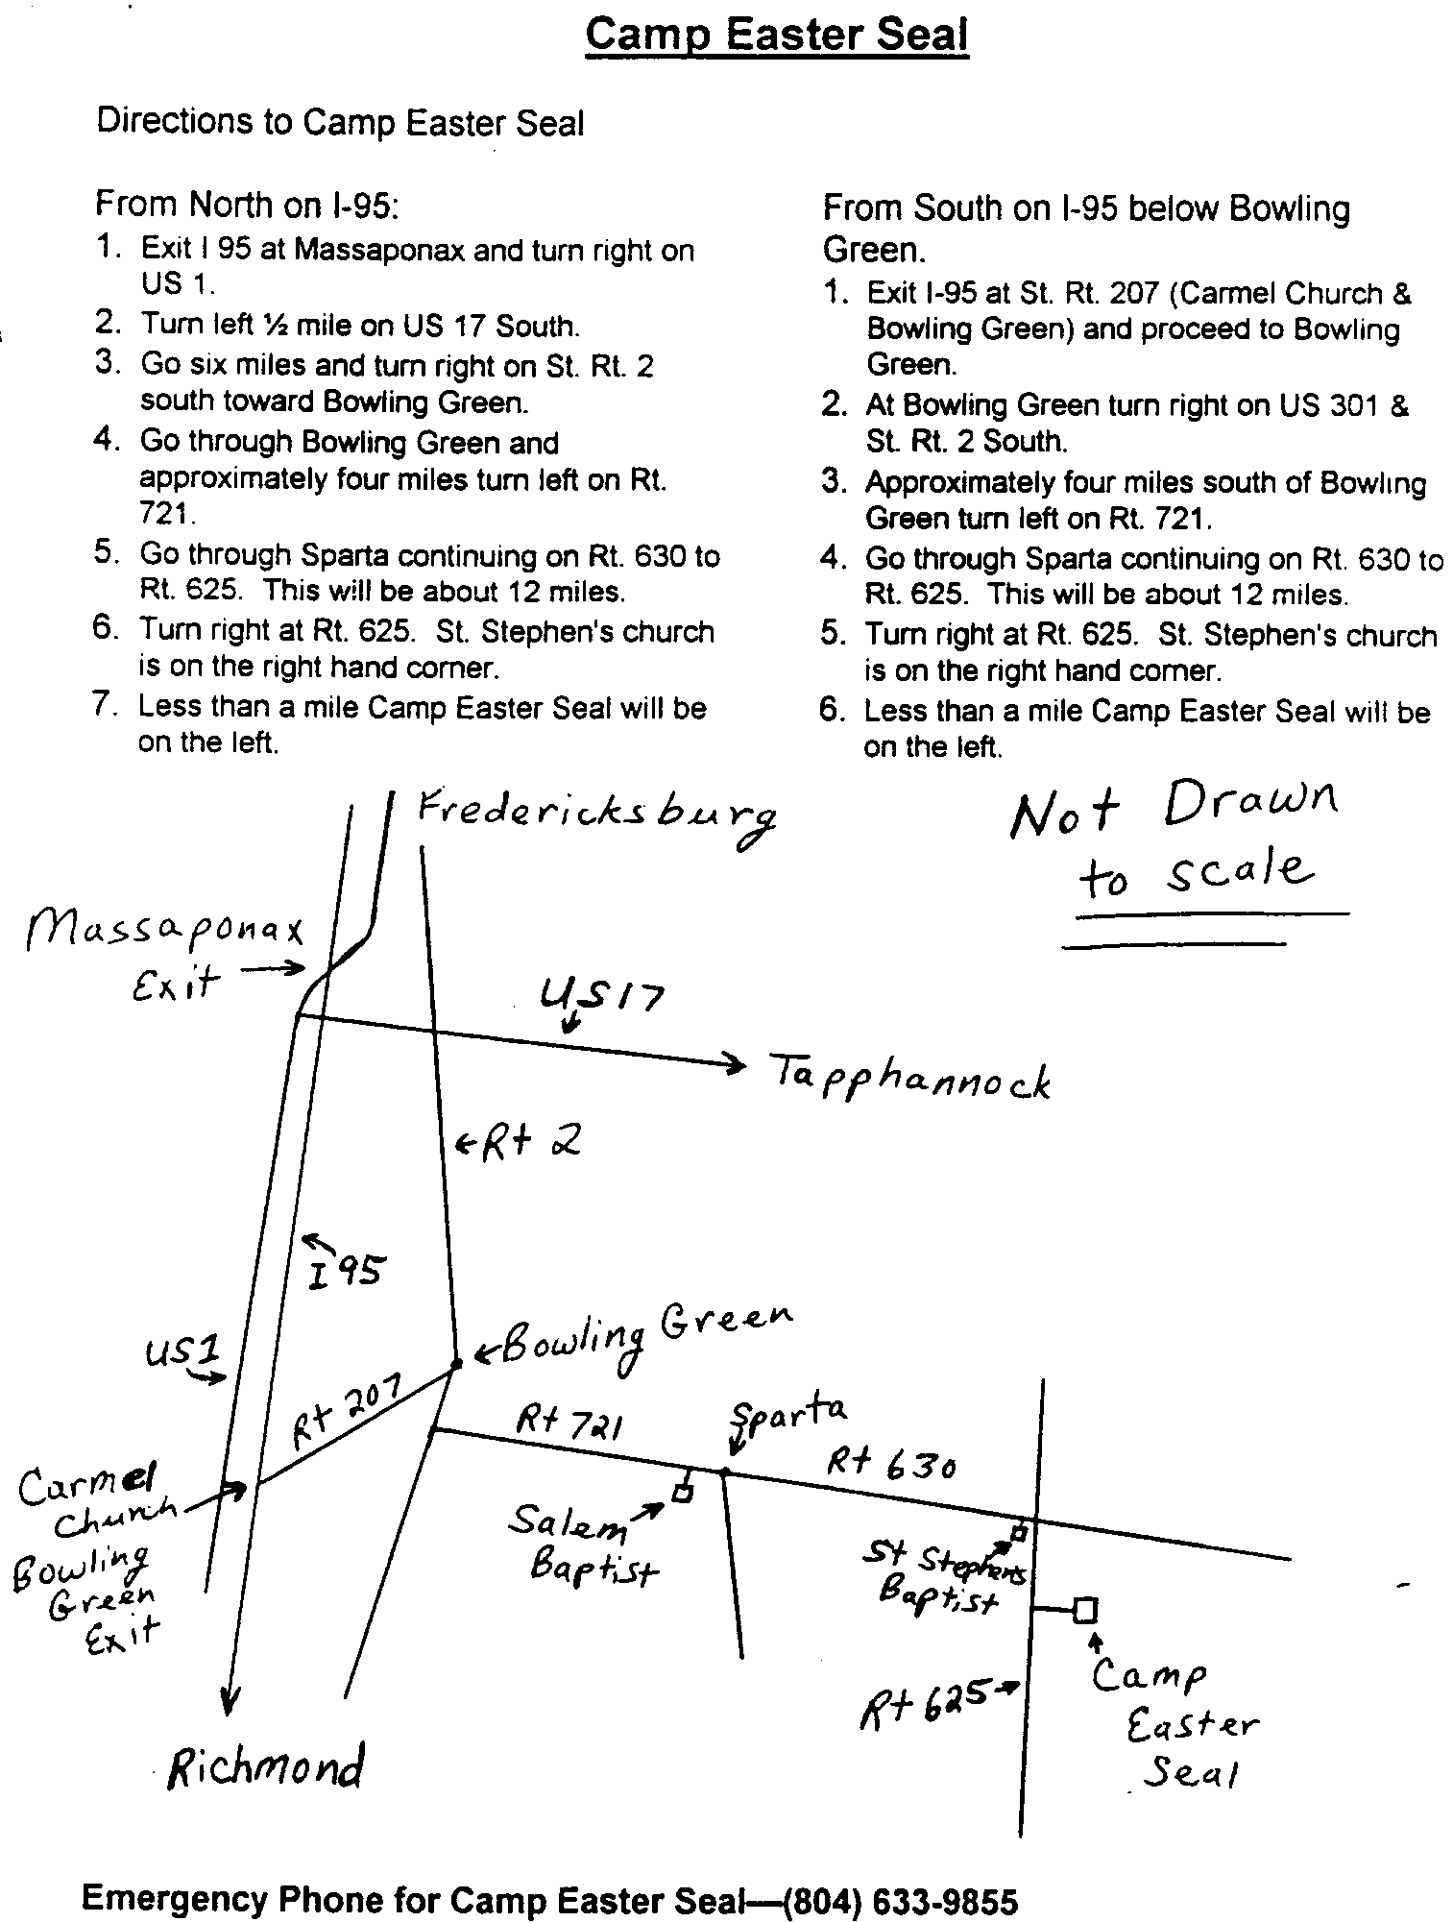

Area-wide Ultreya / Gathering

Some of your brothers and sisters are in the process of organizing a multiple community Ultreya/Gathering. We hope to be able to get members and their guests from all of the area's Cursillo, Emmaus, Tres Dias, Rainbow, Via de Christo, Chrysalis, Youth Encounter, Journey with Christ and Kairos communities together for a joint celebration of God's love through Christ Jesus. As far as we know, it will be the first time that these various communities, which share such a unique bond, will have enjoyed such a combined venture. We hope to have LOTS of music, a meditation/devotion, and at least on (and possibly quite a few more), Fourth-Day speakers. This project is still in it's infancy with little completed beyond a vision and a lot of prayers. Coordinating this with each community's already scheduled events is seemingly impossible. Some of the things that need to be considered are: 1. How do we let everyone know about it? This is the first step; just getting the word out that something like this is being considered. Continued communication with members of each of the various communities to assist with and coordinate announcements in our newsletters, on our websites, through our e-mail mailings, in our churches, and at our own Ultreyas/Gatherings is essential. 2. When will be good time to hold it? We would suggest July or August if it can be arranged that quickly. These are "vacation" months when some of our communities have a bit lower attendance at their own functions. Either a Friday or Saturday evening would likely best fit the schedules of most of those trying to attend. The day and date will also be determined by where and when we can obtain a facility. 3. What kind of turnout can we expect? Your guess is as good as ours. However, the initial response we've gotten from a very informal poll is that this is a great idea, creating a great opportunity to make His presence know to a larger body outside the Fourth-Day community. Internally, it will be a wonderful Spirit-led and Spirit-filled time of fellowship for all our denominations, acknowledging our diversity while celebrating our most cherished common bond, our Redeemer and Savior, Christ Jesus. And, it might be chance to reconnect with people you have teamed with from other communities. As many Fourth-Day communities as we have in the area, we would think that a large turnout can be expected, especially if we get support from most of these communities. And that leads right into the last question.
4. Where would be a good location to hold it? If the turnout is as we hoping and praying for, a large facility such as Immanuel Bible Church in Springfield, Va. or Hylton Chapel or Christ Chapel both in Woodbridge, Va. might be necessary. Of course, we also need to remember that keeping the location central could be a big help in achieving a large attendance. Please direct input, inquiries, helpful recommendations, and especially offers to assist in the planning to: Brian Lewis 11804 Lenox Lane Woodbridge, Va. 22192-5723 or
preferably at: bb3253@aol.com

WANTED—PILGRIM REGISTRAR

The Fredericksburg Emmaus Board needs a volunteer to temporarily (prefer long-term) be the Pilgrim Registrar beginning June 1. The person would be responsible for processing the Pilgrim applications, communication with the Board, oral and written communication with the Pilgrims and their sponsor, and other related duties.

Please contact Hank McCaslin for further information or details. Phone 540-548-3510 or email at: mccas@erols.com

WE NEED YOUR CORRECT ADDRESS INFORMATION !!
Please send corrections/updates of your addresses to our Data Base Coordinator and our E-mailman: Barbara Olds at: roosterlover@erols.comBrian Lewis at: bb3253@aol.com I keep asking for email address updates and additions at the gatherings and in the emails I send out to the community but I get little response. Yet, I also hear that everyone wants to be kept up with all the news and announcements. Thanks. In His grace, Brian

Fredericksburg Web Site
www.fredericksburgemmaus.org

Ballot for the Fredericksburg Emmaus
Board of Directors

1. Certification of membership. I am a member of Fredericksburg Emmaus / Chrysalis, eligible to vote by virtue of attending a Walk to Emmaus sponsored by the Fredericksburg Emmaus Community, or a Walk to Emmaus, Chrysalis, or other Cursillo based weekend in another area.

2. Men (vote for two)  Donnie Cross ( )  Vic Larson ( )  Gene Philipp ( )  Wes Pryce ( )  Joe Reed ( )  Mike Shiflett ( )  4. Clergy 3-yr term (vote for one)  _____________________ ( )  _____________________ ( )  _____________________ |  | 3. Women (vote for three)  Millie Brock ( )  Jane Carwell ( )  Sandy Crossley ( )  Maria Fortune ( )  Janice Williams ( )  5. Each member of an Emmaus family who has attended an Emmaus, Chrysalis or other Cursillo based weekend is entitled to a separate ballot. To be counted, proxy ballot(s) must be submitted at the May Gathering or mailed to  Fredericksburg Emmaus  P.O. Box 42094  Fredericksburg, VA 22404  All mail-in entries must be received prior to the May 12, 2001 Gathering.

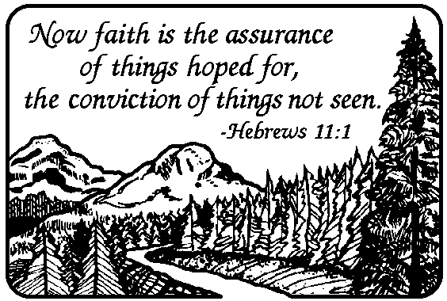

Upper Room Emmaus of the
NON-PROFIT ORG.
U.S. POSTAGE PAID
FREDERICKSBURG, VIRGINIA
PERMIT NO. 347
Greater Fredericksburg Area
PO Box 42094
Fredericksburg, VA 22404


