The Upper Room
Emmaus

October 2002 | of the Greater Fredericksburg Area

From the Lay Director . . .

As we recently remembered the events of 09/11/01 on the one-year anniversary of that awful day, reflection revealed to me that throughout that fateful time and even during the services this year, I felt somewhat detached from the whole experience. It was like I was eavesdropping or overhearing the events through the conversations, emotions, and pictures of others. Do we occasionally have that same relationship with the Gospel?

As readers of the Gospel, we are the eavesdroppers, the overhearers of the truth. We are able to witness Jesus’ person and humanity in a way that neither the crowds nor the disciples are able to in his very presence. As much as we identify with the twelve, and in spite of the fact that we sometimes feel like one of the crowd, we are neither and yet both. We are neither because we have the inside story and two thousand years of Christianity to inform us. We are both because we are self-seeking like the crowds and self-serving like the disciples. As overhearers of the word, our burden is great. The words we speak must reflect the truth as we have come to understand it.

We are also witnesses to our own personal experiences of salvation. These experiences bring life to the scriptures and nurture bonding within the Christian Community. As we witness to our faith – or fail to witness- there are always overhearers and unknown eavesdroppers. In our life day by day, what is being overheard about our faith?

“Jesus went through all the towns and villages, teaching in their synagogues, preaching the good news of the kingdom….” Matt. 9:35.

Yours in Christ,
Paul Prewitt
Fredericksburg UMC
Emmaus #29, Table of Matthew

The Next Fredericksburg

Gathering

When: October 12, 2002

Where: Hillcrest UMC

Time: 6:45 p.m.

The board will meet at 4:30 p.m.
Fellowship begins at 6:00 p.m.

Upcoming Gatherings

November 9, 2002 Hillcrest UMC
December 14, 2002 Hillcrest UMC
January 11, 2003 First Christian Church
February 8, 2003 First Christian Church
March 8, 2003 First Christian Church
April 12, 2003 First Christian Church
May 10, 2003 Fredericksburg UMC
June 14, 2003 Hillcrest UMC
2002 Weekends

Men’s October 17-20
WLD: Bill Simpson

Women’s November 14-17
WLD: Kitti Mann

AGAPE BAGS -

SEW BEAUTIFUL!

Remember when you saw your agape bag for the first time? God filled that eye-catching bag with love letters just for you. Will you help make another pilgrim's walk special? You can buy brightly colored rainbow striped fabric (check the craft section at your local fabric store or WalMart), cording, bright shoelaces to donate. Or you can make agape bags; they are sew simple to make (12" wide and 15" tall, please). Call Diana Farrar at 540-372-7535 or e-mail her at HRHDiana@juno.com to say "I'll help!"


Calling all the YOUNG at HEART
Can you decorate 5 or 10 or 20 or 100 place mats for an upcoming weekend? Maybe you'd like to help, but have no idea where to start or where to get great ideas! Call Ellen Schertz, the Place Mat Connection at (540) 891-9593 or e-mail her at ellouisesc@aol.com to get set up. You may also buy and donate blank white or solid color place mats. There's room for your gifts at whatever level you choose to serve in the Emmaus place mat ministry. Call Ellen today!

Fredericksburg Web Site
www.fredericksburgemmaus.org
BOARD OF DIRECTORS

Prewitt, Paul - Lay Director
Pryce, Wes - Asst. Lay Director
Philipp, Gene - Secretary
Fortune, Maria - Treasurer
Throckmorton, Barry - Spiritual Director

Curry, Bowie Perkins, Susan
DeJong, John Schertz, Ellen
Mann, John Simpson, Barbara
Mann, Kitti Tubbs, Larry
Perkins, Dennis Weinhardt, Pat

FREDERICKSBURG EMMAUS

Emmaus Volunteer Chairpersons 2002-2003

Community Lay Director - Paul Prewitt
Lead Gatherings & Candlelight
Host Weekend Sponsors’ Hour & Closing
Chair Emmaus Board
Pilgrim/Team Selection Committee
Board Nominating Committee

Assistant Community Lay Director - Wes Pryce

Community Spiritual Director - Barry Throckmorton
Gathering Location Coordinator

Treasurer - Maria Fortune

Secretary - Gene Philipp
Manuals Coordinator - Barbara Larson
Records & By-Laws Historian - Gene Philipp

Communications Coordinator - John Mann
Newsletter - Barbara Olds
Database Coordinator - Barbara Olds
Team Registrar - Debrina McKeen
Pilgrim Registrar - Pat & Dick Barnett

Gathering Support Coordinator - Vacant
Community Music Director - Debrina McKeen
Community Baker - Angel Fulkerson
Childcare Coordinator - Pat Weinhardt
Facility Clean Up Coordinator -

Weekend Support Coordinator - Brian Lewis
Community Cha Coordinator - Richard Warner
General Agape Coordinator - Phyllis Howze
Prayer Vigil Coordinator - Sandy Crossley/ Jane Carwell
Placemat Coordinator - Ellen Schertz
Snack Agape Coordinator - Janice Williams
Agape Bag Coordinator - Diana Farrar
Transportation Coordinator - Mo Moses
Supplies Coordinator - Wes Pryce
Fourth Day Packets - Tina Cooper

Fourth Day Coordinator - Vacant
Reunion Group Coordinator - Sandy Crossley
Emmaus “Store” Coordinator - Millie Brock

Nominating Committee Coordinator - Larry Tubbs

Agape
OCTOBER 2002

3- 6 Men 14 Ashland Area Emmaus
Men 96 North Georgia Walk to Emmaus
Men 108 National Capital Area N. VA
Men 88 Central Indiana Cursillo
Men 68 GA-Lina Emmaus Community
2- 6 Kairos 16 Lee Correctional Institute SC
9-13 Kairos 28 Lieber Correctional Institute SC
Kairos 27 Women Correctional Institute SC
Kairos 10 Perry Correctional Institute SC
10- 13 Women 115 North Georgia Walk to Emmaus
Women 69 GA-Lina Emmaus Community
16- 20 Kairos 12 Broad River Correctional Institute
17- 20 Men 133 Puget Sound Walk to Emmaus
Women 164 Dallas Emmaus Community
Men Southern Nevada Emmaus
Women 16 Ashland Area Emmaus
Men 62 North East Texas Emmaus
Men 91 Central California Emmaus
Women 77 Central Indiana Cursillo
Men Cross Bayou Emmaus N.LA
Men 70 GA-Lina Emmaus Community
Women 81 Greater Cincinnati Emmaus
Men Bowling Green Emmaus KY
24- 27 Women 134 Puget Sound Walk to Emmaus
Men 23 New York Annual Conference
Women Southern Nevada Emmaus
Men 91 Heart of Georgia Emmaus
Women 92 Central California Emmaus
Men Marin Cursillo Community CA
Women 71 GA-Lina Emmaus Community
Men 114 Emmaus of SE Michigan
Women Bowling Green Emmaus KY
Women 34 Texoma Emmaus Community TX
31- Nov 3 Men Columbia Indiana Area Emmaus
Women 92 Heart of Georgia Emmaus
Men High Plains Emmaus Com NM
Men 35 Texoma Emmaus TX
DEADLINE for the November newsletter is Wednesday, October 16. Please send your articles to editor, Barbara Olds. Mail to 343 Longwood Drive, Stafford, VA 22556; fax to 540-286-0639; or e-mail to roosterlover@thecrossworks.net. For the timely delivery of our newsletter, it is important to get those articles in on time!
Reunion Groups . . .

We would like to list the Reunion Groups active in the Fredericksburg Emmaus Community. If you are a member of a reunion group, please send the information to Barbara Olds. Please provide the name, meeting time, place, and contact with phone number.

Great Is Thy Faithfulness Emmaus Reunion Group
Meets 7:30 PM Tuesdays
Prince Of Peace United Methodist Church
6299 Token Forest Drive
Manassas, Virginia
Contact: Lloyd Biller (703) 590-1512

Pastor's Weekly Meeting
Meets 9:00 AM Thursdays
Rotates - call for location
Contact: Mark Dunn (540) 786-4025

Lakeside Reunion Group (Men)
Meets 8:00 PM Tuesdays
Lake Of The Woods - call for location
Contact : Vic Larson (540) 972-1928

Rainbow Reunion Group (Women)
Meets 2:30 PM Tuesdays
Lake Of The Woods - call for location
Contact : Barbara Miller (540) 972-7418

Koinonia Women’s Reunion Group
Meets 9:00 AM Fridays
Lake of the Woods - call for location
Contact: Barbara Larson (540) 972-1928

“Amazing Grace” Reunion Group
Meets 8:30 PM Thursdays
Hillcrest UMC
Contact : Ed McAdam (540) 898-3625
e-mail to emcadam@infi.net

Bethel UMC Men’s Group
Meets 7:30 AM Sundays
IHOP, Woodbridge
Contact: Brian Lewis (703) 590-9343
e-mail to bb3253@AOL.com

Joy Breaks
Meets 8:00 PM Mondays
IHOP, Woodbridge
Contact: Lois Myrick (703) 680-0577 or
Susan Perkins (703) 590-3482

God Bearers
Meets 8:00 AM Sundays
Melrose United Methodist Church
Contact: Laurie Basye (804) 529-6953 or 580-5135
e-mail basye@crosslink.net
Alice Harding (804) 529-7854
e-mail archardcl@pen.k12.va.us

Lord’s Lions and Lambs Reunion Group
Meets 6:30 PM Wednesdays
First Christian Church
Contact: Gene Philipp (540) 898-4917
e-mail GeneDiPhil@aol.com

Reality Check (Chrysalis Boys & Girls)
Meets 6:15 PM Wednesdays
Fredericksburg UMC

(Women)
Meets 7:00 PM Tuesdays
Fredericksburg UMC
Contact: Becky Guy (540) 373-8258
e-mail mwcof61@mindspring.com

Interested in a New Reunion Group?

There has been interest expressed for a reunion group for the following days:

Men Thursday PM Stafford area
Women AM Woodbridge
Women Tuesday PM Fredericksburg
Women AM Fredericksburg
Girls Chrysalis PM Woodbridge

If you are interested in joining a new reunion group for one of the above days, please call Sandy Crossley at (703) 221-6977 or e-mail at slcrossley@aol.com

From the Spiritual Director . . .

“United We Stand” may be the most familiar bumper sticker slogan of the day. It speaks to our unity as citizens of the greatest country on earth. But whenever I see this slogan, my thoughts are drawn to the refrain of the hymn: “We are the Church.”

I am the church! You are the church! We are the church together! All who follow Jesus, all around the world, yes, we’re the church together.

This is more than a cute little ditty. It is an affirmation that we are one in Christ! It speaks to the presence of the Holy Spirit at work within us, uniting us!

Bound together by peace, in the power of the Holy Spirit we are more than a mob of individuals. We are a new creation, able to sustain, endure, and thrive through far more ordeals than mere individuals ever could.

We suffered through a severe ice storm in South Side Virginia during the winter of 1998. Ice was so heavy on limbs and branches that trees bent over. Some completely broke, while others split and later died. Yet others were damaged so badly they will never stand straight again.

A member of the congregation, where I served at the time, shared an observation. He had scattered trees along his drive going to his house. A short distance off the drive was a cluster of trees. Every tree that stood alone was severely damaged. Many were destroyed. But the trees that were clustered survived, with very little damage. They leaned on each other, supported each other, and held each other up.

Most of us would agree this concept of leaning on each other pertains to our local congregations. People gather to form congregations. Everyone who actively participates in a congregation counts on the rest of the congregation for support.

I believe that is how the whole Church works also. Our local congregations are stronger, healthier, when we work together in Christian unity. Just as each individual Christian needs a congregation, individual congregations need each other.

Christian unity is essential for the world. Diversity of ideas from around the globe, rapid dissemination of information, and an ever-changing world situation makes it imperative that Christians pull together in proclaiming good news of Jesus Christ!

Placing all our energies into a local congregation is good, but if that is all Christians do we run the risk of turning Christianity into a confederation of cell groups, rather than a kingdom of priests.

We are invited by Jesus to participate with God as new creatures in a new creation. United we stand – in the unity of the Holy Spirit we move and grow.

Make every effort to preserve the unity which has the Spirit as its origin and peace as its binding force.
Ephesians 4:3 (CEV)

Grace and peace,

Barry Throckmorton

Dear Brothers and Sisters in Christ,

Recently, while on a mini vacation on the coast of North Carolina, I took a late night solitary walk on the beach. It was a perfect night with a full moon, gentle waves, and a warm ocean breeze. One of my favorite things to do is to walk on a warm summer night when no sweater or shoes are needed.
I climbed over the sand dune and my bare feet were embraced by warm sand. There was a flashlight in my pocket, but the moonlight reflecting on the ocean was all that I needed. White foam tickled my ankles as I turned left and gently kicked water high into the air. As I strolled along the shoreline, I gazed up at the stars, then at the hotel lights, and then I spotted it….
In front of one hotel was a hammock, and it was empty. I slowly crossed the sand, climbed the dune, and stretched out across the web of rope. It was wonderful! The ocean breeze gently rocked me. I wanted to close my eyes, but the beauty before me kept fast my attention. The sights, sounds, and feel of God’s handiwork engulfed me. Time seemed to stand still.
After some undefined measure of time, I left the man-made comfort and headed back to the water. I walked toward the sea until I felt the warm salty water cover my feet. I then reversed my path walking slowly.
My personal world came into focus as I pondered the events of the summer. I was grateful for the time I had with the grandchildren in Texas, refreshing days at the pool, sleeping late, and lunch with friends. I was concerned about not having a job and what the future would bring.
I found myself praying to God. I said, "Lord, sometimes I feel so alone in this world. I want to do the right thing but I don’t know what that is. What is your will for me?" After that prayer I felt this message come into my heart: "Dennis, I am always with you. The times that you feel alone are the times when you leave the path I have made for you. If you truly have my Son in your heart, you already know my will for you. Don’t be afraid to be what I created in you."I stopped walking and marveled at the waves as they rolled through the moonlight. I wiggled my toes in the sandy water and continued along the coastline towards my hotel.
I didn’t want to leave this paradise. Maybe, this glimpse of paradise can go along with me wherever I go if I remember that God is always with me. I realized that I often treat God like a silent friend. I know He’s there, but I don’t always listen to Him or talk to him in the quiet moments. Tears welled up in my eyes as a gust of wind blew through my hair. A calmness and a sense of gratitude filled my every thought. I realized what appeared to come from someone else was actually my voice. Singing. Now, I’m not a singer, but I sang with everything I had.
"Amazing grace! How sweet the sound. That saved a wretch like me! I once was lost, but now am found, was blind but now I see. Twas grace that taught my heart to fear, and grace my fears relieved; how precious did that grace appear, the hour I first believed! Through many dangers, toils and snares, I have already come; ‘tis grace has brought me safe thus far, and grace will lead me home. The Lord has promised good to me, His word my hope secures; He will my shield and portion be, as long as life endures. Yes, when this flesh and heart shall fail, and mortal life shall cease; I shall possess, within the veil, a life of joy and peace. The earth shall soon dissolve like snow, the sun forbear to shine; but God who called me here below, will be forever mine. A very dear lady once said that God always seems to be just a little bit closer to her when she is at the ocean. At that moment, I fully realized that when I am barefoot, looking over His magnificent creation, I realize that I am standing on Holy Ground. All my senses are exposed, and I can freely accept the rushing flow of His love.
May your heart overflow with God’s love and grace as you acknowledge Him as the friend that stands beside you always! Your Brother in Christ,
Dennis Perkins

FREDERICKSBURG EMMAUS #47
Team Assignments

Dick Barnett Table Leader
Bob Bonshire Table Leader
Lake Cowart Asst Table Leader Readings
Richard Cronin Asst Table Leader Priesthood of Believers Fri., 1:30 pm
Carlton Crooks Asst Table Leader
Donnie Cross Music Team
Robert Fulkerson Lead Music Director
Steve Johnson Table Leader Life in Piety Fri., 7:30 pm
Vic Larson Asst Lay Director Fourth Day Sun., 2:45 pm
Keith Lauer Table Leader
Larry Lenow Lead Spiritual Director Means of Grace Sat., 10:15 am
Sanctifying Grace Sun., 10:00 am
Steve Makely Asst Table Leader
John Mann Asst Lay Director Growth Through Study Sat., 8:55 am
Hank McCaslin Spiritual Director Justifying Grace Fri., 3:00 pm
Jene Parrotte Cha
Gene Philipp Agape Cha Changing Our World Sun., 8:50 am
Paul Prewitt Asst Lay Director Priorities Fri., 9:15 am
Joe Reed Chapel Cha
Mike Remington Cha
Ken Roark Floater
Tony Schroth Table Leader Body of Christ Sun., 11:10 am
John Shutlock Table Leader Discipleship Sat., 8:00 pm
Bill Simpson Lay Director Perseverance Sun., 1:05 pm
Ralph Thomas Asst Table Leader Christian Action Sat., 2:35 pm
Charles Tillapaugh Spiritual Director Prevenient Grace Fri., 11:15 am
Obstacles to Grace Sat., 4:00 pm
Dennis Warne Music Team
Richard Warner Cha Coordinator
Frank Zarzour Asst Table Leader

The Team Chapel is open to the Community during the various talks. Each speaker will have a team member in the chapel as their prayer partner. A speaker’s grouping members, family or others who have attended a weekend are invited and welcomed to be a part of this special time. Chapel Prayer Partners should be discreet in arriving and departing from Camp Easter Seal and should be in the prayer chapel 30 minutes prior to “Talk Time” listed above.
FREDERICKSBURG EMMAUS #47

Pilgrims

Jack | Balenger | LOW Church
Cliff | Carpenter | Fredericksburg UMC
Dale | Donadio | Spotsylvania Assy of God
Joseph | Dunkin | St. Matthias UMC
Dave | Dyer | Hillcrest UMC
Chris | Fair | Shady Grove UMC
Albert | Harvey | Fredericksburg UMC
Ben | Holmes | St. Matthias UMC
Tim | Hume | St. Paul’s UMC
Joe | Johnson | Bethel UMC
Randy | Johnson | Spotsylvania Assy of God
Vince | Klug | LOW Church
Dave | Kreider | Spotsylvania Presbyterian
Dom | LaPore | Salem Fields Community
Bob | Lerner | Hopewell Methodist
Jamie | Lowery | Morrisville UMC
Don | Marriott | Spotsylvania Assy of god
Dee | McCown | Salem Fields Community
Scott | McIntire | Fredericksburg UMC
Vince | Miller | Wright’s Chapel UMC
Mike | Motsko | Spotsylvania Presbyterian
Bill | Osborne | First Christian Church
Tim | Patrick | Fairview Baptist
Eddie | Patten | Little Union Baptist
Brian | Simmons | Hillcrest UMC
Lorry | Speare | Spotsylvania Assy of God
Clifton | Spence | Wright’s Chapel UMC
Jim | Staebler | Fredericksburg UMC
Louis | Woolner | Grace UMC

Schedule - Men’s Emmaus #47 - October 17-20, 2002

The team for Fredericksburg Men’s Emmaus #47 invites sponsors, families and community participation in the following events:

WHEN WHERE WHAT
Thurs., Oct 17 6:30 P.M. Camp Easter Seal Pilgrim check-in/Fellowship followed by Sponsor’s Hour

Sat., Oct 19 7:45 P.M. Camp Easter Seal Candlelight - Please bring flowers for the team to use Sunday morning!!! Community will gather for Praise, Fellowship and Communion.

Sun., Oct 20 3:30 P.M. Camp Easter Seal Closing - Gather at 3:30 for Closing Service at 4:00 P.M. Closing will be held in the gym.

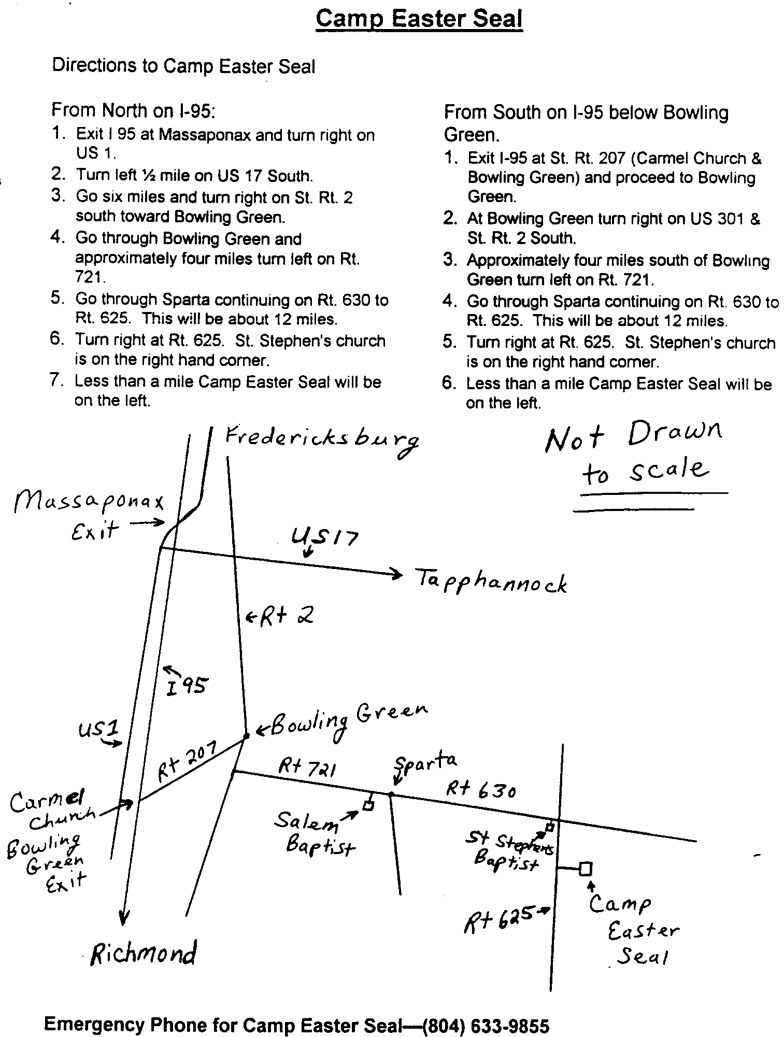

Needed:
Service Worship Leader

Spotsylvania Presbyterian Church

According to the church mission statement, worship at Spotsylvania Presbyterian Church is meant to be “joyful and reverent.” It should also be consistent with the church’s vision to build disciples in the reformed tradition. The Worship Leader of the 9:45 service will be responsible for making all necessary arrangements to lead a service that glorifies God using contemporary and historic expressions of worship.

The person for this position should have education and/or experience that would meet the following qualifications:

- A person with a vibrant faith in Jesus Christ as their personal Lord and Savior;
b) An understanding and conviction of reformed theology which governs music and selection;
c) The ability, experience and knowledge of music for both contemporary and traditional worship services;
d) The ability to read music and play, at least, one musical instrument;
e) Knowledge or ability to operate or oversee all necessary equipment required to lead worship;
f) The ability to develop or direct production of projection materials;
g) The ability to project a spirit-filled, joyful presence which draws the congregation to worship;
h) The ability to organize and supervise worship team resources;
i) Knowledge of or ability to learn the Finale software to adapt music as necessary.

The position of Worship Leader is 20 hours per week. An annual review of the position will be conducted by the session of the church through the Personnel Committee with input from the Worship Committee and the Senior Pastor.

If you are interested in this position or would like additional information,
please contact Louise Motsko at Mlmmotsko@aol.com

